


Panathlon Challenge at Home Games Guide
Multi-Skill Challenges
Thank you for taking part in the Panathlon at home challenges. There are 4 indoor games in this pack, as well as a scoring template
Use these games as a guide. Adapt the equipment to use what you’ve got at home. Adapt the size of games to fit your space. Play for your personal best. Challenge yourself. Determine to improve on your own records.

Adaptations
Visually impaired players: a helper can clap to aid direction of a target or, assistance with directions.
Wheelchair users: ramps can be used to help propel objects, if you don’t have a ramp, grab a long piece of cardboard, change the distances or place the equipment off ground level (on a table) instead.

Let us know how well you’ve done via @panathlon on social media and via #PanathlonIndoorGames!

To receive a certificate for yourself to download please email events@panathlon.com with your score sheet as a record.

Indoor Games
Into the Tower (Indoor)
Video Link – https://youtu.be/4pCM-tmeQlE
Equipment: 3 x Jam Jar Lids (Bean bags, Toy cars, rolled up socks), Chair, Smooth Floor, Stopwatch or Kitchen Timer.
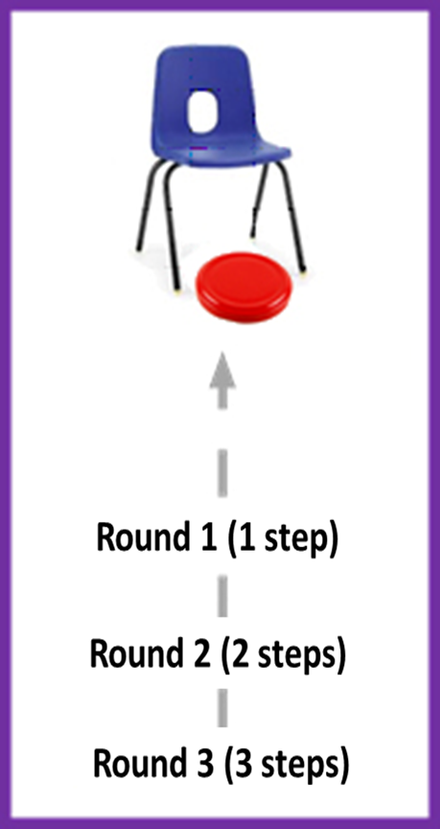
Aim: “Stop the ‘stone’ underneath the tower”
- Starting 1 step back from the chair, push the lid, to come to rest under the chair
- If successful, move back another step
- Each go has three attempts
- If you miss on one attempt, stay at that distance from the chair

Scoring: If successful, you score:
- 1 point @ 1 steps back
- 2 points @ 2 steps back
- 3 points @ 3 steps back
- Maximum points per turn = 1 + 2 + 3 = 6 points.

- Timed: Total points based on 1 minute play. Retrieve your own lids. Using a stopwatch or kitchen timer.
- High Score: 3 full goes (9 attempts). How many can you score, out of a maximum of 18 points?

Variation Games:
- Can be played seated on a table, using a box as the tower
- Knock-Out. Place one lid under the chair. Push another lid, to hit it, removing it from under the chair.


Funfair (Indoor)
Video Link - https://youtu.be/E76uthkCoJY
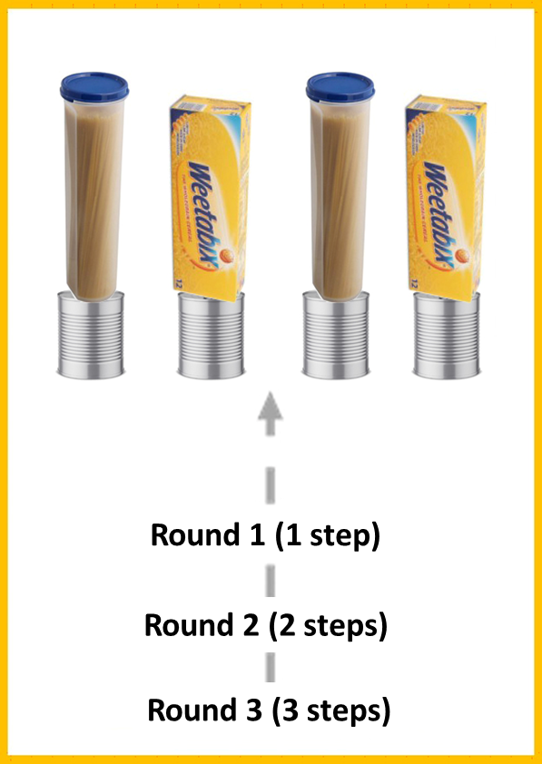
Equipment: 4 x Socks Rolled Up (bean bag or small ball), 4 x Tin Cans, 4 x Objects to stand on the tins (Boxes Tupperware, Soft Toys), Stopwatch or Kitchen Timer
Aim: “Knock items off the tins”
- Round One - Throw 4 socks, from 1 step back
- Round Two - Throw 4 socks, from 2 steps back
- Round Three - Throw 4 socks, from 3 steps back
Scoring:
- 1 point - for each item knocked off in Round One
- 2 points - for each item knocked off in Round Two
- 3 points - for each item knocked off in Round Three
- Maximum score per turn = 4 (round one) + 8 (round two) + 12 (round three) = 24 points.

- Timed: Total points based on 1 minutes play. Using a stopwatch or kitchen timer. Retrieve your own socks.
- High Score: 2 full goes (12 + 12 throws). How many can you score, out of a maximum of 48 points?
Precision Bean Bag (Indoor)
Video Link - https://youtu.be/-_hmqisIGiU

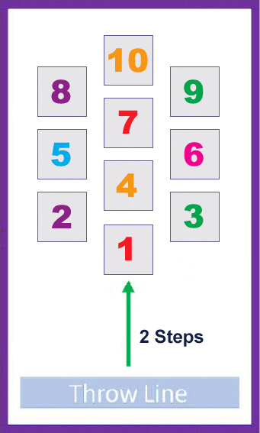
Equipment: 5 x Socks Rolled Up (Bean Bags, Soft Toys, Scrunched-Up Foil,), 10 x A4 Paper with Numbers 1-10, Chair, Stopwatch or Kitchen Timer

Aim: “Land on Numbers”
- Throw 5 socks from a seated position, 2 steps away from the numbered targets
- The score is taken from where the sock first lands, not its finishing position.
- If the sock finishes out of the scoring area, this scores 0. e.g. bean bag hits 5, then slides off, score = 0.
- Only one score per numbered target
e.g. three socks land on 6, scored as 6 points (not 18)

Scoring:
- Maximum score from 5 socks is: 10 + 9 + 8 + 7 + 6 = 40 points
- Timed: Total points based on 1 minutes play. Using a stopwatch or kitchen timer. Retrieve your own socks.
- High Score: 2 full goes (10 attempts). How many can you score? Can you get to a maximum of 80 points?

Variations Games:
- Maths Challenge: 5 throws need to add up to a chosen number, between 15 and 40.
- Change the numbers to letters, spell your (and family) names, in the correct order.

Pirate Ship (Indoor)
Video Link - https://youtu.be/ieMVqynrp4Q

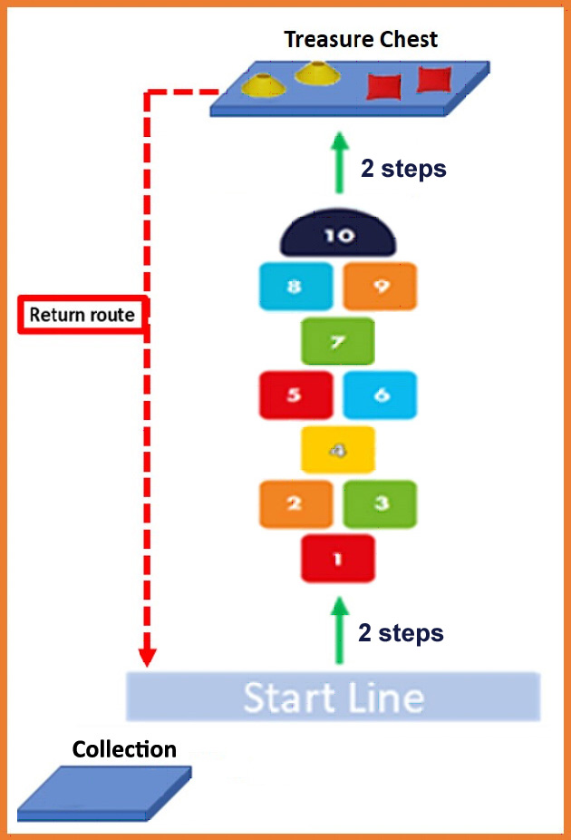
Equipment: 6 x Treasure Items (Rolled up socks, Board Game Counters, Soft Toys), 10 x A4 Paper with Numbers 1-10,Treasure Chest (Rug, sofa, chair), Stopwatch or Kitchen Timer
Set up: Lightly tape numbers floor, if you have a slippery floor.
Aim: “Continuous Hopscotch to grab Treasure”
- Hop & Jump your way to the ‘treasure’, take 1 item at a time back to the collection area behind the Start Line.
- Round One - Hop on numbers 1 – 4 – 7 – 10. Take 1 item. Return back to start line. Leave item in collection area.
- Round Two - Jumping two feet 2&3 - 5&6 - 8&9. Take 1 item. Leave item in collection area.
- Round Three – Full Hopscotch, alternating 1 foot to 2 feet on numbers: 1 – 2&3 – 4 – 5&6 – 7 – 8&9 – 10. Take 1 item. Leave item in collection area.
- Repeat, rounds 1 to 3, until all 6 items are collected (all 6 items must be in/on the collection area to finish).
Scoring:
- Timed: How long does it take you to collect all 6 items from the Treasure Chest & bring them back to the Collection area?

Adaptation:
- Wheelchair users: Complete alternate courses a shown in the video and diagrams below.

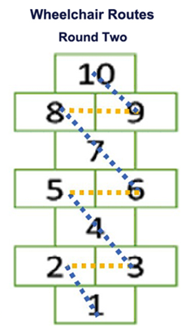
Panathlon at Home - Multi-Skills Scores (Template)

Game: | Best Scores/Times | Best Scores/Times | Best Scores/Times
Email: events@panathlon.com Twitter/Instagram/Facebook: @panathlon #PanathlonIndoorGames

