THE PLATE Balance
Equipment: a piece of paper, a book and a sock
How to play:
- Lay your hand out flat in front of you, creating a ‘plate shape’. Try to hold each item (paper, book, sock) one at a time for as long as possible on your hand (plate) as you were a waiter or waitress in a restaurant..
- Now can you try to move around your room/space whilst keeping the item balanced? Try not to spill the food! Try different iterms and see which one is most challenging.
- Be aware of your space – keep looking around you like an owl to chek you are safe!
- Can you switch hands?
- Can you place pillows down on the floor to create obstacles to move around and climb over?
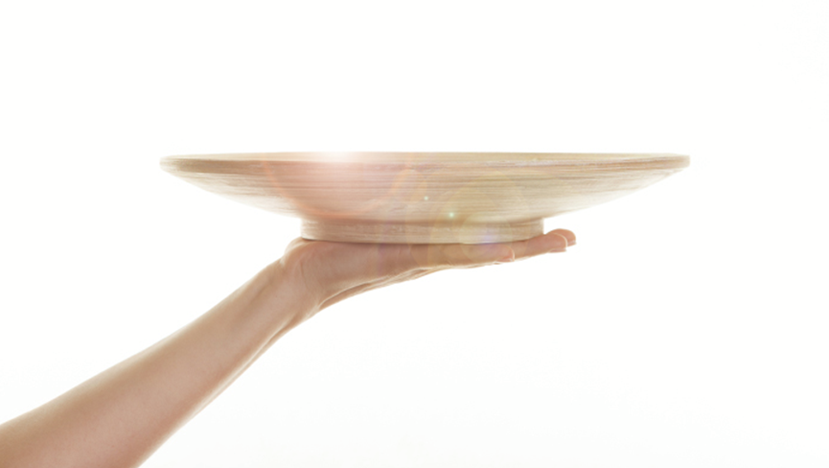

Skill Tip: Keep your tummy tight and straight! Keep your hand flat and arm extended straight.
Challenges:
- Use another body part as your plate- maybe try your head or your shoulder.
- Switch hands and try to move your plate around in different ways – over your head, through your legs.

STEP principle of coaching/teaching- helps to engage, challenge and motivate everyone by altering one or more of the principles
Space - Make the space larger and increase your speed – try to keep your object safe!
Task – Set up a course using pillows and now see how long it takes you to move around it.
Equipment – Use one item on each hand – try larger or smaller objects too.
People – Once you have mastered playing on your own, try and play with a partner – you could even try to knock each other’s objects off.

TRANSPORT TIME Movement
Equipment: none (optional soft objects)
How to play:
- Talk about different types of transport. How many can you name?
- Pick your favourite 4 and choose a movement for each one e.g.
Car – jog on the spot with hands steering the wheel
Plane – Arms out, jumping up and down
Bike – high knees on the spot and hands on handlebars
Train – find a partner and walk on the spot, placing hands on shoulders
- Start by moving around your room as cars and call out each transport type, switching your movements accordingly.
- Can you change your movement quickly?
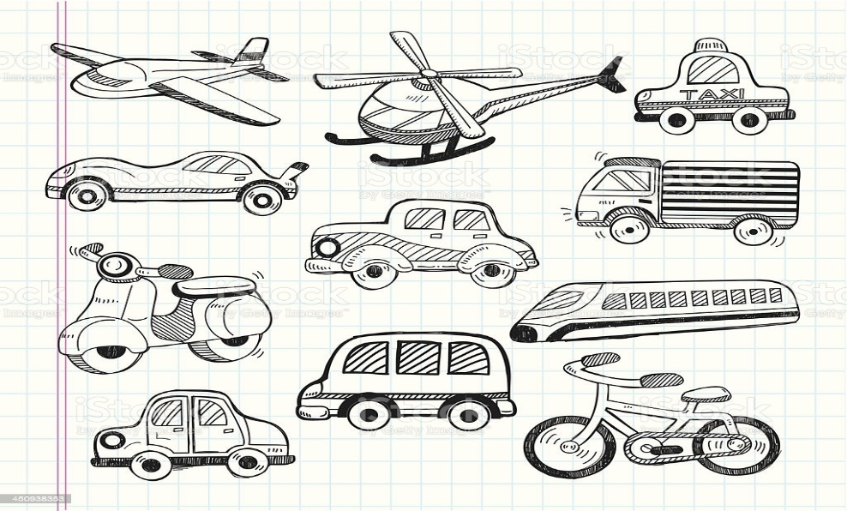

Skill Tip: Try to remain in control when moving. Also be aware of your space, looking around as you travel.
Challenges:
- Can you create an exciting movement for a spaceship or a rocket?
- Can you set yourselves a course around your room to navigate? Maybe try to find safe obstacles to move over, under and around.
STEP principle of coaching/teaching- helps to engage, challenge and motivate everyone by altering one or more of the principles
Space - Make the space larger and increase your speed – stay safe
Task – Set up a course using soft object like teddies or cushions and time yourself as each type of transport. How long did it take? Can you beat your score?
Equipment – Try balancing an object on a body part as you move. How did you get on?
People – Once you have mastered playing on your own, try and play with a partner – you could even try to time each other or race around your course.

NUMBER HUNT Fitness/Movement skills
Equipment: paper, pencil
How to play:
- A parent/carer writes out number (could be 1-10) or choose a suitable set of ten to challenge the child e.g. multiples of 10-100. These must then be secretly hidden around the room.
- The child quickly looks around the room to see if they can touch (not collect) all 10 cards. Once complete, the roles could reverse and the child can hide the cards for their parent/carer.
- Can the numbers now be found and collected in the correct order?
- Hide in high and low places for children to change their levels when collecting.

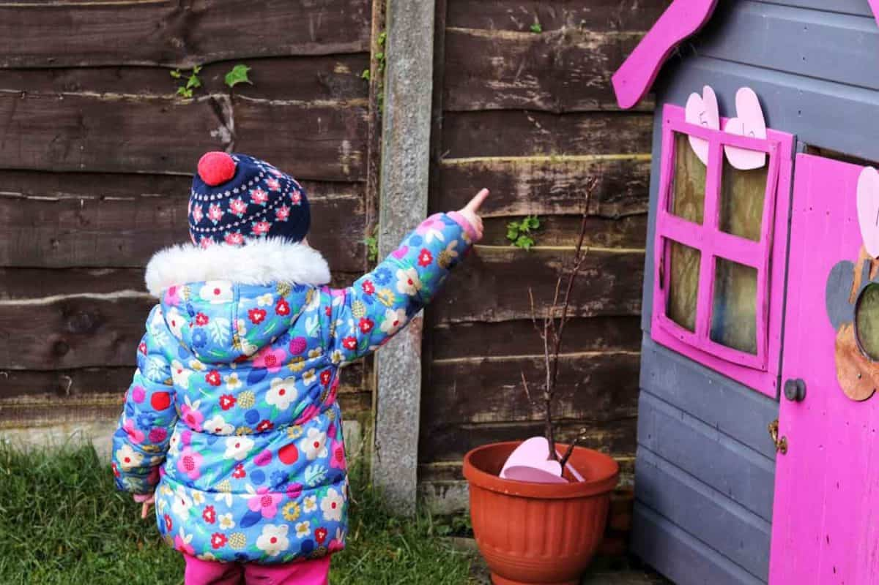

Skill Tip: Children may need prompting to help them find the items. Try to encourage children to work in an order.
Challenges:
- Change your movement as you hunt the number e.g. hopping or skipping.
STEP principle of coaching/teaching- helps to engage, challenge and motivate everyone by altering one or more of the principles
Space - Limit the game to one room to start with and then expand to more rooms
Task – Add an exercise for each number found e.g. 2 star jumps, 3 star jumps
Equipment – Use sounds or common exception words instead of numbers to improve reading skills.
People – Play against a partner! Who can find the numbers first?

SPACE TENNIS Hand-Eye Coordination
Equipment: balloon, pillow/cushion
How to play:
- With help from a parent/carer, blow up your balloon.
- Explore ways of keeping the balloon off the ground. Use your hands, feet, fingers, head. What way did you find easiest?
- This game is called space tennis because this is how an object might move around in space (with less or no gravity) – floating, slowly moving.
- Try to just use only your hands now and count how many individual ‘tap ups’ you can achieve before the balloon hits the ground.
- Now place your cushion/pillow in the middle of your room and stand on it – this is your rocket! Can you try to keep the balloon off the ground now without stepping off your cushion/pillow (rocket)?
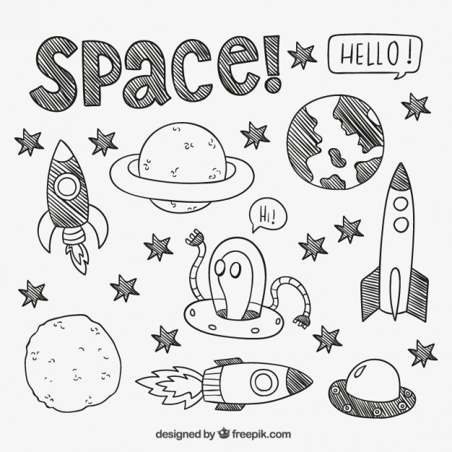

Skill Tip: Hit the balloon with soft touches up to head height. Always bend your knees and keep your eyes on the balloon.
Challenges:
- Try swapping hands after each hit.
STEP principle of coaching/teaching- helps to engage, challenge and motivate everyone by altering one or more of the principles.
Space - Use two pillows/cushions next to one another for an easier challenge or a tiny, soft object to make this even harder.
Task – Use your cushion as a net and play with a partner. How many ‘tap ups’ can you now achieve together?
Equipment – Place 2 pillows/cushions down in different places. Can you hit your balloon form one to the other?
People – Play against a partner like a real tennis game or even play as a family – grown-ups vs kids is always fun!

TARGET TIME Throwing
Equipment: 3 pairs of rolled up socks, three safe, soft targets (household objects)
How to play:
- Place a set of 3 safe, soft objects in a space – these are your targets.
- Stand in a suitable space away from the targets.
- Explain the rules:
One at a time, roll a pair of rolled up socks towards the targets (3 pairs in total).
Play on your own or with others (taking turns).
If the target is hit, you can collect it.
The aim of the game is to collect all three targets.
- Reset the targets after each round.

Skill Tip: Keep your eyes on the target. Slide/push the socks in the direction of the target. Use your palm and fingers like you were stroking a dog.
Challenges:
- How long does it take to hit all three targets? Take 2 steps back and try to match or beat your score.
STEP principle of coaching/teaching- helps to engage, challenge and motivate everyone by altering one or more of the principles.
Space - Make this harder by placing targets further away or wider apart. Make this easier by moving targets closer to the thrower or closer together.
Task – Paly with a partner and both face the targets from opposite sides. Take turns to hit and collect the targets. Who will hit the most targets?
Equipment – Use a variety of objects to act as targets. Vary the size and shape of these for different challenges.
People – Get a family member to join in – get rolling and have fun!

CLEAR THE ROOM Speed, Reactions, Throwing
Equipment: soft objects / paper
How to play:
- Separate the room space into two areas – possibly use pillows or cushions to create a middle line.
- Place soft objects such as teddies on each side. Alternatively screwed up balls of paper could be used here.
- The game can be played with two teams (1v1, 2v1, 2v2 etc), in each area or on your own. Explain that this game is all about clearing the mess from your room/area.
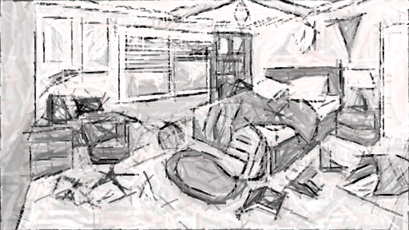

If playing in teams:

- You must grab one object at a time and send this into the opposition team’s area/room.
- You cannot cross the middle line at any time. Stop after 1 minute of play.
- Play several rounds to develop confidence with the game.

If playing on your own:

- Place all teddies in one area and clear into the other.
- Once one side is clear, now switch rooms and clear once more.
- Keep a score of how many objects you clear in 1 minute – maybe ask an adult for help

Skill Tip: Encourage players to be on the balls of their feet, working on quick responses/reactions. Check around as you move to ensure you are safe.
Challenges:
STEP principle of coaching/teaching- helps to engage, challenge, and motivate everyone by altering one or more of the principles.
Space - Making the size of the area larger (easier) or smaller (harder).
Task – Make this easier by asking children to stay in a set space/position. Make this harder by throwing with alternate hands.
Equipment – Use a variety of objects and consider how to successfully send/throw each one. What differences do you notice?
People – Teach the game to a friend or family member. Why not record yourself playing and ask a grown to send this to your friend or family member to help them?

SHAPE FREEZE Movement skills/ Balance
Equipment: music, shape images (below)
How to play:
- Play some fun music!
- Ask a parent/carer to pause the music at intervals.
- When the music stops (just like musical statues), ask the children to freeze in one of the shapes – circle, square, triangle, oval or circle.

- Try to challenge yourself by keeping your eyes closed when holding your balance still. Can you hold the balance for 5 seconds without moving? NO WOBBLING!
- Try the Gymnastics Shapes for an extra challenge.

Challenges: Choose the balance/shape yourself or go through them as a checklist. When you complete all, create your own balance.
STEP principle of coaching/teaching- helps to engage, challenge and motivate everyone by altering one or more of the principles
Space - Try to dance on the spot or with a partner in a larger space.
Task – Can you dance in the style of one of the shapes?
Equipment – Can you balance a sock on a part of your body?
People – Get a family member to join in – get busy and have fun!

LOCKDOWN LADDERS Fitness/Strengts
Equipment: socks, tape
How to play:
- Measure out roughly 3 metres on the floor, marking the start and end with a piece of tape.
- At the start, children should squat low, placing both hands and feet in contact with the floor in a crawl position.
- The aim of the activity is to crawl from the start of the ‘ladder’ (marked with tape) to the end which marks the top of the ladder. Once children have reached the top, can they complete the movement in reverse, climbing to the bottom?

Skill Tip: Bend knees and elbows and only have hands and feet (no other body parts in contact with the floor).
Challenges:
- Can you place objects at the top of the ladder and move them to the bottom (one at a time)?
STEP principle of coaching/teaching- helps to engage, challenge and motivate everyone by altering one or more of the principles
Space - Making the size of the ladder and markings to make it longer.
Task – Now try to face your tummy to the ceiling and travel along the ladder this way…
Equipment – Lay out 2 or 3 pillows to climb over on your ladder.
People – Set up 2 ladders and race up and down with a partner.

Pillow Points Hand-Eye Coordination (Throwing)
Equipment: rolled up socks (5), pillows (3)
How to play:
Make sure you have cleared the room of any objects which might cause an injury or get broken.

- Place 3 pillows at various distances away from a suitable throwing position.
- Collect 5 pairs of rolled up socks to throw.
- Throw each pair, aiming for the pillows. If you hit the pillow you get the points!
- Have a few tries. What is your top score?
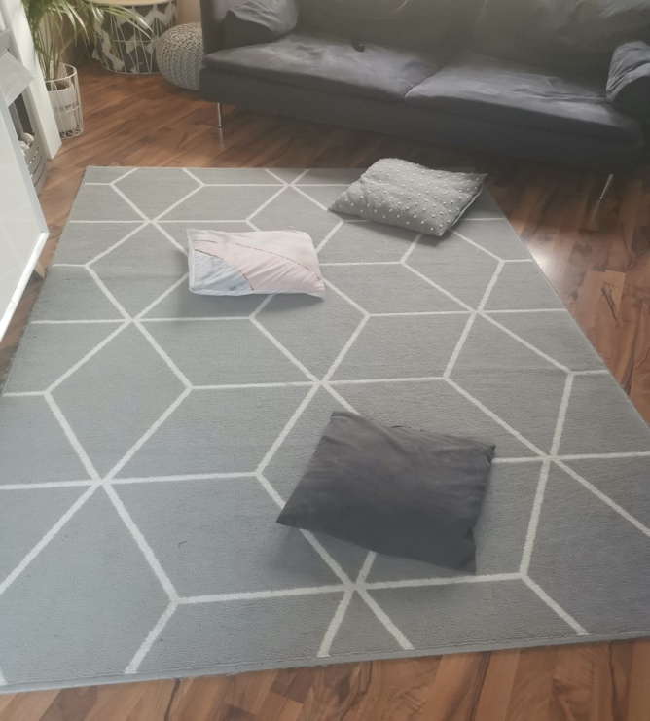

3
2

1

Skill Tip: Focus your eyes on the pillow for improved accuracy. Try different types of throw and see which one works best.
Challenges:
- Can you ask someone at home to set up the pillows in a secret formation? Now try to hit them.
STEP principle of coaching/teaching- helps to engage, challenge and motivate everyone by altering one or more of the principles
Space - Space the pillow closer together (easier) or further apart/away (harder)
Task – Try to score in order – 1 point, then 2, now 3… This is a hattrick!
Equipment – Add bowls and baskets. Can you land the socks in the target this time?
People – Play against a partner. Who can score the highest?

Under the Sea Coordination
Equipment: 3-5 Cushions, 3 pairs or balled socks
How to play:
- Set out an obstacle course of cushions.
- At one end of the course place your balled socks.
- In a crab shape, have hands and feet on the floor with tummy to the ceiling, walk in your shape around the cushions and collect one pair of socks.
- Put the balled socks on your tummy and balance them there as you move back to the start position.
- Repeat until you have collected all three pairs of balled socks.

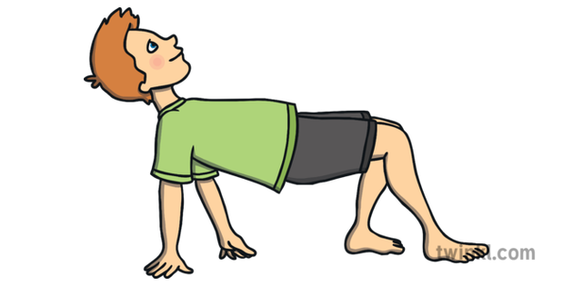

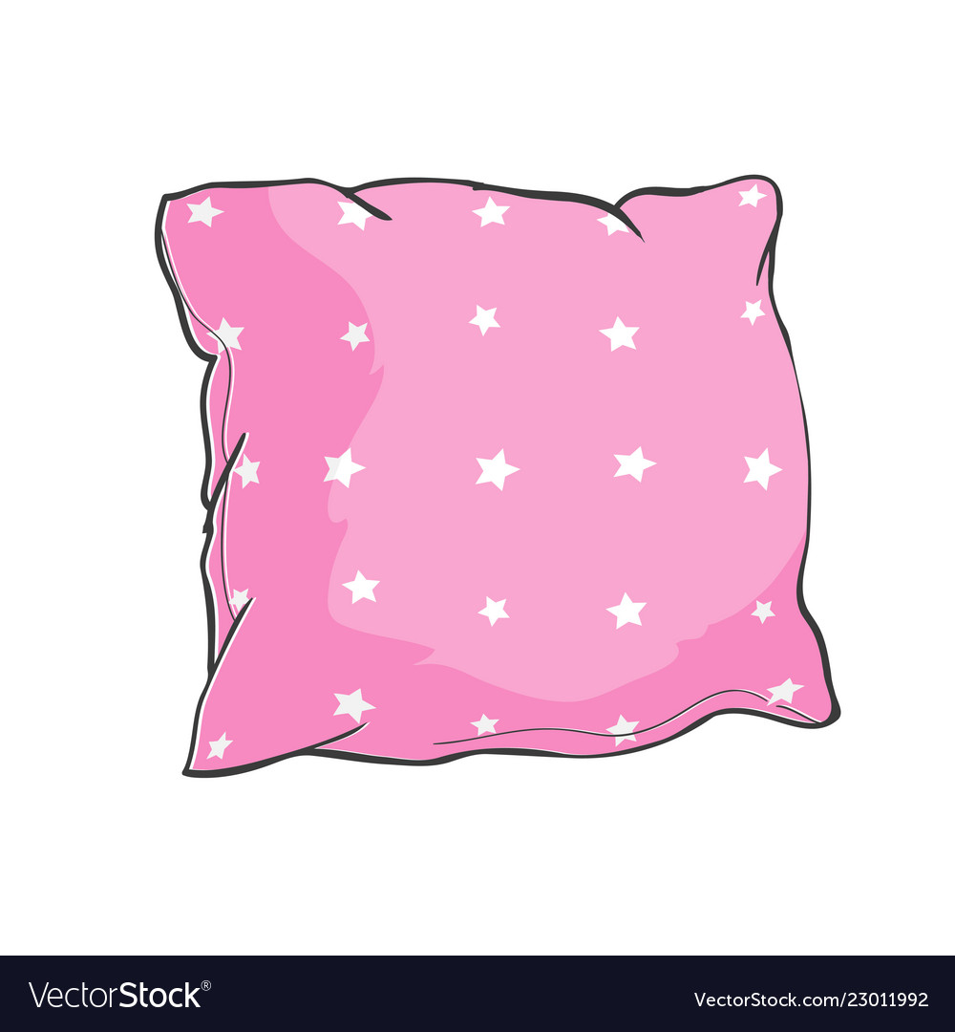

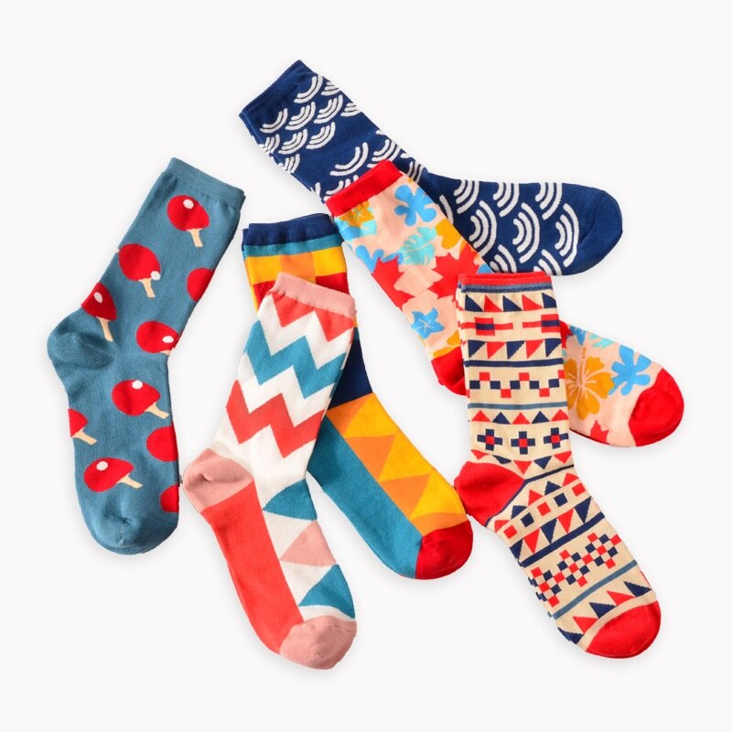

Skill Tip: Remember to keep your bottom lifted from the floor the whole time. Hands must be flat on the floor.
Challenges:
- Time yourself! Can you beat your time on the next go?

STEP principle of coaching/teaching- helps to engage, challenge and motivate everyone by altering one or more of the principles
Space - Make your cushions closer together to make it trickier to move around.
Task – Can you add in other obstacles to go under and over, as well as around?
Equipment – Can you use a ball to balance on your tummy?
People – Can you challenge a family member to race you?

