Ways to keep active
Mencap knows it is hard to get out to your usual activities in the community, including continuing on your Round the World Challenge journey.
The Government are still encouraging, where possible people to keep being active. Keeping active is good for your physical and mental health.
The Government’s advice and information around the Corona Virus does continue to change, this was written on 09/04/20 and can change. Please keep up to date with government guidelines.
To reduce the spread of Corona Virus the Government are limiting exercise outside of your home to once a day. If you exercise outside of your home you must stay 2 metres apart from other people.
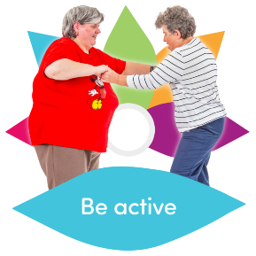
Here are a few free suggestions for you to keep active, as long as you are feeling well.

Outdoor activities
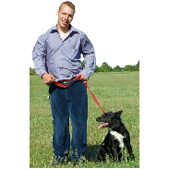
Most parks are remaining open as usual. You can continue to walk, cycle or run in them but only once a day.
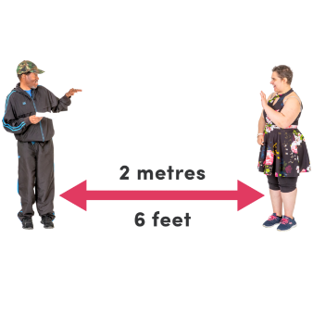
Remember to stay 2 metres apart from other people.

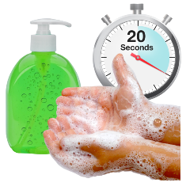
Remember to wash your hands for 20 seconds when you get home again.

Ways to be active at home
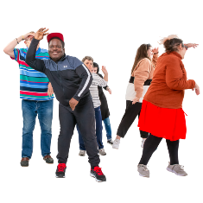
You can try moving around your home, for example walking up and down the stairs, yoga or having a dance.
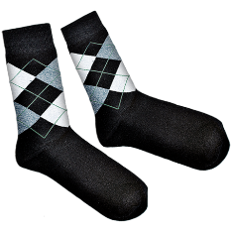
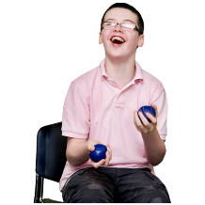
Use soft objects like socks to throw or bowl at targets on the floor. If you want to play boccia check out the rules.

World Health Organisation – The World Health Organisation has created activity cards to help you stay active

Website: http://www.euro.who.int/en/health-topics/health-emergencies/coronavirus-covid-19/novel-coronavirus-2019-ncov-technical-guidance/stay-physically-active-during-self-quarantine
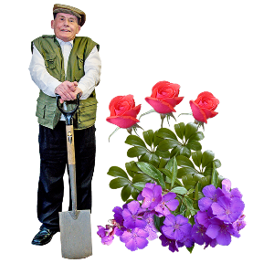

If you have a garden and the weather is nice, you can do some gardening or walking in it. You can do a treasure hunt in your home or garden.

Good House Keeping – Good House keeping have put together 12 expert tips to stay active while in isolation
Website: www.goodhousekeeping.com/uk/health

Following exercise videos online from your computer or TV.

YouTube has lots of videos. You can type in ‘exercise’ or ‘workout’ and choose one.

Website: https://www.youtube.com/

Shapemaster has exercise videos on YouTube that you can do at home

Website: https://www.youtube.com/user/ShapemasterUK

The LTA have created videos for tennis activities that you can do at home.

Website: https://www.lta.org.uk/tennis-at-home

*Remember you can keep doing the same video, if you find one you like.

Wider information on how to keep active
Description: Tips, advice and guidance on how to be active in and around your home. #StayInWorkOut
Website: https://www.sportengland.org/stayinworkout/

For more ideas on staying active you can search #activeathome, #Healthyathome or #stayinworkout on Twitter.

Keep track
Do not forget to keep counting how long you are active for, your journey can continue!
If you can try to record what you did and how long for you. You can do this in a notebook, in your Round the World Challenge passport or on the Round the World website.
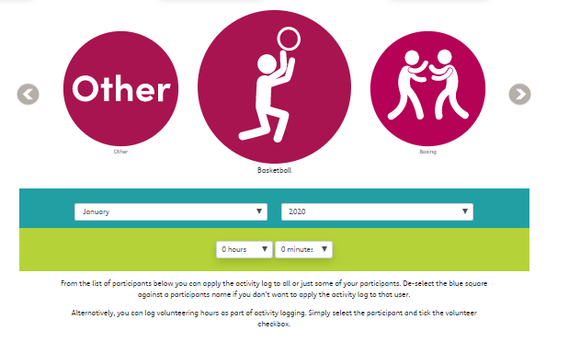

Any questions?

You can email Mencap Sport on: sport@mencap.org.uk

