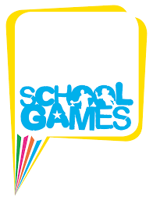

SPRING TERM HOME PE
Year 1
GO GO DISC THROW Throwing skills
Equipment: 3 old Tee Shirts and a bin or target to throw into.
How to play:

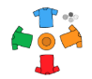
Mark out a circular course with old t-shirts as launch pads, and place a basket in the middle. Crumple up pieces of newspaper as “missiles”.

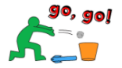
Shout "Go, Go!" and set off around the course as fast as you can, throwing the “missile” into the basket as you reach each launch pad.

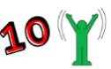
If you miss a target, stop and flap your arms 10 times.

Time how quickly you launch all your “missiles” into the target. Add 5 seconds for every “missile” that misses the target.

Skill Tip: When throwing, if you use your right hand, step forwards onto your left foot. If you use your left hand, step forwards on your right foot. It helps you to balance and become more accurate.

What is your best score today? Try again another day and see if you can get better over the week.

Challenges:
- Play the game again, but this time can you throw the missile by starting with your arm above your head and throwing it downwards towards the bin. Be careful to send it gently so that the missiles do not bounce out.
- Turn around and find a way of throwing the missiles backwards, to land in the bin.
- Make up your own way of sending the missiles and teach someone else your game.

STEP
Space - make the launch pad areas bigger or smaller. Change the level of the target, have it on a table or a chair.
Task – stand on one leg or sit and role the “missiles” into the target. Use your feet to drop kick (volley) the missile
Equipment – use a book as a racket and try and bat the “missiles” into the target.
People – Time yourself against a friend. Have a goal keeper trying to stop the “missiles” going into the bin

Video No Video for this game

SPRING TERM HOME PE
Year 1
SNAKE RACE movement skills
Equipment: A few old Tee Shirts
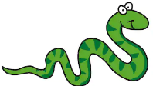
How to play:

Are you as fasssst as a ssssssnake? Lie down on your tummy and sssslither around the coursssssssse!

Mark out a short circular course outside with old t-shirts and lie down on your tummy at the start line.

On the word "Sssss-tart", begin slithering around the course.

Stay in contact with the ground – just like a real snake. Remember to hisssss loudly as you go.

How many times can you slither around the course in 10 minutes?

Time how quickly you launch all your “missiles” into the target. Add 5 seconds for every Tee shirt you make contact with.

Skill Tip: Keep low to the ground, make sure your legs and arms work together to pull you forward. Try to keep your stomach flat and level to support your lower back.

What is your best time today? Try again another day and see if you beat it.

Challenges:
- Play the game again, spread the Tee shirts out further with more acute angles to make turning more challenging.
- Use your hands and feet only to make contact with the floor (Crab crawl).
- Reverse the crab craw and face the ceiling while your hands and feet are on the floor.

STEP
Space - make the crawl course bigger or smaller.
Task – with no other obstacles on the floor, shut your eyes for 5 seconds and try and complete a small section of the course
Equipment – A number of old Tee shirts.
People – Time yourself against a friend.

Video No Video for this game

SPRING TERM HOME PE
Year 1
SPEEDWAY CHALLENGE movement skills
Equipment: Toys for markers and start/finish line
How to play:

Use toys to mark out a start and finish line. Then place 2 markers at equal points along the course.

On the count of 3 you must start to race, but for the first section you can only race on your hands and knees.

Once you reach the first marker, start hopping.

From the second marker, you must then run to the finish.

Time how quickly you move from the start line to the finish line.

Skill Tips: Support leg bends on landing, then straighten to push off. Land and push off on the ball of your foot. Bend non-support leg and swing in rhythm with the support leg. Keep head and trunk stable, eyes focused forward. Bend arms and swing forward as support leg pushes off.

What is your best time today? Try again another day and see if you can get better over the week.

Challenges:
- Play the game again, but hop on your least favoured foot.
- At the start, face way from the course and turn to start.
- Change the direction between start/markers/finish

STEP
Space - make the distances bigger or smaller.
Task – Alternate feet when hopping
Equipment – use toys for markers
People – Race against a friend.

Video No Video for this game

SPRING TERM HOME PE
Year 1
BALL SKILLS bouncing, balance skills
Equipment: Inflated Balloon
How to play:
Grab a balloon. Count how many keepy-uppies you can do with your feet, hands
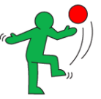
and head.

Now try with just your head and feet.

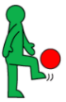
Now with just your feet. as you reach each launch pad.

How many keepy-uppies can you count in 60 seconds?

Skill Tip: When using your feet, keep a straight foot. Use centre of foot. Use less favoured foot too.

What is your best score today? Try again another day and see if you can get better over the week.

Challenges:
- Play the game again, count using your least favoured foot only.
- Clap your hands in between keepy-uppie.
- Try with a ball.

STEP
Space - make sure there is enough area to play in.
Task – Drop the balloon from your hands kick it up and catch it.
Equipment – Use a balloon.
People – Count yourself against a friend. Who can record the most keepy-uppies?

SPRING TERM HOME PE
Year 1
JUKEBOX JIG balance, flexibility skills
Equipment: Music player/Radio.
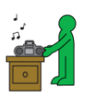
How to play:

Start playing some music or put the radio on.

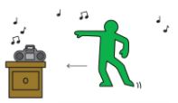
Take 2 sideways steps right and tap the toes of your left foot on the ground in time with the music. Then do the same to the left.

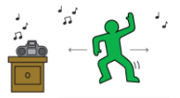
Now add some arm moves! As you step each way, wave your arms
side to side above your head!

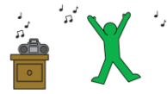
Finally, after your 2 steps in each direction, do a special dance move -
try a star jump, dabbing, flossing or swivelling your hips like you have
a hula hoop. It can be anything – make the most of your agility!

Skill Tip:

Can you keep dancing till the end of the song? Try again another day and see if you can add more special moves.

Challenges:
- Play another song, this time moving quicker to the music.
- Make sure you really get your arms moving too.
- Can you dance for two songs in succession?

STEP
Space - make the dance area is clear of all obstacles.
Task – Keep your energy levels high and concentrate on controlling your movements
Equipment – Music player / Radio.
People – Dance with a friend. Can you add even more moves to your dancing?

SPRING TERM HOME PE
Year 1
TRAINING TEST Hopping, Bouncing, coordination skills
Equipment: None
How to play:

Have you got the skills to pass this training test?
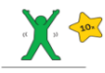
Stand to attention! …and start by doing 10 star jumps.

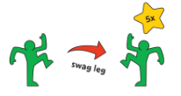
Now do 5 hops on your right leg, then 5 on your left.

Finish by running on the spot for 10 seconds and then salute.

Time how quickly you complete all the movement skills.

Skill Tip: When doing a star jump, keep your head up and your back straight. When hopping, tray and land softly, with your knee aligned over your toe (of same leg).

What is your quickest time today? Try again another day and see if you can get better over the week.

Challenges:
- Take the training test again, but this time can you do 3 push ups after running on the spot?
- Use your arms for balance when you hop?
- Can you add a side to side or forward/back movement to you hopping?

STEP
Space - make the area is clear of all objects and obstacles.
Task – Clap your hands above your head when doing star jumps
Equipment – None.
People – Time yourself against a friend. Who can do the end salute the quickest?

Video No Video for this game

SPRING TERM HOME PE
Year 1
TOW TRUCK TRIAL balance, agility skills
Equipment: A soft toy and other toys for markers
How to play:

Your favourite soft toy has been very busy and needs a bit of rest, can you give it a tow home?
Use some toys to mark out a start and finish line.
Get on to your hands and knees and place a ball or soft toy on your lower back

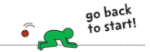
You've got to get to the finish line without dropping the ball, but take it slowly – if it falls, you need to start again!

Time how quickly you take to get to the finish line without dropping the object?

Skill Tip: Keep your balance, with your knees and hands working together and keep your back nice and flat.

What is your best time today? Try again another day and see if you can get better over the week.

Challenges:
- Play the game again, can you crawl sideways?
- Can you add a second object to carry?
- Try without your knees touching the ground (Bear crawl). This one is difficult!

STEP
Space - make the area is clear of objects
Task – extend the length of the course. Add changes of direction to the course.
Equipment – A soft toy and toys to make start/finish lines with.
People – Time yourself against a friend.

SPRING TERM HOME PE
Year 1
BOOK BUNDLE CHALLENGE balance, agility skills
Equipment: 10 old books, toys to mark finish line
How to play:

Collect a pile of 10 books and mark a start and finish line.
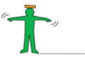
Now balancing them on your head one at a time, carefully walk the books to the finish line.
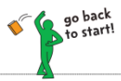
Be careful – if you drop it, you must go back to the start.

Time yourself and see if you can beat your time as you get better at it.

Skill Tip: Use the book you’re carrying to find the balancing point on your head (could be different for each book) and keep your chin lifted (parallel to floor). Use arms for balance. If a book is difficult, use a cushion to start with.

What is your best time today? Try again another day and see if you can get better over the week.

Challenges:
- Play the game again, but this time can you walk straight down a length of string?
- Can you add a one footed balance for 5 seconds half way down the course?
- Add some side hip moves like a belly dancer!

STEP
Space - make sure the area is clear of objects and obstacles.
Task – Stand, Sit, Stand with a book on your head
Equipment – use lightweight books
People – Time yourself against a friend.

SPRING TERM HOME PE
Year 1
HOPSCOTCH hopping, leaping, landing skills
Equipment: coin or bean bag, tape measure
How to play:

Mark out a start line and stand along it.

Throw a coin or beanbag as far as you think you can hop two footed.

Measure how far you hopped – can you do it again, but with a bigger hops?

Then hop on one foot, with as big a hops as you can manage. Try with your other foot. Measure how far you hop. Start again if you lose balance and touch the floor with you hand.

Skill Tip: Bend your leg. Push off from toes in take-off. Look ahead with head and eyes level. Use your arms for power and balance. Find your rhythm – don’t force it.

What is your best score today? Try again another day and see if you can get fewer hops over the week.

Challenges:
- Play the game again, but this time hop sideways or (being very careful) backwards.
- Throw yourself a catch with a ball as you hop.
- Think of some other types of moves you can make between the start and finish.

STEP
Space - make sue the area is clear of objects.
Task – complete a course on one leg while throwing and catching a ball
Equipment – toys to mark out start/finish
People – Time yourself against a friend.

SPRING TERM HOME PE
Year 1
SLALOM DASH running, changing direction skills
Equipment: Empty plastic bottle or similar for obstacles
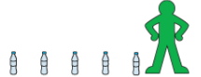
How to play:

Set up a course using any objects you can find (like shoes or cuddly toys)
with gaps in between.
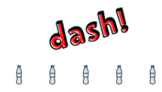
Dash from start to finish as fast as you can, weaving in and out of the objects.

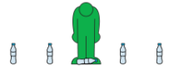
If you touch or knock over any of the objects, go back and set them back up.

See how many laps you can do in 2 minutes.

Skill Tip: Have “soft” knees when going through the slalom. Keep eyes up and concentrate

What is your best score today? Try again another day and see if you can get better over the week.

Challenges:
- Play the game again, this time tie how fast you run the course there and back in full.
- Add 2 two footed speed bounces over each obstacle.
- Add 2 one footed speed bounces over each obstacle (changing landing foot in needed)

STEP
Space - make sure the area is clear of objects and flat.
Task – Perform a figure of 8 at the first and last obstacle
Equipment – empty plastic bottle or similar for obstacles
People – Time yourself against a friend.

