SPRING TERM HOME PE
YR 2
Blast the Bag Sending and aiming skills
Equipment: Target = plastic bag filled with air and tied, rolled up socks to throw

How to play:
A sending, aiming game. You need a plastic bag filled with air and tied loosely at the top, 4 or 5 pairs of rolled up socks per team member.
Individual skills: Start with the bag beside you and throw the socks at it to move it to the end of the room. How many throws did it take you? See if you can take less throws to get it to move to the end of the room. Try using your other hand to throw and see if you can still hit the bag.
Blast the bag Game: Start with two players standing either side of the plastic bag. The players take three or four steps backwards, so the bag remains in the middle of the area and players are both equidistant from the bag.
Player A X X Player B
Plastic Bag
On the command “go” each player tries to blast the bag towards their opponent using their socks. The winner is the player who has the ball nearest to their opponent after all the socks have been thrown.
Tactical questions: Do you throw fast or slow? Do you throw lightly or strongly? Do you use all your socks in one go or wait to see what your opponent is doing? Do you throw overarm or underarm?

Challenges:
- Play the game again, but this time can you stand further away from the bag.
- Turn around and find a way of throwing the socks backwards.
- Can you add in more bags, so you have more targets to hit?
Space - Move closer or further away from the bag.
Task – Can you play sitting down or standing on one leg? Throw with your non-dominant hand. Play it football style by kicking the socks towards the bag.
Equipment – use a beach ball or balloon as the target, use tennis balls to throw.
People – play in pairs or with all the family in teams.

Video : Go to the website or click on here to see the game : https://youtu.be/o79gBiPNkQc

SPRING TERM HOME PE
YR 2
Treasure Hunt Walk Stamina and problem solving
Equipment: Paper and pen / a list on phone
How to play: Going outside for a daily walk, scooting, cycling ,or running is a really good form of exercise.
Why not make your own Treasure Hunt list for your family for when you go to the park, on a walk.
Here’s an example to start you off , but deisgn your own one too. You could take a photo of this list on on a phone or take some paper with you.

TREAURE HUNT WALK
White bird  This Photo by Unknown Author is licensed under CC BY | Post box
Green door  This Photo by Unknown Author is licensed under CC BY-NC-ND | Yellow car
The number 12 | 1yellow, 1red , 1green, 1orange & 1brown leaf .
1 white dog, 1 black dog , 1 brown dog | Litter bin
Goal posts | Ball
Door Knocker | White fence
Window Shutters | Bicyle helmet

Challenge: Change the way you travel next time, so if you walked last time, can you scoot, skip, or run next time. Make up another treasure hunt for all your family to do.
STEP
Space – Change the length of walk, if you turned right out of the house, turn left this time.
Task – Change the rules of the game. Perhaps take turns to find something on the list. Go on a letter treasure hunt, so everyone must find as many things beginning with the letter T.
Equipment –Take a ball with you and dribble it along – maybe use skipping rope or a scooter.
People – Have people help you or play against a family member to see who can get the most items on the list.

SPRING TERM HOME PE
YR 2
Agility Star Agility, stamina, Coordination
Equipment: 8 toys, stopwatch, basket/ bucket.
How to play:
Game 1: AGILITY STAR. This activity is all about ‘Agility’ and changing direction at speed. Look at the diagram below to set up the challenge. Use whatever space you have and use toys as your markers. Starting in the middle you need to run as fast as you can around the first toys at (A) and back to the middle. You need to run round every marker and back to the middle. Now time yourself and see how many seconds its takes and then try and beat your time.
2 toys B
A

2 toys A
A

You start in the middle

2 toys D
A

2 toys C
A

Game 2 AGILITY STAR PICK UP In this game, instead of running around the toys, you must run and collect just one toy from each station and bring it back to the middle. Start at A, then visit B, C and D and repeat until you have all 8 toys in the middle. What was your time? Try and beat it.
Skill tip : Be light on your toes and as you get to a toy, take a big lunge step and then push off to turn back to the middle.
Challenge: Can you change the shape of your agility course?
Space – make the space bigger, if you can go outside. Change the shape of your pathway.
Task – change the rules of the game. Can you do it with different moves, side stepping, skipping, jumping?
Equipment – collect more toys, put in an obstacle to jump over, or a ladder of tea towels to improve your footwork.
People –play by yourself. How quickly can you complete all the tasks? Play against an opponent to see who is the quickest.
Video: Click here to see the game https://youtu.be/i2shoC8_Aks

SPRING TERM HOME PE
YR 2
TOILET ROLL CHALLENGES Aiming, sending, stamina & coordination skills
Equipment: Toilet roll inner tubes, small ball or rolled up piece of foil and a timer.
How to play:
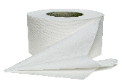
Here are five fun Physical activities you can do with a toilet roll. Click on the link below to see the challenges or follow the instructions below.
This Photo by Unknown Author is licensed under CC BY-NC
https://youtu.be/seUWi1HBLuw

Toilet roll bounce: Take a toilet roll and place on the ground. Stand sideways and see how many two footed speed bounce jumps you can do in 20 seconds.

Tower: Using just one hand see how tall you can make your tower of toilet rolls.

Tunnel: Lay down 4 toilet roll tubes against a wall and using a golf ball, small
ball or rolled up foil ball, see if you can roll your ball into the tunnels.

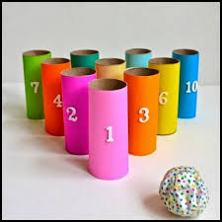
Ten Pin: Stand 10 toilet rolls upright in a pyramid shape. How many rolls does it take you to knock them all down with the ball?

Toilet Roll Flip: Take one toilet roll and lay it on a table so that half of it is hanging over the edge of the table. With the back of your hand flip it in the air and try and catch it before it lands.

Catcher: Place some tape over the bottom of your toilet roll, to make your catcher. Using a rolled up piece of foil or a small light ball, see if you can throw the ball in the air and catch it in your toilet roll.

Challenge: Use your non-dominant hand for all your challenges. Play against someone else and keep score. Create your own toilet roll challenges.
Space – move closer or further away from the toilet rolls in aiming games.
Task –add numbers to ten pin toilet rolls and add up your scores. Change the actions or rules.
Equipment – Use more toilet rolls in the speed bounce to make it higher.
People – Play by yourself to beat your best time or play as a family in a competition. Teach someone else the activities.

SPRING TERM HOME PE
YR 2
Tennis Taps hand eye coordination
Equipment: Book or racket, rolled up socks or tennis ball
How to Play:
This is a challenging skill and will take a lot of determination to get right, but if you practise, you will see improvements. Start by seeing if you can do just one tap and see if you can challenge yourself to complete more.
Skills drills:
- Take a pair of rolled up socks and see if you can keep throw them up and catch them in two hands
- Now try keeping the socks in the air by tapping them, using your hand like a racket. To make it harder , try the same activity using a small ball.
- Do tennis taps again, but this time with your non-dominant hand.
- Can you use the back of your hand sometimes, to keep the ball in the air?
- How many taps can you do without the ball landing on the floor? Try and beat your score.
Skills drill with a racket or book:
- Keep the ball in the air using a book as a racket.
- Can you alternate from backhand to forehand , by turning the book over?
- If you have a racket , see how many tennis taps you can do.
Tennis Tap Game
Stand opposite a partner and tap the ball or socks backwards and forwards to each other. Play to see how many taps you can make without the ball landing on the floor.

Skill Tip: Do small actions with your hands, so that the ball doesn’t travle too high. Make sure you move your feet to follow the flight of the socks or ball.
Challenge: If you have a wall in the house that you can use, send the socks towards the wall, so that they rebound back to you. How many taps can you do against the wall? Try and beat your score. Use a ball to make it very challenging.

Space – Make sure you are in a safe space. If you can go outside in a bigger space that will make it easier. Put tape or makers down to mark a court area.
Task – Change which hand you use to hit the ball. Use two hands to make it easier. Change the rules to catch and throw tennis to make it easier. Keep inside the court area with the ball.
Equipment – use bigger, lighter books to have greater success. Use bigger balls or socks to make it easier for tapping.
People – Play on your own to beat your score or play tennis taps against someone else.

Video clip: To see the games click on the link: https://youtu.be/bOoIdhRCrk8

SPRING TERM HOME PE
YR 2
TRAFFIC LIGHTS Instruction & Movement skills
Equipment: a little bit of floor space
How to play:
- The aim of the game is to listen to the instructions and complete the movements.
- Each round lasts for 30-60 seconds with someone calling out the instructions.
- Keep doing the same movement until the next instruction is called out!
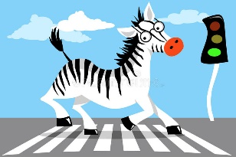
- Round One will start with the three basic instructions;

- Red – Stand still
- Amber – Jog on the spot
- Green – Walk/Jog (depending on floor space)

After each complete round, add two instructions at a time from the following list;
- Roundabout – Spin on the spot once
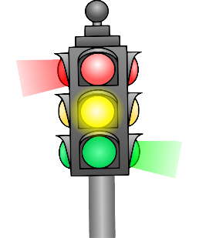
- Speed Bumps – Jump up and down on the spot
- Reverse – Walk backwards
- Petrol Station – Squat down then jump to the sky continuously
- Low Bridge – get into a press up position with arms straight and hold the position
- High Bridge – Reach up as high as you can and hold the position
- Speed Camera – Move in slow motion
- Motorway – Speed up and move around quicker (depending on floor space)
- Flat Tire – hop around/on the spot (depending on floor space)
- Zebra Crossing – skip around (depending on floor space)

- The round starts when the ‘caller’ shouts ‘Start your engines’ followed by the first instruction.
- See how many rounds you can complete whilst remembering all the correct actions.
- What is your best score today? Try again another day and see if you can get better across the week.
Challenges:
- Play the game again, but this time can you add more of your own instructions. Bear in mind the space you have to play the game.
- Lengthen each round and add more instructions in.
- Can you change the actions for the instructions to challenge yourself further?
STEP
Space – make the playing area bigger or smaller to restrict certain movements. Maybe try it outside.
Task – change the actions of the instructions or make your own up.
Equipment – add an object to act like a steering wheel. Hold a ball whilst completing the actions or add some new instructions to incorporate the equipment added.
People – Test your family members to see how well they can do.
Video - https://www.youtube.com/watch?v=1ICyEjc16Ss

SPRING TERM HOME PE
YR 2
AGILITY CHALLENGE Movement skills
Equipment: Toys for markers
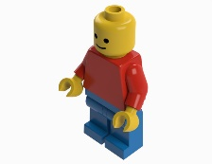
How to play:

Place one toy/object in the middle of the room, this will be your ‘base’.

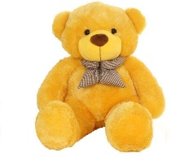
Than using the other Toys/objects place them in different places, all within view. (Start with easy locations, but no closer than 2 metres from the ‘base’ toy/object).

Make sure to name or number each toy/object. (This is to increase difficulty later on).

Begin by standing next to the ‘base’.

You then have to run to each toy/object, make contact and then return to the ‘base’, continue to do this until you touched every object once.

Finish by returning to the ‘base’.

You may wish to time yourself and aim to beat it.

What is your best time today? Try again another day and see if you can get better over the week.

Skill Tips: Stay in a strong low body position when moving to each toy/object. This will maintain your balance and allow you to push off through your legs to the next toy/object.
Challenges:
- Play the game again, but move/add toys/objects to different locations.
- Add obstacles if you have the space.
- At the start, close your eyes and get someone to move the objects.
- Change the way your allowed to move (hop, skip, bear crawl, jump etc).
- Get someone to call out an object to touch or a sequence you have to complete the touching of each toy in.

STEP
Space - make the distances bigger or smaller.
Task – Alternate hands when contacting each toy/object.
Equipment – try different objects or carry something with you.
People – Race against a friend.

SPRING TERM HOME PE
YR 2
BALANCE TIME fitness, stamina, and agility skills
Equipment: A large and suitably safe space to balance.

How to play:
- How many different body parts can you balance on?
- Can you balance on your back and tummy? What can you do with your arms and legs to stop you wobbling?
- Can you balance on your hands and feet? Can you lift one hand or leg off the floor?
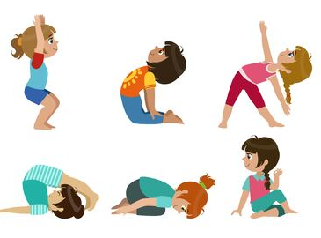
- Choose your favourite 3 balances. Can you add them together to make a sequence? Perform your sequence to someone else. What do they think?
Challenges:
- Can you hold your balances still?
- Have you tried using music?
- Can you add a jump and/or a turn to your sequence?

STEP
Space – Make the space that you are using to balance on smaller to make it harder.
Task – Can you make a symmetrical balance? Can you balance at high, medium and low levels?
Equipment – Make a balance keeping a pair of socks on your head, foot, or different body part.
People – Balance with a partner; try and make symmetrical shapes and balances.

SPRING TERM HOME PE
YR 2
GOLF ROLLING target and precision skills
Equipment: 5 targets (soft toys, plastic cups, mixing bowls, plastic bottles etc…), a small ball or rolled up tinfoil.

How to play:
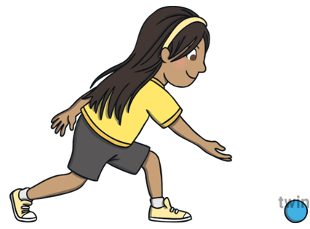
Place the 5 targets on the floor in different locations around the room. The aim of the game is to roll the ball (object) close to the target, trying to get it to touch the object in the least number of rolls possible.
The winner is the player who rests the ball (object) against the target with the fewest rolls.
Now move onto target 2 and try to get the object ball to touch the target in the fewest number of rolls possible.
Challenges:
- Can you use an umbrella or broom to softly ‘putt’ the balls towards the object?
- Place obstacles in front of the targets that the player may need to avoid.

STEP
Space – Make target bigger and smaller by using different size objects. Maybe place one target at the bottom of the stairs and see if you can ‘putt’ the ball down the stairs?
Task – Have a time limit. If the task too easy, use your non-dominant hand to roll the ball.
Equipment – Vary the size of the rolling ball. Use large obstacles to increase the difficulty.
People – Play in a pair and take turns when using only ball between you. Can you beat your score?

SPRING TERM HOME PE
YR 2

JIG-SAW PUZZLE HUNT movement & problem solving skills
Equipment: a picture (a Christmas card or something similar)

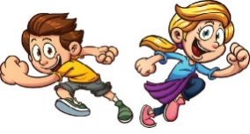
How to play:

Cut a picture up into a number of pieces, of equal size, creating a jig-saw puzzle.

Place one piece of the puzzle in a different room of the house (or spread them out in one room)

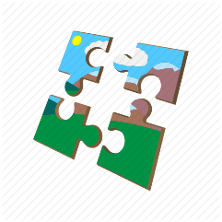
On ‘Go’ you must locate one piece of the puzzle at a time and bring back to a centre point to put back together the jig-saw.

The game finishes once the jig-saw puzzle is completed.

How quickly can you put the puzzle back together

What is your best score today? Try again another day and see if you can complete the puzzle in a quicker time.

Challenges:
- Cut the picture up into different shapes and sizes.
- Use more than one picture at a time.
- Hide the pieces to increase the difficulty

STEP
Space – play over less or more rooms in your home.
Task – different pictures/puzzles/problems to solve. Change the rules: find different objects of certain colours, or things made of wood.
Equipment – add equipment to carry as you to travel, to increase difficulty (egg & spoon for example) (boiled egg!!!)
People – Time yourself against a friend.

