SPRING TERM HOME PE
YR 3
Cones and Domes fitness, stamina, and flexibility skills
Equipment: 10 domes or cones (alternative equivalents could be table mats/coasters; paper with two coloured spots (one on either side); or plastic cups.
How to play:

You can play against a partner (or by yourself against the clock)

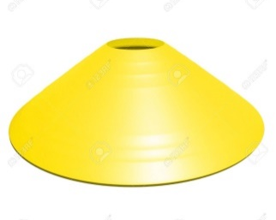
Place the 10 objects in a space on the floor. Make sure half of them (an equal amount to begin with) are the opposite way. For example if using plastic cups – half one way and the half upside down.

On the start command, players race against each other to turn all of the objects the same way – either into a dome or a cone. The aim is to be the first player to have all the objects the same way or have the most objects the same way in the time set.

No guarding or shielding of any object (to prevent partner from turning it) is allowed.

Who is the quickest? Does it make a difference if you are placing the domes or the cones? Try again another day and see if you can get better over the week.

Skill Tip: Spread your legs to create a wide base when bending to turn/place the dome or cone object. They help you to balance and become more accurate. Make sure that you stretch (by standing up tall and straight) in between each game to prevent back ache.
Challenges:
- Where can you position the socks and the bowl (target) so that you are lifting your legs across your body?
- Can you move the target area further away from your head, so that you will need to aim and throw the socks into the target?

STEP
Space – Make the playing target area bigger or smaller. Change the levels of the domes/cones, have some on a table or a chair. Move the domes or cones further away from the winning player to make the game more even.
Task – Use different hands (or parts) to place and turn the objects (For example: use only your non-dominate hand or just your thumbs).
Equipment – Change the domes/cones for different sized objects – are perfectly flat objects (like paper/card) harder to turn? Increase the number of objects for the faster player to turn (e.g. the quicker player starts with more objects turned against them)
People – Play against a friend or family member.

Video www.youtube.com/watch?v=E2VVsNXg-4E

SPRING TERM HOME PE
YR 3
Toilet Roll Alley throwing and aiming skills
Equipment: 6 or more toilet rolls (or soft equivalents such as plastic cups, soft toys etc…) and some throwing objects similar to bean bags (sponges, rolled up pairs of socks, soft toys etc…)
How to play:
You could place a soft object on top of the pyramid stack to aim for.
DO NOT USE anything hard or living – such as a family pet or sibling! add
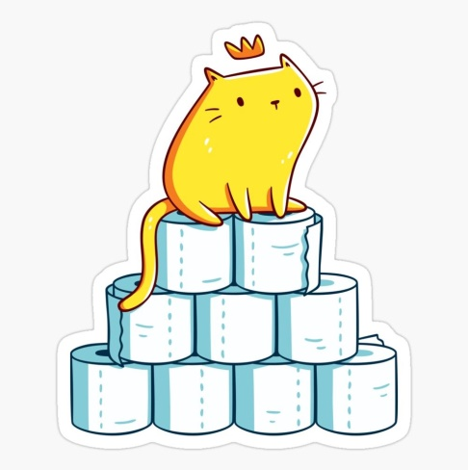
Ask an adult to help you find a safe place to play and set up your targets (toilet rolls) into a pyramid stack on a sturdy base (such as a table, a chair, the stairs etc…)

Standing a short distance away, the aim of the game is to knock the targets (toilet rolls) over before knocking them completely off of the base/stand in as fewer shots as possible.

If you are playing against a friend/family member, see who can knock the objects over and off the stand in the fewest numbers of throws. Repeat the game but the winner needs to stand further away this time.

Skill Tip: Use your outstretched non-throwing arm to improve your aim and balance. Stand with your feet slightly apart to create a wide and stable base. Don’t try to throw too hard and keep your head still when throwing.
Challenges:
- Play the game again, but this time create a different shape with the toilet rolls – maybe try some columns or have larger gaps between them.
- Before each throw, introduce a small exercise (like 5 star jumps or 3 sit ups or finding a particular word in the dictionary (You could write words on a series of cards for players to select in advance).

STEP
Space – Make the starting position closer or further away from the pyramid.
Task – Increase/reduce the number of objects to throw at or the number of objects you are throwing.
Equipment – Vary the size of the objects you are throwing – use smaller objects when you are having success to add challenge.
People – Play against family members and friends. Create a mini league of scores.

Video www.youtube.com/watch?v=0S0z8gFp1Y0

SPRING TERM HOME PE
YR 3
Funny Feet Racer agility, fitness, and stamina skills
Equipment: sets of markers with feet shapes (these can be printed off or alternatives such as inner soles from trainers used or drawn round on recycled card).
How to play:

Make several sets of feet.

Place these in a straight line, slightly apart so that the player needs to complete a small jump to reach the next set.

Vary the direction that the feet point, requiring the player to think about the landing position of the feet before they jump.

If you have several sets, race against another player to be the first to reach the end – making sure you land on the feet in the correct position and direction. If you are playing by yourself, then time yourself and see if you can improve your time.
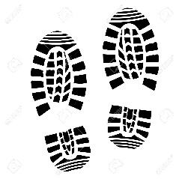

Now play again with the winner starting further back or increase the number of sets they need to complete. Who is the fastest funny feet racer?

Skill Tip: Keeping the spaces between the sets of feet small to begin with. When jumping, keep low to the ground as this will help you balance and decrease the risk of falling over. Co-ordinate the jump with a twist of the hips to match the direction of the feet.
Challenges:
- Play the game again but change the pattern of the pathway – does it have to be a straight line?
- Add in an object which needs to be delivered or thrown into a target midway through the course; the object/s can be carried in the bag.

STEP
Space – Make the gaps between the sets of bigger or smaller. Change the total distance and pathway of the course.
Task – Add in some items to be delivered throughout the course for additional points.
Equipment – Use markers with only one foot showing so that the player needs to jump and land on one foot only.
People – Play against family members; time yourselves over the same course and create a league of results – add in time penalties.

Video www.youtube.com/watch?v=SDzLFHXA6VU (from 49 seconds)

SPRING TERM HOME PE
YR 3
Temple Run Adventure speed, co-ordination, agility, and timing skills
Equipment: String (or equivalent) and soft objects to swing like part-filled water balloons, soft cuddly toys, toilet rolls, balls of rolled socks or cloths/t-shirts stuffed into tights. Objects to rescue (such as cuddly toy, bottle of juice, plastic cups etc…).
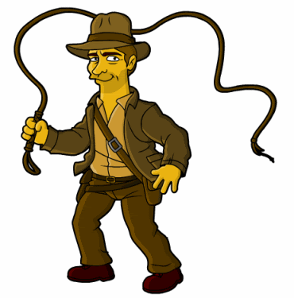
How to play:

Secure a length of string at one end of the room (tie it to a door handle, the handle of a window, a chair – ideally something that is over 1m from the ground. At equally spaced points along the string, tie further lengths of string with a soft object attached to the bottom (cuddly toy, toilet rolls, tights stuffed with t-shirts/socks etc…) These objects shouldn’t touch the floor; they need to swing freely from side to side without hitting any furniture.

At the opposite end to your tied starting point, place the item that needs to be rescued (bottle of juice, larger cuddly toy etc…).

With an adult holding the string taut, gently begin to swing the weighted (soft) objects on string to create a temple run style trap. The player is trying to rescue the object by manoeuvring between the swinging objects, avoiding being touched.

Skill Tip: Watch and time your movements to avoid the objects touching you. Try dodging the object by swaying out of the way and/or ducking and bending your knees.
Challenges:
- Play the game again, but this time can you try to keep your knees off of the floor?
- Try balancing an extra pair of socks on the back of your neck and then dropping them in the bowl (target) without using your hands.
- Make up your own penalty exercises for every time you miss dropping the socks (objects) into the bowl. For example: if you miss, do 5 star jumps or 5 sit ups etc…
STEP
Space – Make the course longer or shorter. Change the course pattern – maybe add in objects at different heights.
Task – Avoid using your hands to stop the swinging objects touching you – if they do, go back to the start (maybe have 3 lives to start with).
Equipment – Use larger and smaller objects on the swinging string.
People – Play against family members; time yourselves over the same course and create a league of results – add in time penalties.

Video www.youtube.com/watch?v=SDzLFHXA6VU (from 1.03)

SPRING TERM HOME PE
YR 3
Un-screw-bottle scramble speed, co-ordination, agility, and timing skills
Equipment: String (or equivalent such as ribbon or washing line) and empty plastic bottles.
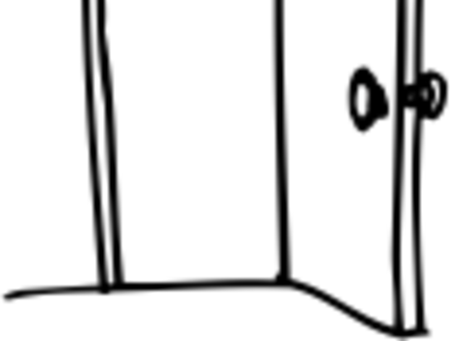
How to play:

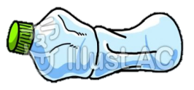

Secure a length of string at one end of the room (tie it to a door handle, the handle of a window, a chair – ideally something that is over 1m from the ground. At equally spaced points along the string, tie on plastic bottles by wrapping the string around the neck of the plastic bottles. The bottles should remain about 1m from the floor, making sure they don’t touch any furniture.

Start at the opposite end to your tied starting point. Race against time to unscrew the bottle caps (you could deposit the bottle lids into a bowl before moving onto the next one). Once you have done one, before you move to the next, duck under the string without touching it. Repeat until all caps are removed and deposited.

With an adult holding the string taut, gently begin to swing the bottles to create a temple run style activity.

Skill Tip: Try keeping your feet wide apart and bend your knees when ducking under the string.
Challenges:
- Try using only one hand or two fingers to make the game more difficult.
- Make up your own course with obstacles along the way (think about going over, under, through and around different obstacles (a chair, a vacuum cleaner or duvet covers)
STEP
Space – Make the course longer or shorter. Change the level of the course or finishing point, move up or down stairs.
Task – Try using only one hand when ‘unscrewing the bottle caps’.
Equipment – Try and carry objects (soft toys) and deposit them into targets (bowls) along the course.
People – Play against or with a friend.

Video www.youtube.com/watch?v=SDzLFHXA6VU (from 2.04)

SPRING TERM HOME PE
YR 3
PLANK CHALLENGES movement skills
Equipment: none
How to play:

- We are going test your planking skills which will help develop your core stability and tummy muscles.

- Try and give all the plank variations a go - some are harder than others.

- Make sure you keep your back as straight as possible and maintain good breathing throughout.

- Plank Variations

- Standard Plank – elbows and forearms on the floor along with feet.

- High Plank – like a press-up position, but maintain straight arms at all times.

- High Plank with hand movement – create a line in between your hands whilst in the press-up position, keeping your arms straight, move both hands to one side of the line and then back across to the other side.

- High Plank with foot movement – staying in the press up position, keeping your arms straight, move one leg outwards at a time. The further you move the harder it becomes.
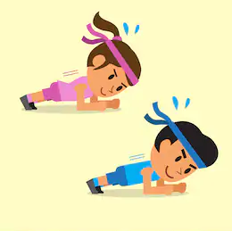
Now the challenges;
Can you hold each plank variation for the following amounts of time?
- 10 seconds
- 20 seconds
- 30 seconds

- Make sure you rest between efforts to get your energy back.

Challenges:
- Try the challenges each day and see how good you can plank.
- Keep your hands/feet close to your body to make it harder to balance
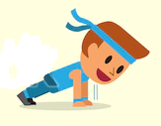
STEP
Space - Make sure you have a safe area to work in
Task – Add different movements into the plank variations (see video for ideas)
Equipment – A towel or mat for support.
People – Time yourself against a friend.

Video - https://www.youtube.com/watch?v=3nLkz_2S3Fc&t=89s

SPRING TERM HOME PE
YR 3
Colour Combination problem solving and stamina
Equipment: Objects, books, and toys of different colours.

How to play:
- Layout several different coloured objects on the floor.
- Partner one calls out three colours, and partner two to runs out and touches the object in the correct order and back to the start.
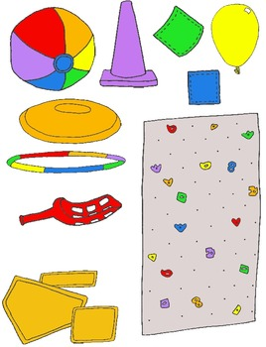
- Swap over roles.
- Add one more colour each time and see which player remembers the most colours in the correct order.
- How quickly can you react?
- Can you start to look and plan before the instructions?

Skill Tip: Be ready, listen carefully and stay alert!
Challenges:
- How many objects can you touch in 60 seconds?
- Can you beat your score?

STEP principle of coaching/teaching- helps to engage, challenge and motivate everyone by altering one or more of the principles.

Space: Make the space bigger or place the objects further away.
Task: Move in different ways to challenge yourself (e.g., hopping, crawling) . Change the rules from calling out 3 colours, to calling out objects beginning with different letters of the alphabet.
Equipment: Dribble a ball as you travel to touch the objects.
People: Challenge someone different from your household.

SPRING TERM HOME PE
YR 3
BLINDFOLD ADVENTURE Communication & Movement skills
Equipment: something to make a blindfold with and some toys/objects.
How to play:

- Create an obstacle course in a room at home by placing several objects on the floor.

- A family member must guide you using verbal instructions across the course.
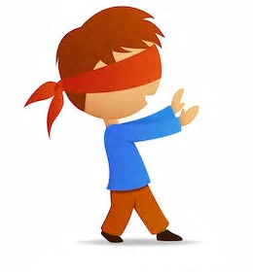

- The aim of the game is to make it across the course blindfolded and without touching any of the toys/objects in the way

- Each time you make it across the course, add some new obstacles to increase difficulty.

Challenges:
- Play the game again, but this time change the locations of the objects.
- You can only use the words RIGHT, LEFT, FORWARD & BACKWARDS to instruct the player across the course.
- Add some areas in which you have to complete an action (360 degree spin for example)

STEP
Space – make the playing area bigger or smaller to restrict certain movements. Maybe try it outside.
Task – change the actions of the instructions or make your own up.
Equipment – add more equipment/objects to increase the difficulty.
People – Test your family members to see how well they can do.

SPRING TERM HOME PE
YR 3
Healthy Hearts Stamina and strength
Equipment: Something to hold whilst doing squats, ball, toy, or book.

How to play:

Warm up by gently circling your shoulders, arms, wrists, hips and ankles .

Circle each one 10 times to get ready for exercise.
Now get your heart working with these cardio exercises:
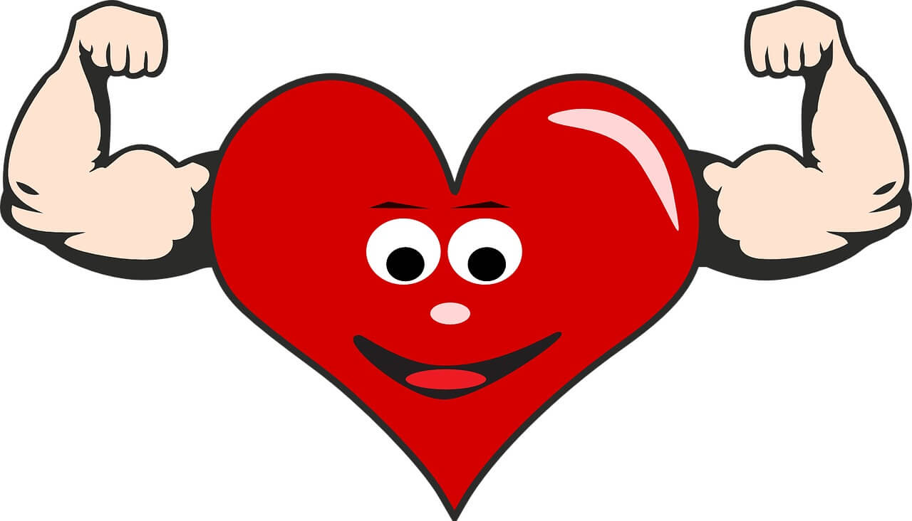
Station 1: Perform ten start jumps.
Station 2: Perform ten high knees.
Station 3: 10 heel kicks (kicking your heels behind you)
Station 4: Holding a toy in both hands, legs apart, squat,
and swing the toy between your legs ten times.
Station 5 Perform ten burpees (onto hands and lie down and then jump up)
Station 5 : Holding your toy, complete ten squats.
Skill tip: Keep your back straight as you do your squats and get your bottom low, so that you are using your leg muscles to bend and stand up.
Challenge: Add your own stretches after each exercise. Make sure you include stretching your legs and arms.
STEP principle of coaching/teaching- helps to engage, challenge and motivate everyone by altering one or more of the principles
Space – After each station move to another part of the room.
Task- Make up your own exercises to get your heart pumping. Be creative!
Equipment- Hold heavier or lighter objects when performing squats and arm exercises.
People- Work opposite a partner and teach them your exercises.
Video Link : Click here to see the activities. https://www.youtube.com/watch?v=5vqMSyTAny8&ab_channel=AuraLeisureIreland

SPRING TERM HOME PE
YR 3
Wacky Races stamina and agility
Equipment: Any kind of objects to mark the track. A ball .

How to play:
- Mark out a start and finish line using an object to mark out these points.
- Think of different ways you could move from the start to finish.
- Can you move on your hands and feet? Can you move backwards?
- What was the quickest way of moving and what was the slowest way of moving?
- Can you race against a partner using the different ways of moving?
Challenge:
- Create your own wacky races, with obstacles and different routes.

STEP principle of coaching/teaching- helps to engage, challenge, and motivate everyone by altering one or more of the principles.
Space: Use bigger and smaller areas. Travel forwards or backwards or sideways.
Task: Change the rules of the race, to number of circuits, or how many laps can you do in a minute. Travel by hopping, skipping, on hands and feet. Build in action stations to perform at different points on the route.
Equipment: Travel with a ball, carrying it, dribbling it, bouncing it, throwing, and catching it.
People: Challenge someone different from your household.

