BATTLESHIPS target and precision skills
Equipment: 6 Targets (Plastic Cups), rolled up socks or balls
How to play:
- With a partner, stand 5 metres apart and have 3 targets (cups) each and place them somewhere in front of you.
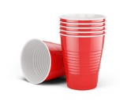
- Take it in turns to throw your socks/balls to try and hit each other’s battleship.
- Once a battleship is hit it is removed.
- Players cannot stop their battleship from being hit.
- The winner is the first person to hit all their partners’ battleships.

Challenges:
- Can you throw the ball a different way? If so did it make you more or less successful?

STEP
Space – Move the Battleships either closer together or further apart to make it easier or harder.
Task – throw using your non dominant hand
Equipment – Change the targets so they are smaller to make it harder to hit
People – Play in pairs against another pair . Take it in turns to throw.

AVOID THE DEFENDERS Ball Control skills
Equipment: 1 Ball, Cones, Socks (anything to make defenders)

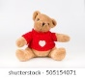
How to play:

Choose a start point and place another marker at the opposite end of the space.

Layout the objects, teddy bears, cones across the playing area. These are known as the defenders.
- Can you dribble using your feet, from the starting point, around the marker and back avoiding the defenders?

- If you dribble around the markers and back you score 1 point. If you hit a defender they score 1 point. The first to score 5 points are the winners.
Challenges:
- Use both feet and different parts on the foot
- Keep your head level (not looking at the cones). Partner to hold up colored cones to see.

STEP
Space – Place defenders around different areas.
Task – Only use your left foot, use the outside of your foot only. Loose or gain points if you hit a defender
Equipment – Equipment use rolled up socks, or a bigger ball.
People – Play against other members of your family.

BALANCE TIME fitness, stamina and agility skills
Equipment: A large and suitably safe space to balance.

How to play:
- How many different body parts can you balance on?
- Can you balance on your back and tummy? What can you do with your arms and legs to stop you wobbling?
- Can you balance on your hands and feet? Can you lift one hand or leg off the floor?
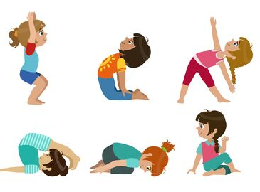
- Choose your favourite 3 balances. Can you add them together to make a sequence? Perform your sequence to someone else. What do they think?

Challenges:
- Can you hold your balances still?
- Have you tried using music?
- Can you add a jump and/or a turn to your sequence?

STEP
Space – Make the space that you are using to balance on smaller to make it harder.
Task – Can you make a symmetrical balance? Can you balance at high, medium and low levels?
Equipment – Make a balance keeping a pair of socks on your head, foot or different body part.
People – Balance with a partner; try and make symmetrical shapes and balances.

BOOTCAMP fitness, stamina and agility skills
Equipment: A safe space to exercise and a ball (or small soft object like a cuddly toy)

How to play:
- Spend 30 seconds on each exercise.
- Rest for 30 seconds (or longer if you need to).
- Try and keep a record of your score for each activity.
Try these exercises:
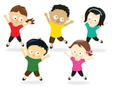
- High Knee’s – lift one knee towards the ceiling, keep your toes pointed down towards the floor.
- Squats – with your arms outstretched in front of you, bend both of your knees and go as low as you can. Make sure you keep your back nice and straight.
- Star Jump’s – Stand tall and straight to start; can you clap your hands above your head on each jump?
- Hopping - start on one foot and then keep changing to the other foot every 5 seconds.
- Jumping Squats - Squat down (like in exercise umber 2) and then jump as high as you can out of the squat. Repeat as many times as you can in the time.
Challenges:
- Use an object to hold to make it harder as you exercise.

STEP
Space – Travel to a different space in the room. Perform the exercises in different directions
Task – Perform to music. Make up your own exercises.
Equipment – Hold a ball (or small object like a cuddly toy) in your hands as you exercise.
People – Teach other people in your family your routine.
RIGHT WAY / WRONG WAY strength and endurance skills
Equipment: small (soft) toys or objects and a stopwatch/timer

How to play:
- Find a space to lay out a selection of objects and toys; make sure they are all facing the same way (for example, make them face the door or the sofa).
- You could play by yourself to see how long it takes to change the direction of all the objects (toys)time yourself to see how quickly you can turn all the toys over.
Game 2 – a game for two players
- Make sure half the toys are facing the one way (towards the door or the ceiling) and the other half are facing the opposite direction (the window or the floor).
- Player 1 is going to try and turn all the objects one way and player 2 is going to try and turn all the objects the opposite way.
- Play for 60 seconds. At the end of the game the player who has the most objects facing ‘their 'way is the winner.
Challenges:
- Can you try and turn the objects over/around using different body parts?
- What about only using one hand or hopping between objects?

STEP
Space – Use bigger and smaller areas.
Task – Lay out more toys/objects. Travel in different ways between objects.
Equipment – add more toys; vary the size of the objects; place some objects at different levels.
People – challenge other members of your household.

KITCHEN CURLING co-ordination and aiming skills
Equipment: Anything that slides - lids, bottle tops, rolled up socks, pieces of paper and two towels.

How to play:
- Clear a space on a smooth surface (i.e. a table or hallway floor) and place a target (this could be drawn onto a piece of paper) at one end.
- Roll up the two towels to act as bumpers for the lane.
- Using the objects that slide (bottle tops, lids from jars, rolled up socks etc…) try to slide them across the surface to stop as close to the centre of the target as possible.
- You could play against an opponent. Each player has 3 objects to slide (pairs of socks etc…). The object closest to the centre of the target scores a point. The player with the most points after 3 rounds is the winner.

Challenges:
- What did you find easy or hard about the game?
- Could you try with your eyes closed?

STEP
Space – Make the towels wider apart so the lane space is bigger.
Task – To try and outscore your partner. Can you send the socks by pushing using a book as a brush (shover) like in the real game of Curling?
Equipment – Use different objects (smaller or bigger) to make it harder or easier to push.
People – Challenge different people and keep a results table to see who is the overall winner.

MOVE TO THE BEAT fitness, stamina and body control
Equipment: A safe space (larger enough to dance in) and some music

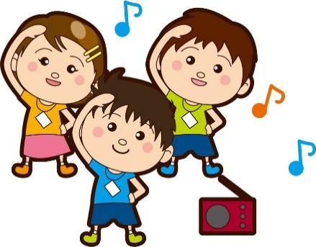
How to play:
- Find a space where you are free to move around and put on some ‘lively’ music (Pharrell Williams – Happy etc…).
- Start by clapping in time to the music. Keep clapping and move your feet in time to the music by marching on the spot. Once you are really ‘feeling’ the beat, move around the room and add in some of your own moves.
- Challenge yourself to add new movements like heel flicks, side steps, knees up, spins, turns. Can you do these in time to the music?
- Watch some dance/music videos to give you some new ideas (Using ‘Just Dance’ is really good for new moves).
Challenges:
- What different movement ideas did you come up with? Can you teach these to someone else?
- What about changing the style of the music – maybe something slower?

STEP
Space – Only use certain rooms or certain spaces within a room.
Task – Limit parts of your dance to arms only or legs only.
Equipment – Add in a lightweight scarf/cloth to throw up and catch as part of the dance.
People – Can you teach the dance to someone else?
Video - https://www.youtube.com/watch?v=CyfM2o0d0IE (from 43 secs)

CATCH ME OUT sending and receiving skills
Equipment: Ball (or equivalent such as a soft cuddly toy, balled socks or cushion.)

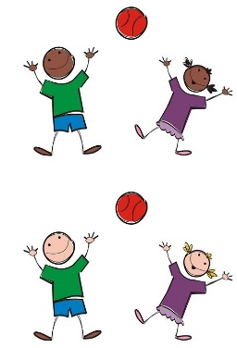
How to play:
- You can play by yourself, though these games can be played with a partner, sibling or parent.
- Start by standing 3 – 5 steps apart.
- Players work as a team and throw the ball to each other; try to make 10 catches without dropping the ball.
- Now swap positions (sides). Players now try to make 9 successful catches in their new positions. If successful repeat the swapping and throwing, decreasing the number of throws by 1 (e.g. 8 catches, swap, 7 catches, swap….) continuing this process until they reach 0.

Can each pair reach 0 without dropping the ball?
If competing against another pair the first pair to reach 0 will be the winners.
Challenges:
- Can you catch using one just hand? What about using your non-dominant hand?
- Can you throw the ball (object) a different way (like under one leg)?
- What about placing a barrier or obstacle between you and your partner (like a chair or some cushions) to make it more difficult?

STEP
Space – Vary the distance between you and your partner; stand closer or further away.
Task – Set yourself a time limit. Use different passes, underarm, rolling and/or chest pass.
Equipment – Vary the object being thrown. Use a smaller or larger ball or a light cushion.
People – Play on your own throwing against a wall and/or play as a three.

GOLF ROLLING target and precision skills
Equipment: 5 targets (soft toys, plastic cups, mixing bowls, plastic bottles etc…), a small ball or rolled up tinfoil.

How to play:
- Place the 5 targets on the floor in different locations around the room.
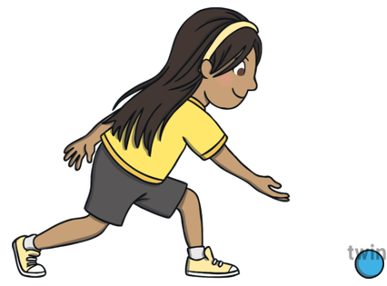
- The aim of the game is to roll the ball (object) close to the target, trying to get it to touch the object in the least number of rolls possible.
- The winner is the player who rests the ball (object) against the target with the fewest rolls.
- Now move onto target 2 and try to get the object ball to touch the target in the fewest number of rolls possible.
Challenges:
- Can you use an umbrella or broom to softly ‘putt’ the balls towards the object?
- Place obstacles in front of the targets that the player may need to avoid.

STEP
Space – Make target bigger and smaller by using different size objects. Maybe place one target at the bottom of the stairs and see if you can ‘putt’ the ball down the stairs?
Task – Have a time limit. If the task too easy, use your non-dominant hand to roll the ball.
Equipment – Vary the size of the rolling ball. Use large obstacles to increase the difficulty.
People – Play in a pair and take turns when using only ball between you. Can you beat your score?

CRAWLING MONSTERS balance, stamina and strength skills
Equipment: a small ball (pair of rolled socks) and various objects (soft toys, plastic cups, shoes and trainers etc…)
How to play:
- Choose a start point in the room and finish marker (a random object) at the opposite end of the space.
- Layout the various objects (soft toys, plastic cups, shoes and trainers etc…) within the area as obstacles to block the route - these are known as the space monsters (defenders).
- You can only move on your hands and feet.
- Can you dribble the ball from the starting point, using only your hands, to the finishing marker avoiding the space monsters and staying on your hands and feet?
- If you dribble around the marker and back, you score 1 point. If you hit a space monster they score 1 point. The first to score 5 points is the winner.
- Skill tip: Keep your hands flat when travelling on the floor.
Challenges:
- Can you use alternative hands when dribbling?
- Set a time limit and see how many times you can make it to the finish marker and back before the buzzer sounds (time limit is over).
STEP
Space – Make the area bigger or smaller. Make sure that the obstacles are placed so that your will need to change direction.
Task – Change to a ‘crab’ position with your tummy facing up and dribble with your feet.
Equipment – Vary the size of the ball you dribble with. Use more targets to dribble round.
People – Challenge someone else to see who can score the most points.

