SPRING TERM HOME PE
YR 4
Just Dance Challenge Dancing skills
Equipment: a laptop / computer with access to Youtube
How to play:
Follow along with this Just Dance video on Youtube and copy the actions to the song ‘Baby’ by Justin Bieber.

Follow along to the actions, pause rewind and fast forward if you need to.
JUST DANCE 2020: Baby by Justin Bieber - YouTube

Skill Tip:
Watch the video clip then repeat it attempting to copy the actions. Learn a bit then pause, repeat and then try and add in some more actions.
Challenge:
Learn the routine off by heart and perform in front of your family or in front of your class on a Zoom/Teams call if you are feeling brave.

STEP
Space - Make sure you have enough space to perform the dance actions without knocking into anything or knocking anything over when moving your arms or legs during the dance routine.
Task – Learn the routine and then play it with just listening to the music and not following the actions.
Equipment – Can you incorporate a prop to use within your dance?
People – Can you encourage a member of your family to learn the actions from you?

Video JUST DANCE 2020: Baby by Justin Bieber - YouTube

SPRING TERM HOME PE
YR 4
Avoid the defenders coordination/dribbling skills
Equipment: a ball, cones or teddy bears
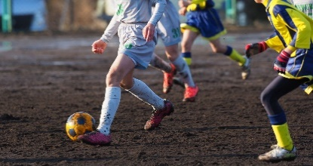
How to play:
- Choose a start point and place a cone/teddy down and at the opposite end of the space do the same.

- Layout objects across the playing area- these are known as the defenders.

- Can you dribble using your feet, from the starting point around the marker and back avoiding the defenders?

- If you dribble around the markers and back, you score 1 point. If you hit a defender, they score 1 point, the first to score 10 points are the winners.

Skill Tip: Keep the ball close to you, use small touches.
Use the inside and outside of your foot to control the ball around the objects.
Challenge:
Can you change the pattern that you are dribbling around?
Can you make the defenders closer together?
Give yourself a time limit to dribbling around the defenders and back again.
STEP
Space - adapt the space to make it easier, have less defenders to make it harder can you add in more defenders?
Task – adapt the task so you are not dribbling in a straight line.
Equipment – increase the number of defenders to dribble around.
People – can you encourage a member of your family to play as an active defender, can you dribble around them?

SPRING TERM HOME PE
YR 4
Ultimate Frisbee Sending skills
Equipment: Frisbee (disc) or an upside-down paper plate, or a circular container lid
How to play:
This game will need to be played outside.

Can you ask someone in your family to throw your disc to you so you can catch it?

Try catching it with two hands and then one hand. Which is easiest?

Practise catching the disc using pincer grips- with your thumbs on top of the disc for a low catch.

For a high catch thumbs go underneath the disc.
- This catching technique is for high and low catches.

Ask someone in your family to throw the disc to you at about head height or knee height and practise catching the disc using your fingers like the pincers on a crab!

Skill Tip:Move your feet to get into position to make the catch and have your hands and ‘pincer fingers’ ready! Make sure you get your thumbs in the correct position depending on the height of the disc. Keep your feet shoulder width apart and knees slightly flexed.
Challenge: Practise moving into a space to catch the disc. You can do this by asking whoever is helping you to throw the disc into a space either side of you so that you must move to catch it. Give yourself one point for each successful pincer grip catch.

STEP

Space - change the distance you are standing to the thrower, closer to make it easier or further away for more of a challenge,
Task – Devise a game to play with a family member where points are scored for accurate catches. Could you score more points for a pincer grip catch?
Equipment – Can you create your own disc with a design pattern using a paper plate?
People – Can you encourage more family members to play with you?

SPRING TERM HOME PE
YR 4
Sitting Volleyball Sending / reactions skills
Equipment: a ball or balloon or rolled up socks.
How to play:
Practise the two sitting volleyball ‘ready positions’ below. Can you try these movement and ball control activities sitting in these positions?

Practise moving forwards, backwards and sideways. - Pass the ball round your body one way and then the other. - Throw and catch the ball high in the air.
‘Crab Walk Ready Position’ used for defence, overhead passing and sideways movement. Sit with both legs out in front.

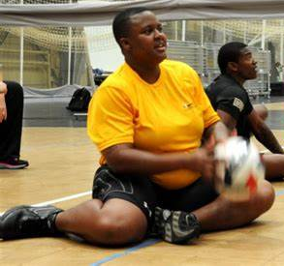
‘Hurdles Ready Position’ Used for attacking, serving and front and back movement. Sit with one leg bent in front and one leg bent behind.

Skill Tip:
Hands high and thumbs in above your forehead. Keep your bottom on the floor.
Challenge:
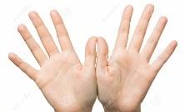
Try throwing the ball a little to the side or in front of you and try moving on your bottom to catch it. Now try throwing it high and catching it with your hands high just in front of your forehead- ‘thumbs in’.

STEP
Space - make the space you are working in larger to make it harder or smaller to make it easier.
Task – ask someone to help you by throwing the ball high to you and then push the ball up by straightening your arms and then push it back to them.
Equipment – Can you create a net using a towel or a bed sheet that is hanging?
People – play a rally with a family member passing the ball backwards and forwards over the net.

SPRING TERM HOME PE
YR 4
Wall ball - 60 second challenge Sending/reaction skills
Equipment: ball or pair of rolled up socks
How to play:
How many times can you throw a ball against a wall and catch it in 60 seconds?

You must stand 2 seps away from the wall.

If you drop the ball start again from zero

Points system:
Gold Award = 50 throws and catches
Silver Award = 40 throws and catches
Bronze Award = 30 throws and catches

Skill Tip: Keep your eyes on the ball stand with feet shoulder width apart, knees slightly bent.
Challenge:
Use a variation of throws- underarm or overarm.
Stand further away from the wall and run forwards to receive the catch then run back to throw from further away.

STEP
Space - make the space you are working in larger, stand more than 2 steps away from the wall or closer to make it easier.
Task – can you use a variety of sized balls to catch? Or use more pairs of rolled up socks to make the ball larger,
Equipment – Can you place pieces of paper up on the wall using bluetack/sellotape to act as targets you need to hit to get additional points?
People – can you play against a family member to try and beat their score.

SPRING TERM HOME PE
YR 4
Bop It Co-ordination
Equipment: Piece of paper, space
How to play:
- Get your piece of paper and scrunch it up into a ball.
- Throw the ball up and see how many times you can tap it in the air without the ball touching the ground. (No catching allowed)
- Do this three times and see what your best score is?

Skill Tip: Don’t throw the ball up too high, Always keep your eyes on the ball.
Challenges:

- Get some toys or something similar and create a circle. Stand in the circle and do the activity again but you cannot move out the circle.
- Use only one hand.

STEP
Space – Make the area that you are using bigger or smaller.
Task – Give yourself a time limit.
Equipment – If you are finding it too hard, make the ball bigger. Use a book as a racket.
People – If you have someone to play with see if you can hit the ball back and forth between
you.

Video https://www.youtube.com/watch?v=CIeiNqlb3MM

SPRING TERM HOME PE
YR 4
Ultimate Bottle Flip hand eye coordination and stamina
Equipment: 4 Pieces of Paper and a bottle that you are allowed to flip
How to play:

- Set out your 4 pieces of paper in row on the floor, with roughly 30cm gap between each.
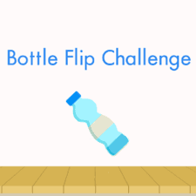
- Fill up your bottle with water halfway.
- Hold your Bottle and stand at one end of the row.
- Jump between the pieces of paper until you get to the other side.
- Turn and try and flip your bottle with it landing upright on the first piece of paper.
- You only get one go, if it lands collect that piece of paper and place it on top of the next one. If you do not land it, pick up the bottle and jump to the other side and repeat the whole action.
- Once all papers are in a pile to finish you must land the bottle on top, if you do not do it first try you must jump over the papers before trying again.

Skill Tip: When bottle flipping, take your time.
Do not throw the bottle too hard.
Challenges:

- Give yourself 60 seconds to try and complete the whole challenge.
- Once you have completed it with your strong hand now try and complete it with your weak hand.

STEP
Space – Make the gaps between the papers further away.
Task- Start a timer and see how long it takes you to complete the task.
Equipment – Use bigger or smaller pieces of paper to make it more challenging
People – See if you can beat someone else’s time.

Video https://www.youtube.com/watch?v=Ip-_n6pQqus

SPRING TERM HOME PE
YR 4
Clean up the washing Core strength/Target
Equipment: 5 items of clothing, box/ laundry basket
How to play:
- Lay on your back with the pile of clothes near your feet and the basket behind your head, on the floor.
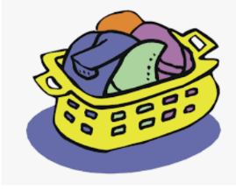
- Grab one item of clothing, no hands allowed, and lifting your legs put the item of clothing in the basket.
- Continue to do this until all items are in the basket.

Skill tip: Use your stomach muscles to lift your legs ups, hold onto the clothes with your feet tightly.
Challenges:

- Time yourself to see how long it takes you and challenge someone to beat your time.
- Have two boxes and put them either side of you, see if you can put the clothes in the boxes sideways.

STEP
Space – If you have good flexibility see if you can move the box further away from your head.
Task – See if you can do it only using your hands, your bottom must not come off the floor at any time.
Equipment – Use smaller bit of clothing or toys to make it harder to grab and control.
People – Race against someone else.

Video https://www.youtube.com/watch?v=eEa9QNwj80A from 52 seconds.

SPRING TERM HOME PE
YR 4
Fitness Towel fitness and stamina
Equipment: Space and towel
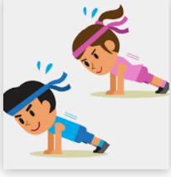
How to play:
Roll the towel up so it is in a sausage shape, length ways.

Perform the following skills:
- Jumping forwards beside the towel and then jump backwards.
- Scissors: Put one foot either side of the towel and jump, to cross your legs to land on the opposite side, continue jumping, changing legs to the end.
- Bunny Hops: Facing downwards, place hands either side of the towel have both feet one side and staying where you are jump your feet at the same time the other side. Keep going back and forwards until you have done 20.
- Stand and balance on the towel walking from start to finish.
- Squats: Place feet either side of the towel and squat down to touch the towel with your hands, remember to keep your back straight. Do this 20 times.
- Crab walking: Facing downwards, have hands one side of the towel and feet the other. Keeping in that position move to the end of the towel and back, travelling sideways.

Skill Tip: Make sure you take a break when needed. Always have hands flat on the floor when travelling.
Challenges:

- Complete each activity for 45 seconds and have a 15 second rest before doing the next activity.

STEP
Space – Use two towels to make the line longer.
Task – Have a longer or shorter break if required.
Equipment – Hold a Sock and see if you can do these activities whilst balancing the sock.
People – Play with a partner to make it more competitive.

SPRING TERM HOME PE
YR 4
Cup Challenge Coordination and aiming skills
Equipment: Paper rolled up, plastic cup
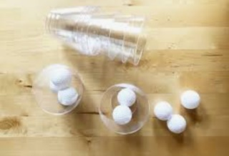
How to play:

- Roll up a piece of paper.
- Have the paper in one hand and the cup in the other.
- Toss the paper in the air and see if you can catch it in the cup.
- See how many times you can catch it without it dropping to the floor.

Skill Tip: Always keep your eyes on the ball, try not to throw the ball too high.
Challenges:

- Instead of throwing the ball from your hand see if you can throw it from the cup.
- Give yourself 60 seconds to see how many you can do.
- Throw the paper against a wall and see if you can catch it in the cup.

STEP
Space Make the space around you smaller to challenge yourself.
Task Have the cup in both hands to try and catch the paper.
Equipment If you are finding it hard to catch in the cup, see if you can catch with your hands first. Use a larger target to catch with - a bucket or box.
People Get a partner and throw the ball to each other whilst catching it in the cup. See how many you can do in a row.

Video
https://www.youtube.com/watch?v=dYEoZoj2rxU This video shows many different ways you can challenge yourself.

