SPRING TERM HOME PE
YR5
Vertical Jump strength and stamina
Equipment:
A safe space
Tape
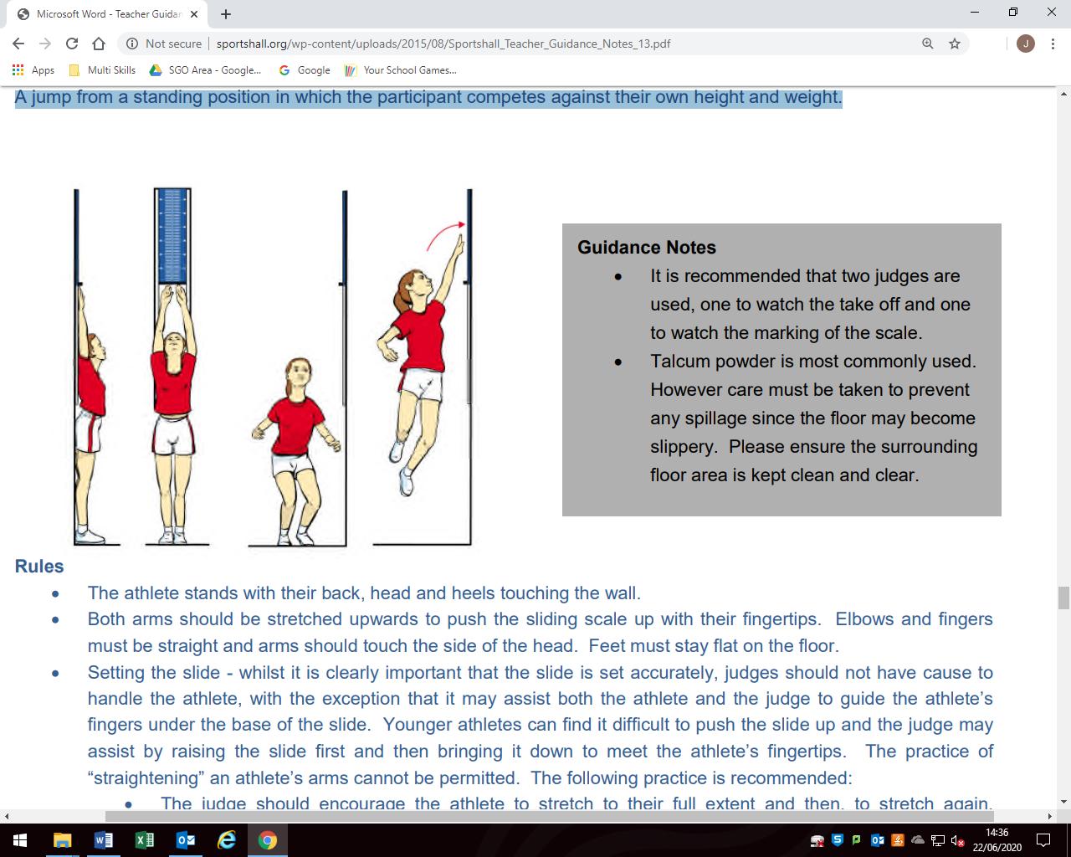
How to play:

Stand with back to the wall. Stretch arms up to reach as high as possible.

Mark the wall (with something removal like tape) where the tips of your fingers reach to, or ask a parent to judge the mark.

Stand sideways on with jumping arm closest to the wall. Take one big jump up as high as possible and tap the wall (if you can hold a piece of tape and stick this to the wall as you tap, even better!)

Measure the distance between the standing height and jumping height.

Skill Tip: Bend knees before your jump to generate power.
Challenge:
Have a competition with yourself to try and beat your highest score.

STEP principle of coaching/teaching- helps to engage, challenge, and motivate everyone by altering one or more of the principles

Space – change the level of the jump –jump for length across the floor, rather than for height.
Task – Make up a different jumping game that can be measured. Jump for distance, or a hop for distance game.
Equipment – markers of the floor to jump over.
People – Get more family members to join in – have a competition to see who can jump the highest.

Video –https://www.youtube.com/watch?v=pu5dYtr1gFE (SKIP TO 59 secs)

SPRING TERM HOME PE
YR5
Walk the Line
Equipment: balance and agility
Skipping rope / Dressing gown tie

How to play:

Try and walk along the rope without touching the floor?
Try walking backwards.
Try balancing some socks on your head as you walk.

If this is easy:
Try walking along the rope throwing and catch the socks without falling and touching the floor.

Include the following actions in a sequence, trying to stay on the rope:
walk balance tuck shape turn jump

Skill Tip: Keep you head up and try to find a point in your room to focus your eyes on.

Challenge: Once you have had some practise of the first exercise, find someone in your household to have a race with. How quickly can you walk along the rope and back without losing your balance?

STEP principle of coaching/teaching- helps to engage, challenge, and motivate everyone by altering one or more of the principles.
Space - Make sure the space is big enough and clear of hazards. Stay close together initially, if you want to make it harder make the space you play in bigger.
Task – Make it harder by balancing objects on your head as you walk on the rope or throwing and catching an object. Add more actions to the sequence.
Equipment – Introducing objects to balance on the head or throw and catch.
People – Keep challenging different players in your household, maybe you could create a competition.

SPRING TERM HOME PE
YR5
Skipping to Songs
Equipment: Skipping rope or dressing gown rope.
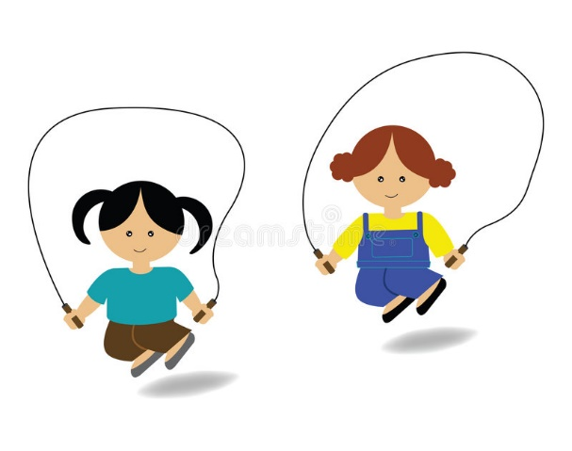
How to play:

Choose a motivational upbeat song of your choice.

See how many skips you can complete for the length of the song!

Can you keep going for the whole song length?

Maybe try rotating as you skip for an extra challenge!
Challenge: How many different types of skipping jumps can you master? Can you try two-footed jumps, running , hopping, jumping jacks (crossing your feet over - be creative! Can you keep going for the whole song?

STEP principle of coaching/teaching- helps to engage, challenge, and motivate everyone by altering one or more of the principles
Space - Plenty of space you are safe. Travel around the space or stay in one place. Can you skip backwards and forwards? Change your pathways.
Task – You can make this easier by single leg skips. Go slow or fast. Can you make up your own skipping rhyme as you skip?
Equipment – skip without a rope and use your arms as though you are skipping. Use a longer rope and get two people to turn it for you as you jump.
People – Do it with your family and see who can keep going for the longest!

Video: https://www.youtube.com/watch?v=2Oe9PTp39Qo

SPRING TERM HOME PE
YR5
Target Throw Teddies aiming and sending skills
Equipment:
Lots of different sized teddy bears/soft toys or socks
Basket


How to play:

Set the basket out 1 large step away from where you are standing.

Attempt to throw the socks/bear into the basket.

Each time you succeed, take a step back.
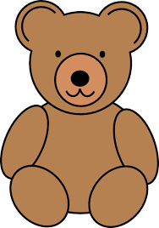
Try to hit the target as many times you can in 1 minute.

How many steps did you take back?

Have a few goes and see if you can beat your highest score.

Skill Tip: Face the palm of your hand towards the target.
Challenge:
- Throw using your non dominant hand.
- Can you do a cricket bowling action and bowl the balls into the basket?

STEP principle of coaching/teaching- helps to engage, challenge and motivate everyone by altering one or more of the principles

Space - Bring the basket closer if too difficult or move it further away to make it harder. Try playing it at different levels , so put the basket on a table or sit on the floor.
Task – Keep taking steps backwards each time you succeed to make it harder each time. Change the rules and send it in a different way, perhaps by throwing backwards. Make up your own scoring rules.
Equipment – Use smaller teddies to make it more challenging.
People – Get your family involved. See who can do the most. Race each other.

SPRING TERM HOME PE
YR5
Reaction Time Strength and agility
Equipment:
Pieces of paper
Something to stick paper to the wall (tape/blu tac)
How to play:
1
2
3
4
5
6
7
8

Write down numbers 1 to 8 on pieces of paper.

Stick them up on the wall- space the numbers out in a pattern.

Stand facing the wall.

Someone needs to shout out the number and you must then tap the number with your hand
as quickly as possible.

Time how many numbers you successfully hit in 1 minute.

Skill Tip: Bend you knees and be on your toes in a ‘ready position’.
Challenges:

Keep practising to try and beat your highest score.
Challenge someone else in your family.

STEP principle of coaching/teaching- helps to engage, challenge, and motivate everyone by altering one or more of the principles
Space – Ensure you have plenty of space to do the challenge. Put the numbers at different levels on the wall.
Task – Try introducing more numbers to make it more difficult. If the numbers are on the left side, try and touch them with your opposite hand , so your arms go across the body and you have to twist . Use alternate hands.
Equipment – paper, more numbers.
People - Have a competition against somebody else in your household.

Video - https://www.instagram.com/tv/CJ8YDWdAMkh/?igshid=1wbts21drnwob

SPRING TERM HOME PE
YR5
Dice game! Stamina and agility
Equipment: a dice or 6 pieces of paper written with a number 1-6 on. A piece of paper and a pencil drawn like below -
How to play:
Look at the 6 different exercises –
If you roll number that is the activity you will be doing –
1-lunges
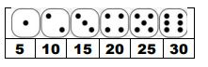
2-sit ups
3-tuck jump
4-burpees
5-high knees in front
6-jumping jacks
Now roll the dice 6 times and write
In the number in the 6 boxes below.
Dice Throw 1 | Dice Throw 2 | Dice Throw 3
Dice Throw 4 | Dice Throw 5 | Dice Throw 6

Challenges
1.Can you perform all 6 throws on the dice?
2.If you have done it once – throw 6 dice again and repeat it!
3. Make your own 6 activities up and challenge a family member.

STEP
Space Do the jumping activities on the spot or travel around as you do them.
Task – make up your own 6 activities.
Equipment –To make it harder hold a ball or soft object in your hands as you jump.
People – Play against a family member or a friend (e.g., on facetime). You throw the dice for your partner and they throw for you!

SPRING TERM HOME PE
Year 5
Character choice rhythm, stamina, agility
Equipment: YouTube
How to play:

Choose your favourite character from the options below. Copy the link into YouTube and complete the workout challenge.
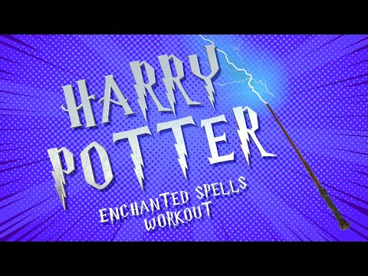
https://www.youtube.com/watch?app=desktop&v=fu-ZCwMrvKc

https://www.youtube.com/watch?app=desktop&v=enI5HT_4sbM
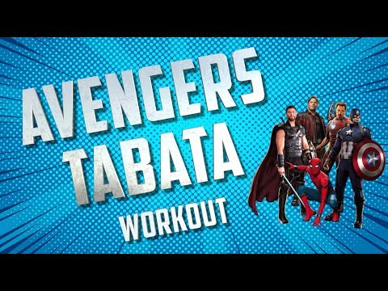
https://www.youtube.com/watch?app=desktop&v=jyWyBern6q4

Challenges
- Can you complete two workouts? Or all three?
- Make up your own workout routine with moves to suit your favourite character from a book or movie. Share this with a family member or a friend.
STEP
Space -Change the levels of your workout. Change the pathways of your travelling actions.
Task – change some of the activities to suit your favourite sport. Change the timings to make each exercise easier or harder.
Equipment – Try holding a ball or soft toy in your hands as you exercise.
People –Teach another person your routine.

SPRING TERM HOME PE
Year 5
Spell your name Agility and fitness
Equipment: Alphabet sheet and a ball (or a sock rolled up like a ball)
How to play:
Look at the different letters for your name below.
Do the exercises as you spell out your first name and surname.
When you have completed this can you do the next set of exercises for your surname.
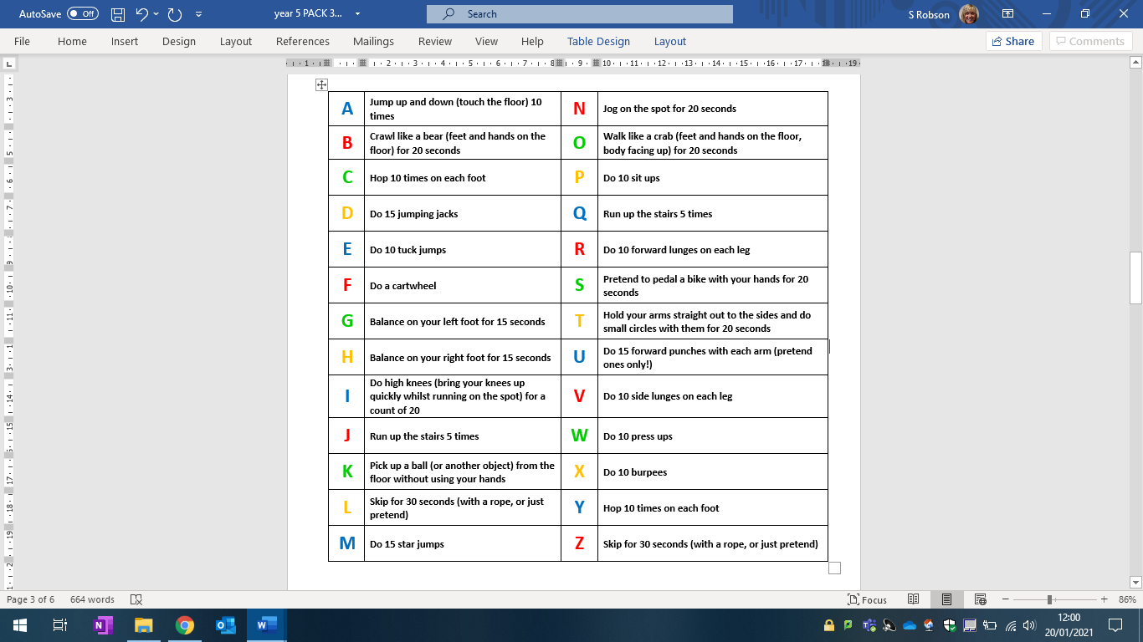
Challenges : Can you do all your name? Can you do your road name where you live? The
names of your family?
Space - Use different pathways whilst travelling : zig zag, straight or circular.
Task – change some of the activities to suit your favourite sport. Change the timings to make each exercise easier or harder.
Equipment – Try using a bigger or smaller ball. Hold a toy in your hands as you perform the actions.
People – play on your own or do the actions together with someone else.

SPRING TERM HOME PE
Year 5
60 second challenges Agility and fitness
Equipment: stopwatch, a ball (or socks rolled up like a ball), skipping rope, cones/ markers
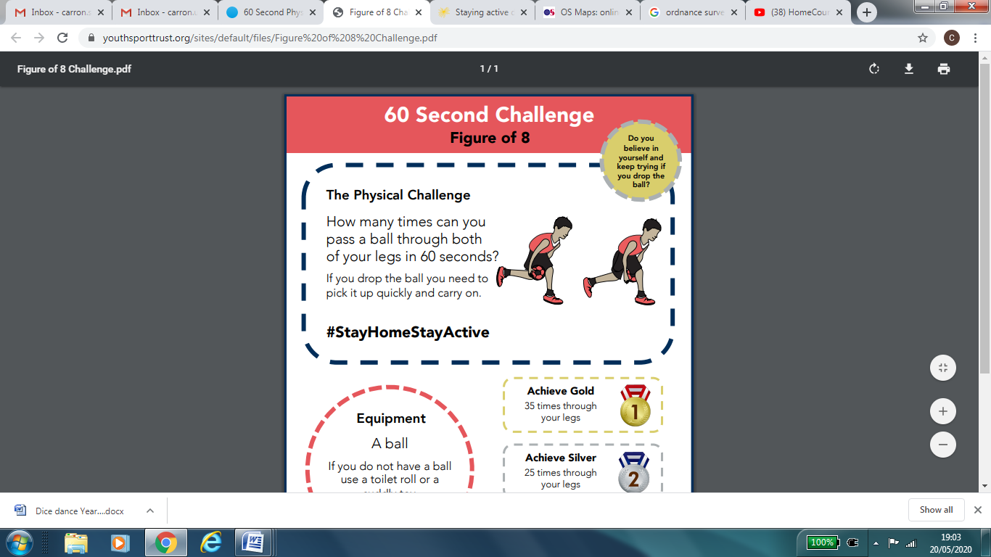
How to play:
- Figure of 8

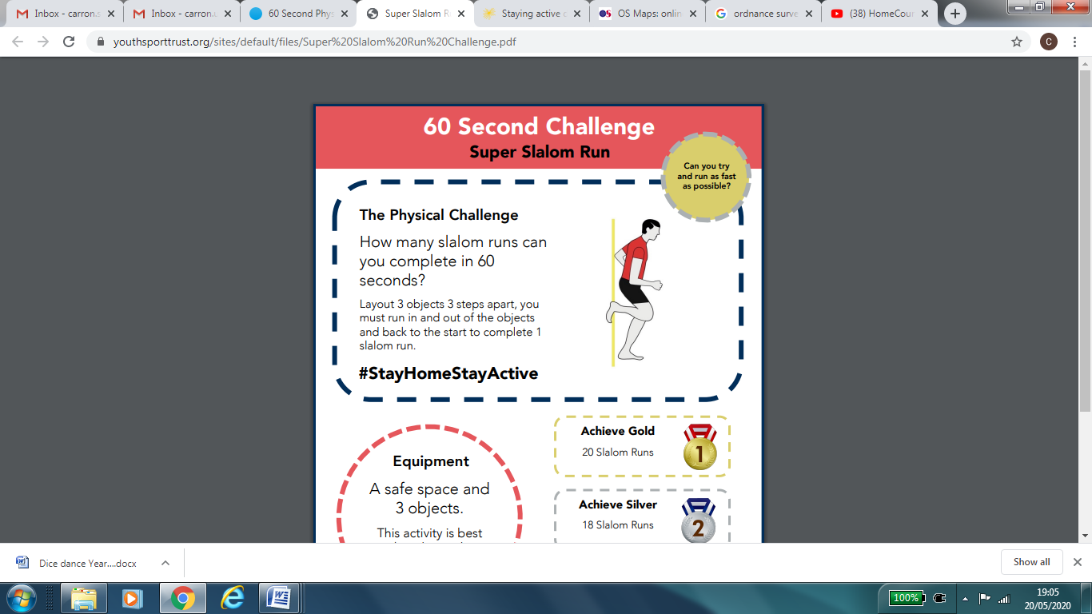
- Slalom run

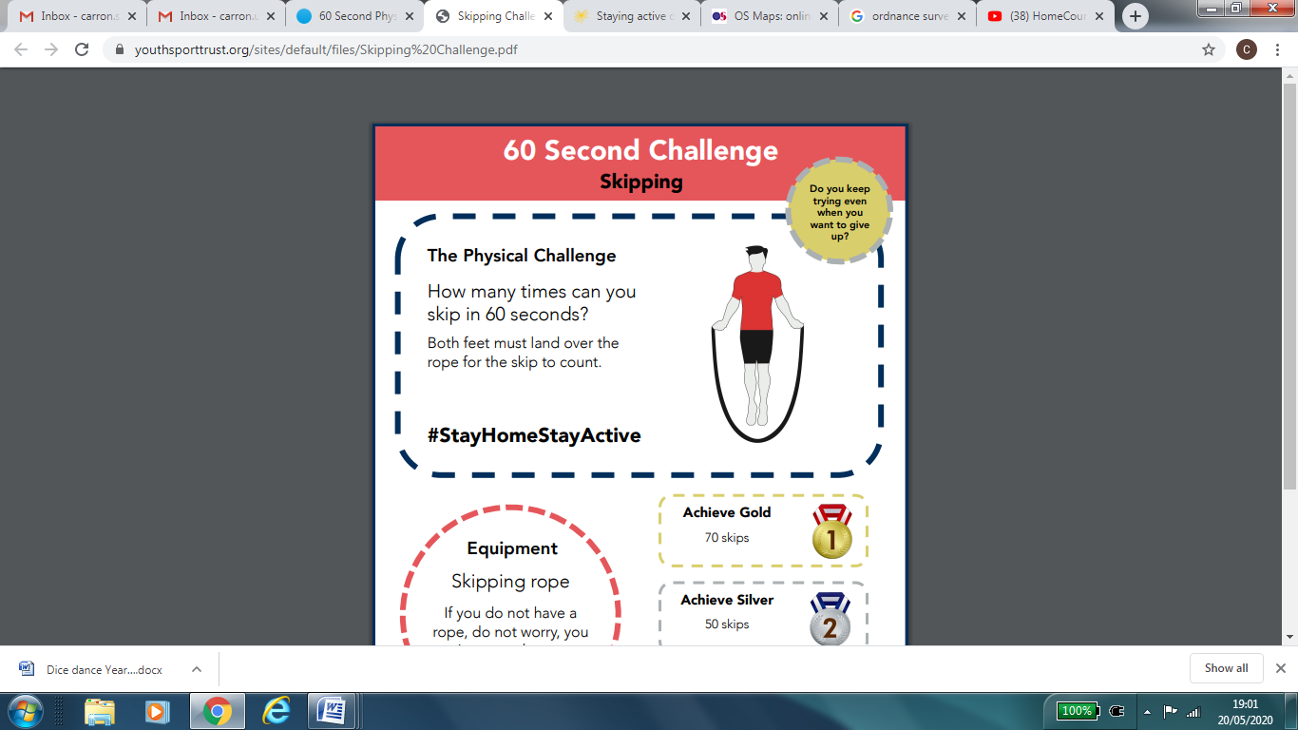

- Skipping
Challenges:
Figure of 8 – Try with a smaller ball or a bigger ball – which is easiest/hardest?
Slalom run – add in an extra object to run around – go faster so you still complete the same number of runs in 60 seconds.
Skipping – can you skip backwards?

STEP
Space Make the slalom run longer or shorter.
Task Slalom – add in a basketball or football to dribble. Skipping – use different moves (e.g., 2 feet
skips, alternate feet, skip backwards, double jump to make the task easier)
Equipment Try using a bigger or smaller ball.
People Challenge a family member or a friend (e.g., on facetime) to complete the activities with you.

SPRING TERM HOME PE
Year 5
Video games fitness and stamina
Equipment: YouTube
How to play:

Choose a video game to ‘play’ from the options below. Copy the link into YouTube and complete the workout challenge.
https://www.youtube.com/watch?app=desktop&v=tbCjkPlsaes



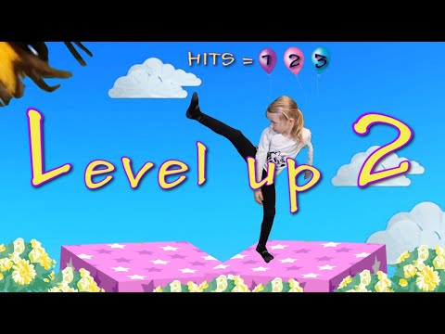
https://www.youtube.com/watch?app=desktop&v=wu--9fOkOJM

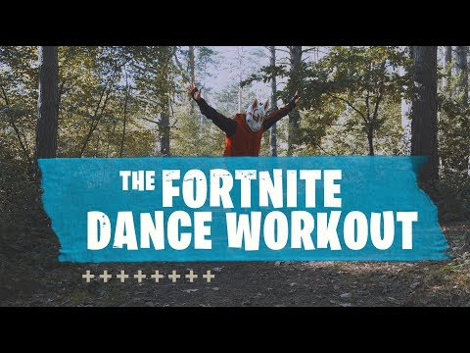
https://www.youtube.com/watch?app=desktop&v=MnpxQr3KXNw

Challenges: Can you complete two workouts? Or all three? Make up your own workout routine with moves to suit your favourite video game. Share this with a family member or a friend.

STEP
Space – use up a larger space when doing the routines.
Task –Change the tasks in the routines, perform them at different speeds.
Equipment – Hold a ball or objects as you work out.
People –work on your own or teach someone else your routine.

