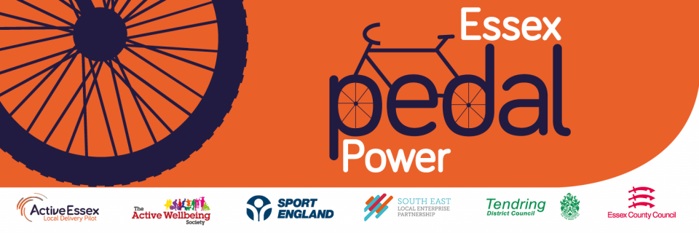

Essex Pedal Power launches in Clacton and Jaywick Sands

Tuesday 15th June

A first-of its kind community-led project in Essex will make cycling more accessible for people living in Clacton and Jaywick Sands, as 1,300 free new bikes will be given to eligible residents over the next two years.

In a launch event at the Jaywick Community and Resource Centre on the 12th June, the first bikes were given away to successful applicants and arrangements are being made to distribute the rest of the bikes in stages between now and 2023.

Essex Pedal Power is a £2.7 million initiative that will help people to benefit from the many rewards of cycling, from improved physical and mental health to accessing new employment, training and education opportunities.

The pilot scheme is a partnership of Active Essex Local Delivery Pilot; Essex County Council; The Active Wellbeing Society (TAWS); Tendring District Council; Sport England; Cycling UK and local community groups.

Research has proven that the biggest barrier to cycling is being able to afford a new quality bike and Essex Pedal Power aims to create more opportunities for cycling in areas that have suffered from deprivation and have been hardest hit by the impact of Covid-19. Cycling is a skill for life and yet not everyone has a bike. By giving away bikes for free, helps to address inequalities and creates new and exciting opportunities for the local community.

To improve transport connections and access to employment in the area, the project includes upgrades to the existing National Cycle Network from Jaywick Sands to Clacton and the construction of a new cycle route connecting Clacton to the train station.

Cllr Lee Scott, Cabinet Member for Highways Maintenance and Sustainable Transport, said: “Active Travel is better for the environment, better for people’s health, reduces congestion and avoids creating pollution. Providing access to sustainable forms of transport is a key part of Essex County Council’s ambitions for climate action and our wish to provide people with alternative ways to travel. I am delighted to be here to support the launch of this fantastic project”

Following on from the initial phase, Essex Pedal Power will see the development of new community cycling groups and clubs providing volunteering opportunities for residents. Training will also be provided free of charge to assist residents in learning how to ride a bike and carry out basic bike maintenance.

The initiative has an ambition to expand to other areas across Essex following on from this pilot. This will create equal opportunities for social mobility across Essex, tackle growing health issues due to physical inactivity, and directly address the dangerous levels of air pollution rising in local communities.

Rickie Russell, Essex Pedal Power applicant and volunteer said: “Becoming a volunteer was a fantastic opportunity to meet members of the community, in which I recently moved to. The bikes are built by the community, for the community and I feel very proud to be a part of the Essex Pedal Power journey.”

Applications for a free bike are open to eligible residents in Clacton and Jaywick Sands. You can learn more about the project and apply here: http://bit.ly/Essex-Pedal-Power

ENDS

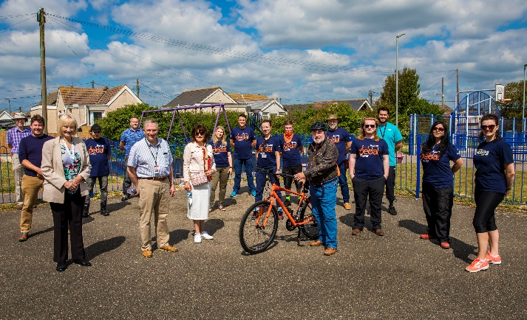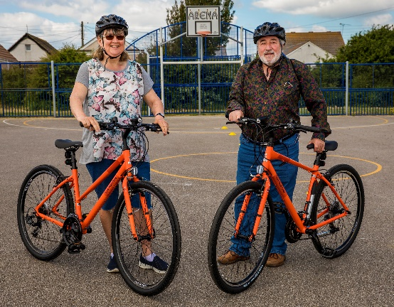

Notes to editors:

- Funding for Essex Pedal Power has largely been through Government’s Getting Building Fund, managed by the South East Local Enterprise Partnership. Essex Pedal Power will work in conjunction with Essex County Council’s skills and employment strategy, in a bid to revive and renew the area.

