**Active Essex School Sport & Physical Activity Bulletin**

**Active Essex School Sport & Physical Activity Bulletin**



**September 2021**

As the County’s Active Partnership, Active Essex is the commissioner for School Sport. As such, it is responsible through funding provided by Sport England and Essex County Council to provide support for schools throughout Greater Essex. Below is a quick summary of latest development:

**Primary PE and Sport Premium:** In June, we received confirmation of Primary PE and Sport Premium funding and our Education Practitioners remain dedicated to supporting schools across the county to make the most of the funding and support you to get back to PE. We will be releasing dates soon for new webinars designed to support, inform, build confidence and to share good practice. We hope you can join us.

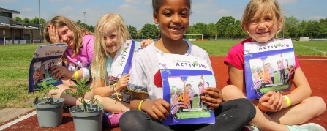**Essex Activate:** This summer, our Essex Activate team in partnership with 100s of schools, community groups, charities and organisations have delivered over 200,000 fully funded places on **Essex ActivAte - Holiday Food and Activity** Clubs. Holidays are pinch points for many families and FareShare report that up to 3 million children nationally are at risk of going hungry at these times. We’re pleased to have been able to offer all Essex children eligible for benefits-based free school meals places at clubs offering fun activities and healthy lunches Monday-Friday over the summer break. Essex County Council also backed the scheme and have funded places for working families who require support.

**Health and Safety:** Essex **Health & Safety in Primary PE Courses** are now coordinated and delivered by Active Essex in partnership with the Essex County Council Health & Safety team. This is a two-part course based on ECC PE & School Sport Risk Assessments, with a practical focus on delivering Physical Education lessons safely, adhering to national guidelines. The course is essential for NQTs or anyone returning to the delivery of Primary PE.

**The Essex School Games:** Active Essex continues to work closely with School Sports Partnerships and School Games Organisers (SGOs) across the County to ensure a high quality and inclusive **School Games** **offer** is available. We’re pleased to announce that we are planning a full school games programme this academic year and are pledging to reach more children in ever through our new school games strategy. For more information, please contact your SGO or visit: <https://www.activeessex.org/children-young-people/physical-activity-at-school/school-games/>

**The Daily Mile: **All primary schools in Greater Essex will have now received their Daily Mile Essex Destinations pack. Nearly 60% of primary schools in Essex have now signed up to participate in The Daily Mile. The Daily Mile is a simple to manage activity that will provide children and staff a much-needed opportunity to be active outdoors daily.

If your school is interested in signing up or if you have any questions, please contact Tom Weller, our Children and Young People Projects Officer: [Tom.Weller@activeessex.org](mailto:Tom.Weller@activeessex.org)

**Active Lives Survey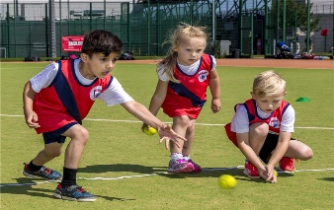:** We’re now entering Year 5 of our commitment to the **Active Lives survey**. <https://www.sportengland.org/know-your-audience/data/active-lives>   
Each term, a list of randomly selected schools is chosen to complete the survey. On completion, schools are able to claim incentives via the Sport England scheme and all schools completing the required number of responses receive their own bespoke school report. Once again, we thank all schools who have already participated in the survey for their support. The data shows there is a positive association between levels of engagement in physical activity and sport, and levels of mental wellbeing in children and young people. For more information please contact: [Tom.weller@activeessex.org](mailto:Tom.weller@activeessex.org)

**Join the WOW Challenge****:** WOW isa pupil-led initiative where children self-report how they get to school every day using the award-winning WOW Travel Tracker. WOW helps reduce congestion and pollution outside the school gates, while increasing safety and improving the physical and mental wellbeing of pupils.

The package usually costs around £500-£1000 but is offered FREE of charge to primary schools for the 2021-22 academic year, thanks to funding from the Department for Transport (25 funded places available first come first served). For more information please contact Zoe Lynch: 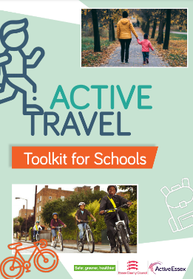[zoe.lynch@livingstreets.org.uk](mailto:zoe.lynch@livingstreets.org.uk)

**Active Travel Toolkit for schools:** This is an online resource that will provide full information for schools on the support available from ECC around Active Travel. You can access the document [here](https://www.activeessex.org/wp-content/uploads/2021/05/HA_ActiveTravelToolkit_v.11.pdf).

**Opening School Facilities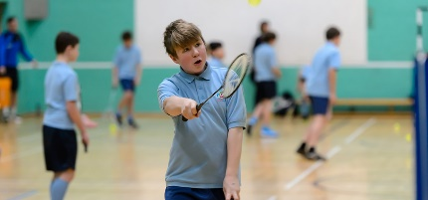:** Through 2021, Active Essex has been working with many secondary schools to reopen their facilities and have distributed over £300,000 to help navigate the challenges in opening their facilities in a Covid-secure manner. Funding has allowed schools to buy new equipment, help with short term staffing requirements and cover addition cleaning costs to enable extracurricular and community sports and activities to resume. A recent Sport England survey found 91% of schools would be prepared to open their facilities for community use when restrictions are lifted, despite the fact only 52% have been able to at any point over the last year. For further advice or support please contact: [Lee.Monk@activeessex.org](mailto:Lee.Monk@activeessex.org)