WOW is Living Streets' flagship Walk to School Challenge.
Pupils log their daily journeys to school each day on the WOW Travel Tracker- our pupil friendly online platform to log journeys. Those who travel actively to school by walking, cycling, wheeling in a wheelchair, scooting or parking then striding, at least once a week for a month earn a WOW badge, with 11 to collect across the year. It’s as easy as that!
On average, WOW schools see a 30% REDUCTION IN CAR JOURNEYS taken to the school gate and a 23% INCREASE IN WALKING RATES
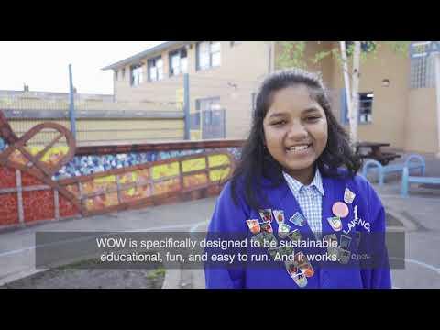
Schools in Essex can sign-up to take part for FREE! Register your interest here www.livingstreets.org.uk/freewow - places are going fast!
To hear how de Vere Primary school in Essex are loving WOW, watch their short video here
_________________________________________
Video links:
https://www.youtube.com/watch?v=MG0GH0Qgqk8
https://www.youtube.com/watch?v=f3LtgY2BOh4
Living Streets logo:
