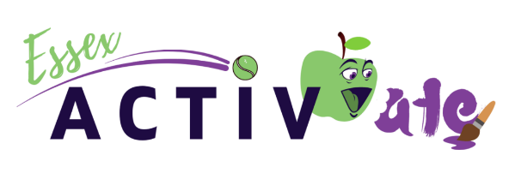
Winter camp booking form
Child’s Name
Child’s Age and Date of Birth
Child’s Ethnicity (optional)
Child’s Address & Postcode
Child’s school
Has your child attended an Essex ActivAte Free holiday club before?

Wonde Code
Medical Conditions
Dietary Requirements
Any Additional information
Monday 20th December 2021 – Thursday 23rd December 2021
10:00am – 3:00pm

Please complete and return this form to info@reacheverygeneration.com

Eligibility (tick at least one):
My child is eligible for benefits-based free school meals ☐
We are a working family who is struggling financially and would benefit from this support ☐
Parents Name:
Parent’s Phone Number:
Parents email:
Alternative Emergency Contact:
Emergency contact phone number:
Emergency contact email:
Is anybody else authorised to collect child? Yes /No

If so, Name and Phone Number:

Photos and videos may be captured from time to time to be used when promoting future holiday camps and activities. Please indicate below if you consent to your child’s image being used for these purposes.

Yes, I consent to this ☐

No, I do not consent to this ☐

--------------------------------------------------------------------------------------------------------------------------

Sessions run Every Thursday starting November 11th 4:30pm-6:30pm
Please tell us which sessions you would like to book for your child, by placing a cross in the box next to each relevant session:

2021
Thursday 11th November

Thursday 18th November

Thursday 25th November

Thursday 2nd December

Thursday 9th December

Thursday 16th December
2022
Thursday 6th January
Thursday 13th January
Thursday 20th January
Thursday 27th January
Thursday 3rd February
Thursday 10th February

Please be aware that there are limited spaces per day, so we will contact you in advance to inform you if your chosen sessions are available.
Please return this completed form to info@reacheverygeneration.com

