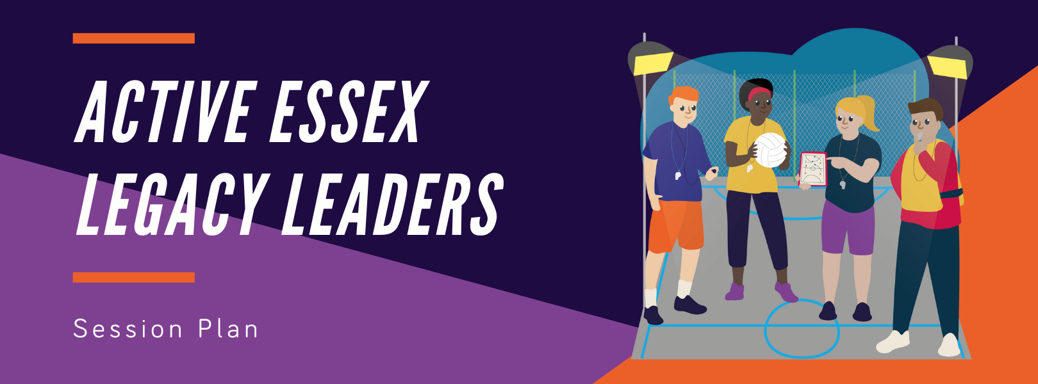

Date |  |  | Size of group
Time |  |  | Group & Age
Equipment/ Resources |  |  | Venue & Facility

Group needs/motivations & reflections from last session (WHO):
What do I know about the group? What to consider from the last session...

Session Goals for the Participants (WHAT): | Personal Coaching Goals
By the end of the session the participants will be able to... | By the end of the session I will have...

Practical Session (HOW)
Time | Activities | What will success look like? | Organisation/  Safety key points
 | Starter activities to prepare the participants for the session (safety) and to make sure that they’re all involved (maximum participation)
 | Activities to ensure that everyone (inclusion) can do something new or better by the end of the session (learning)
 | A fun activity (enjoyment) for everyone to put their learning into practice (success for all)
Review
What went well for the participants?
What would have been even better for the participants if…?

