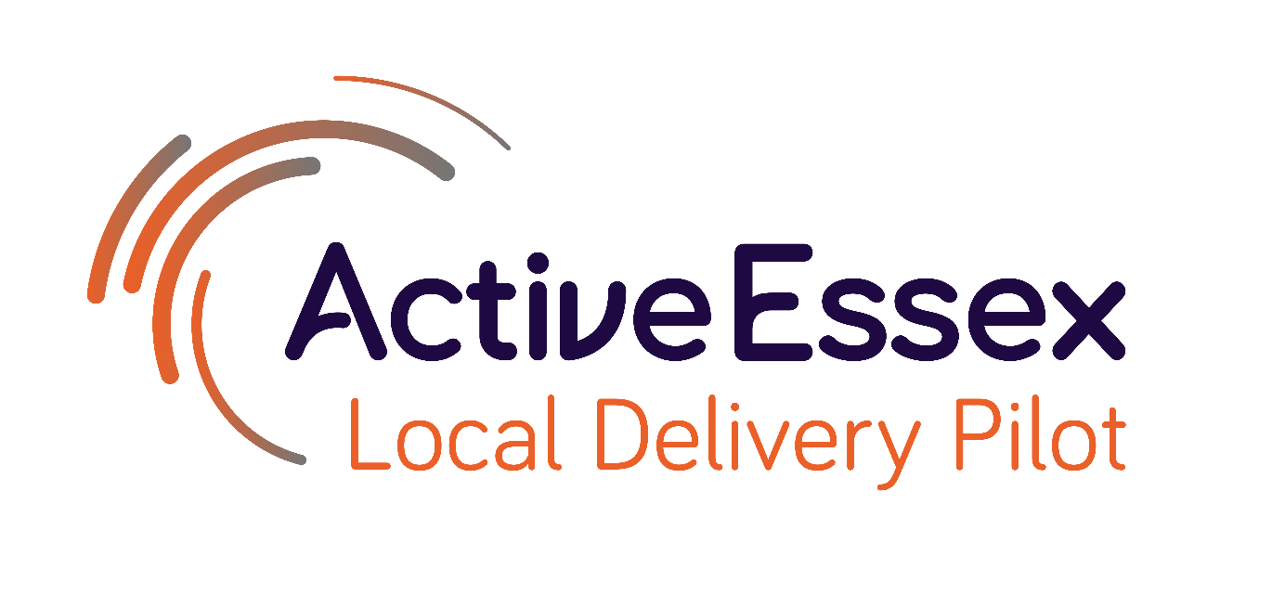

Process Learning Report
April 2022

Prepared by Hannah Taylor, Hibah Iqbal and Rob Southall-Edwards
For further information, please contact hannah.taylor@essex.gov.uk

Introduction
The Essex Local Delivery Pilot (LDP) is an initiative, led by Active Essex, to build healthier, more active communities across the county of Essex. The LDP is an important strand of the work of Active Essex, leading the focus on tackling high levels of physical inactivity, particularly in the most disadvantaged areas of Essex. The Essex LDP is the only one in the East region and is focused on over 400,000 people who live in the county’s most disadvantaged areas, and where individuals and families are facing the greatest inequalities.
This report intends to use an explanatory framework to showcase some of the work that has been undertaken within the Essex LDP and consider how and why some of the changes we have observed in the last 6 months might have come about. This will take the form of five ‘how and why stories’:
Asset-Based Community Development (ABCD) - Since 2019, a proactive approach has been taken by Essex LDP to understand ABCD, with an aim to using it to underpin our work. So far we have trained over 300 practitioners and system leaders across Essex and have seen a number of positive outcomes including changes to how the LDP team and other system leaders work.
Influencing the Youth Justice Sector - Criminal justice is one of the sectors that the Essex LDP is aiming to work within. We positioned ourselves well and gained a place on the Essex Violence & Vulnerability Board. More recently, we have invested in a 3-year, pan-Essex project aiming to continue influencing the youth justice sector.
Essex Pedal Power - Essex Pedal Power (EPP) is a pilot community-based free bike scheme that has been set up in Clacton and Jaywick Sands by Essex LDP, Essex County Council (ECC) Localities Team and ECC Sustainable Travel Team. So far, the pilot has distributed 200 bikes to local residents with plans to give away 1200 bikes by 2025. There are also plans to replicate the scheme across Essex.
Levelling Up - ECC have been developing plans for levelling up in Essex since before the Government published its initial Levelling Up strategy. The “stars have aligned” between the LDP’s core principles and the Levelling Up agenda in Essex, meaning that we are well positioned to influence the development of this work and aim to ‘hardwire’ physical activity into it.
Developing A Realist Evaluation Framework - Our previous evaluation contract expired in December 2021 and a change in direction has been taken with an approach which is collaborative and utilises realist evaluation. The new evaluation team have collaboratively developed an evaluation framework and are in the process of developing explanatory theories for the changes we are seeing and hope to see.
Within each of these stories we highlight areas that we want to celebrate, share our learning, explore with others and what we plan to do next.
The methodological premise of this work is a Realist informed articulation of how and why. The methods of data collection were interviews with the LDP team and partners, theory gleaning workshops run by an evaluation partner and documentary analysis.

The Story of Asset-Based Community Development in Essex
Asset-Based Community Development (ABCD) challenges the traditional deficit-based approach that tried to solve urban and rural development problems. It proposes that local assets (people and physical assets like local parks) are key to ensure sustainable community development, and that people have a life of their own choosing. For ABCD, the focus must always start on what is strong, not what is wrong. ABCD is the way to build healthier, safer, prosperous and more inclusive communities from the ground up, with citizens in the lead. It invites us to understand that people, their families and communities have unique competencies that cannot be replaced by professional intervention. The only people who can build community are the people who live, and work there.
Since 2019, a proactive approach has been taken by Essex LDP to understand ABCD, with an aim to using it to underpin our work, using the existing strengths and passions within local communities to drive up physical activity levels and embed good practice across the LDP network.
What has happened? | Why (was this action taken or why has it worked)?
Nurture Development were chosen as partners with Essex LDP following research and conversations with networks. | Essex LDP needed an expert partner. Nurture Development (ND) were chosen because they are recognised as world leaders for training in ABCD
Initially a smaller LDP team (project leaders and coordinators) were trained, followed by the wider team. | This gave the team a deeper understanding of ABCD which was used to shape the way place-based working was done and how resources from Sport England were used.
Three LDP coordinators were set up to work at a local level in our target areas of Basildon, Colchester and Tendring. Microgrants were also set up to support the community with their ideas.  The LDP coordinators engaged people by helping facilitate connections between people, information and opportunities. | The coordinators were intended to be people on the ground who were easily accessible with the potential to influence the community.  Their roles included ensuring nurturing of community-generated activities enabling communities do it by themselves.
Coordinators identified ‘sticky’ people within communities (those who people in the community gravitate towards). | It was thought that there would be a higher chance of the message being perceived as powerful, if not more powerful, than it coming from a Local Authority staff member.
Free ABCD training through a physical activity lens was offered to known practitioners and managers from varying systems and sectors on a first come first served basis. | This was with the aim of influencing the wider system, with the hope that if the system started to adopt the training, it would benefit the community.

Outcomes
- The LDP and Nurture Development have so far trained over 300 practitioners and system leaders across Essex in ABCD, as well as piloting ABCD rapid reviews and stewardship circles (ABCD leadership programme developed by Nurture Development).
- The high quality of the training and networking is why people stayed in touch with each other in terms of how they implement ABCD methods.
- The training influenced how the LDP team worked and invested money.
- The training has influenced our new 10-year physical activity strategy for Essex, ‘Fit for The Future’. Of the five strategic policies, strengthening communities is key.
- The training has had an influence on senior system leaders, such as the Chief Executive of Colchester Borough Council and the Director of North East Essex Clinical Commissioning Group.

Learning
- In 2019, the LDP had not thought about a legacy plan, this is only happening now.
- It would have been useful to bring everyone who had received training together as an effective network.
- It is important to be selective about the organisation used to deliver training and the people offered training when focusing on physical activity.
- The LDP could benefit from doing more groundwork before rolling out training into some areas.
- There are challenges of working with communities resistant to considering ABCD because of culture within council.
- Precipitating citizenship and community building should be the starting point, not as an effort to save the system money, but to reduce the levels of institutionalization.

What’s next?
- We hope that the stewardship circle comes together, sponsored by Active Essex, and becomes a strong advocate for ABCD, in addition to showing evidence of how ABCD has made a difference in their organisations.
- We hope to have a clear legacy programme linked to Active Essex.
- We hope to establish a network of everyone who attended the training.
- We hope that over time there is a decreased role of LDP coordinators as community takes more control.

The Story of Influencing the Youth Justice Sector in Essex
Criminal justice is one of the sectors that the Essex LDP is aiming to work within and there is a strong evidence base that sport has a positive impact on reducing youth offending in particular. Forging a space on the Violence and Vulnerability (V&V) board has been central to the LDP’s influence in this sector. This occurred through building a relationship with the person who ran the board through a series of meetings. Initially this involved presenting the role/benefits of physical activity in violence prevention and giving examples of organisations who were already using physical activity to keep young people at risk of offending safe.
The LDP was able to gain a place on the board because we were constantly working to be part of conversations and demonstrate that our work is not just about money but that we have a role to play. Relationships have been key to the process; it was important for the relationship to be collaborative, rather than transactional. In addition to good relationships, having knowledge was important because when the board recognised what the LDP had to offer, they were able to break down barriers and support us in sharing knowledge. It was also helpful that there were individuals on the board who enjoy sport and already understood the benefits.
Outcomes of the LDP being part of the V&V Board include:
- Being invited to be part of the community voices sub-group to feed ideas and insight on the ground into the operations board.
- Being on the panel for the V&V community fund which meant that the LDP was able to advocate for sport and physical activity. 60% of the projects that have been given funding since have included sport and physical activity.

Working with the V&V Board has also provided insight and direction to ensure that any projects that the LDP funds within this sector have a clear focus and need. For example, the Essex LDP has recently invested in a 3-year, pan-Essex project in collaboration with National Lottery Community Fund and Active Essex Foundation. This project aims to:
- Continue influencing the youth justice sector at a systemic level in Essex to change policy and increase the access to training and resources that aid the understanding and application of how to use sport to prevent vulnerable young people from offending and violence
- grow a large network of locally trusted organisations across Essex who are quality guided to use sport effectively to divert young people away from crime and violence,
- create a strong evidence base (with support from Loughborough University) of proven blueprints and approaches that increase positive life outcomes for vulnerable young people that can be replicated at scale across Essex

What’s next?
- We hope to use this project over the next 3 years to highlight the role sport and physical activity has to play in the criminal justice system, so that it becomes part of the young offenders’ order.
- It is hoped that the V&V Board accepts sport and physical activity as a sub-group that leads to the strategic planning so that this project can be used to highlight the work in Essex as part of national work taking place.
- It is hoped that in three years’ time, the network will have grown to over 100 locally trusted organisations who are rooted in their communities, care deeply about the future of young people, and see the value of sport as a tool to develop positive outcomes for those young people.

The Story of Essex Pedal Power
Essex Pedal Power (EPP) is a pilot community-based free bike scheme that has been set up in Clacton and Jaywick Sands. This stemmed from the knowledge that local residents had a desire to be able to cycle along the seafront. However, one of the biggest barriers to cycling is the cost of a bike. The local area (Tendring) is ranked the most deprived of all Essex districts and Jaywick contains the most deprived area in the country when considering indices of deprivation, meaning it is very difficult for residents here to access cycling.
We initially considered setting up a bike loan scheme (e.g., Boris Bikes), however, such schemes are extremely costly to implement and require a large number of people to run (storage / collection of bikes etc.). We looked at what was working elsewhere and heard of the inspirational story of Big Birmingham Bikes, a scheme set up to provide free new bikes to the most deprived areas of Birmingham. This aimed to overcome barriers to cycling and increase sustainable transport for those who are usually excluded, as well as improving the health & well-being of residents and encouraging cycling around the city. This led to the desire to set up a similar scheme here in Essex, which would be based on replicating and adapting the good practice that had been implemented by The Active Wellbeing Society (TAWS) in Birmingham.
An important part of EPP is providing residents with a free, quality, new bike. It is not a loan, as lending bikes is not believed to be successful in these communities and the experience of “taking it back” is unpleasant for the residents.
The EPP pilot is focussing on six key outcomes to increase:
- Cycling participation
- Sustainable travel through cycling
- Employability & local economy
- Fitness & physical health of inactive individuals
- Wellbeing of inactive individuals
- Resilience, connectedness & social capital in local communities

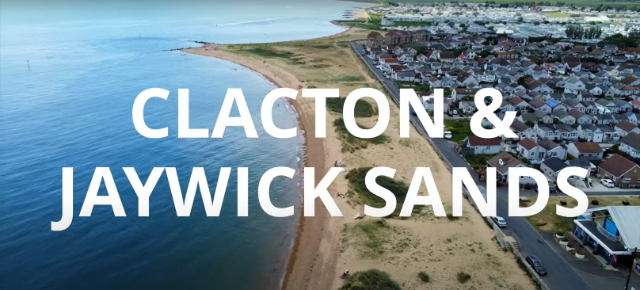(Ctrl + Click for an introduction to Essex Pedal Power)

What has happened? | Why (was this action taken or why has it worked)?
Investment for an active travel project (2.3m) was received through the Getting Building Fund run by the South East Local Enterprise Partnership, which included money for a free bike scheme. The bid for this money had been created collaboratively by the LDP, ECC Sustainable Travel Team, Localities Team and The Active Wellbeing Society. | This provided initial investment which led to additional funding from Sport England through the LDP (400k). The initial investment provided the key to unlocking additional funding.
Community-bike scheme launched around a year ago in the Clacton & Jaywick area. So far, the pilot has distributed 200 bikes to local residents. | The bikes are being built by the community for the community. We have listened and responded to the individual needs of the community and incorporated them in what we do. We have had to go slow - it’s all about listening, learning and giving space. This has allowed us to engage with a range of individuals from 12+ to individuals in their 70’s. It has involved a grass-roots approach, by people who know the people and the area, who have lived here for a long time, and “not just shipped in based on their job title”.
Data on the EPP pilot is being collected using a mixed methods approach (qualitative & quantitative). | To enable us to see the impact on key outcomes for the individuals and to continually reflect and share learning from the project. GPS (SeeSense) and survey data will provide insight into how the bikes are being used, who the project is reaching and how it is influencing key outcomes. Interviews with service providers, volunteers and bike recipients will capture their ways of working and lived experiences, crucial in helping to understand what is working and why in this community.
It is apparent that EPP is about so much more than just giving someone “a bike”. Along with a bike, recipients are provided with safety equipment, information on local cycling infrastructure, access to bike training, mechanic access, knowledge of bike maintenance and community led rides. It is an ongoing wrap-around service, continuing to listen to individuals and maintain that relationship with bike recipients, to build that community. At times this has been challenging to keep up with, due to available staff and resources. | This has been crucial in developing a real community around EPP and providing additional opportunities locally. We want to ensure individuals feel safe using a bike and teach them to be independent in using a bike (e.g., Dr Bike, guidance on maintenance) and also provide the support that is required to build a local community around cycling. The bikes are a drive for engagement (catalyst). There is a sense that the principle of “Give a Man a Fish, and You Feed Him for a Day. Teach a Man to Fish, and You Feed Him for a Lifetime” fits very well what has occurred through EPP. We hope that it will also change infrastructure in the local area, firstly to create safety of cyclists but also to increase the enjoyment of cycling and benefit not just cyclists but the whole community.
Individuals have been able to access year-round employment due to having bike travel available to them. Links have developed with the job centre to prioritise bikes for individuals who could not take up employment without transport. Training for three volunteers to receive City & Guilds mechanic training. An EPP volunteer has gone on to take up a funded role within EPP as Volunteer Coordinator. | The local area is a seaside town with a high amount of seasonal work. The local transport links are poor in the area, meaning it is difficult for residents to access other employment opportunities. Providing these opportunities for training helps increase how EPP is working towards its outcome of improving employability & the local economy.
We have worked with VCS to provide bikes as part of social prescribing, a process which has developed organically. | To improve the mental health of residents in local community through cycling.

A number of positive outcomes have been observed in response to implementing EPP:
- Development of a community of volunteers
- The “biggest strength is our people”
- We have learned that nurturing your volunteers is key if you want a project to be successful, making them feel valued
- Growth of individuals (in confidence, training and pathway to employment opportunities)
- Sense of community
- Facebook group, community newsletter, formal & informal cycling groups
- New friendships & networks, often involving individuals who had not previously met, tackling isolation
- Partnership working
- E.g., Job centre, social prescribing
- There has been a real passion from all involved, often going above and beyond what would be expected of them
- Helped to reduce historical stigma between the Jaywick & Clacton communities
- Project well received by the local community
- local authorities are not always welcomed
- Why? A bike is tangible and provides a sense that “somebody cares”
- Provides a freedom that individuals haven’t had before

There have been learnings involved in implementing EPP, allowing reflection and growth to occur as the project progresses:
A sense that it would be quick and easy - Some of the individuals involved in delivering EPP initially thought it would be a quick and easy process and that we would have a big launch event and hand out lots of bikes straight away (I.e., 50 bikes). However, this did not occur; delays due to Covid and equipment supplies meant a more gradual approach was taken. On reflection, this is considered a good thing as it allowed the project to develop organically and greater support to be provided to those who did receive a bike.
GPS Trackers - There were issues with the GPS trackers initially fitted to the bikes as they required the user to charge the device. This led to the loss of important data which is crucial to understanding how the bikes are being used. On reflection, it was naïve to assume the recipient of the bike would be focussed on this as they have other priorities they are more focussed upon. Bikes are now being fitted with dynamo charging trackers to alleviate this issue moving forward.
Premises & People - Premises are required to operate the project to provide office space, bike building and bike training. The scheme also requires a full-time bike mechanic and a volunteer structure. EPP did not have these in place beforehand and this is an important step to consider when setting up future bike schemes.
Bike Storage - Prior thought was not given to where the individuals who received bikes would store them. This led to bikes being stolen from a communal area before being later recovered. It is important to consider how recipients will be able to safely store the bikes they are given, providing a lock alone is not enough.
Partnership working - EPP has involved partnership working with a large number of stakeholders from around the country. However, there was some lack of clarity or understanding from the start into the individual roles and responsibilities. This led to issues such as not being aware of where to go for support. TAWS are still establishing their role in EPP, with the aim to have a greater presence going forward. Future working may benefit from a clearer plan from the start, as to how all the partners will operate together.
Overall, the project has led to a large amount of learning which is helping to create a “playbook” of how-to best setup and run EPP. This learning is now helping to feedback to other organisations and LDPs currently running free bike schemes (TAWS, Southall) and those looking to develop them in the future.

What’s Next?
Funding has been secured to continue running the Clacton & Jaywick EPP project until 2025, with plans to distribute a further 1200 bikes. This will allow for more data to be collected, including the lived experiences of those who have received a bike. This is vital in ensuring evidence is provided to politicians and senior leaders, to gain support and funding for future free bike schemes. Additionally, we are looking into electric bikes and considering how these could assist people with medical conditions that present a barrier to cycling and help individuals access employment opportunities further afield. There are also plans to expand EPP to additional areas in Essex (Colchester, Basildon, Harwich, Harlow), based on learning from the EPP pilot. Further funding will be required as bike schemes are expensive to implement.

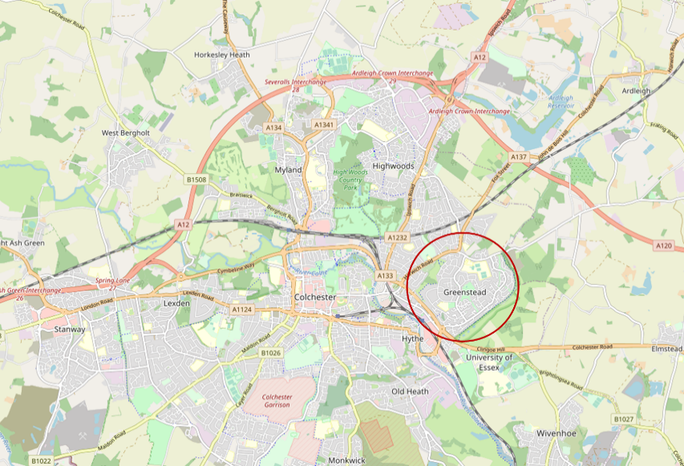
Colchester has plans to implement an EPP free bike scheme which will focus on Greenstead, another area associated with high levels of deprivation and inequality. Funding for the project was received from the Town Deal which acted as an initial catalyst and has led to further funding being provided by the LDP and North East Essex Clinical Commissioning Group. The project was informed by the practical elements observed in Tendring and will prioritise the same outcomes, hoping to learn from and avoid previous mistakes. The project is looking to launch in July this year with the plan to provide 800-1000 bikes. There is a desire to widen the project to other areas of Colchester in the future, however, this would require additional funding.
There are also aspirations to deliver EPP in Basildon, another target area of the Essex LDP, with funding for this still being required. This project would have a slightly different focus in order to ensure it accurately met the needs of its residents. Unlike in the previous EPP areas, Basildon does not have the same issues with unemployment. Basildon was a town designed in the 1950s with the focus on car travel, leading to high levels on congestion and a need for more active travel. The project will look to work closely with the local hospital (an anchor employer) to see how it can help overcome travel inequalities for its staff. Learning is still ongoing to fully understand what the people in the local community require.

The Story of Levelling Up in Essex
Essex County Council (ECC) have been developing plans for levelling up in Essex since before the Government published its initial Levelling Up strategy. Levelling Up is about ensuring everyone has an equal opportunity to fulfil their potential in life and this should be available to all places and communities. Essex is a fairly affluent county; however, 123,000 residents still live in areas that are in the 20% most deprived in England and that are associated with significantly worse health outcomes. Therefore, levelling up is not just about addressing a north / south divide within the Country. Levelling up is about spreading the right opportunities and support across the country to the people and places that have not previously had them. ECC is focusing on four key areas set out in the “Everyone’s Essex: our plan for levelling up the county 2021 to 2025”, covering twenty commitments to improve the lives of people in Essex:
- Economy – Strong, Inclusive, & Sustainable Economy
- Environment – High Quality Environment
- Health – Health, Wellbeing & Independence for All Ages
- Family – A Good Place for Families & Children to Grow
Levelling Up is a very broad agenda but it is important that it focuses on those places and people that need it the most. A data driven approach has been taken to determine the key places and people to focus upon:
- Places - Tendring, Basildon housing estates, Colchester housing estates, Harlow, Rural Braintree, Canvey Island
- People – (1) Children and adults with SEND, learning disabilities, or mental health conditions (2) Children on free school meals (3) Working families (4) Young adults (16-25) who have not been in education, training or employment for around 6-12 months
The council has set out core operating principles around Levelling Up and is mindful of two things. 1) Communities are really important, without these there is no sustainable long-term path, 2) It must be evidence led, using the best evidence and data at its disposal. It is also important to note that devolution is central to Levelling Up, however, not just to local government but also to our local communities.

What has happened?
In response to the Government strategy on Levelling Up, Tim Hollingsworth (chief executive at Sport England) released a statement acknowledging the vital role sport and physical activity (PA) has to play in Levelling Up agenda. One of the key factors will be making sport and PA a normal part of life for everyone, which is also vital for Sport England’s Uniting the Movement strategy. There are also wider benefits for society that are provided through sport and PA which are crucial for levelling up: such as connecting communities and creating a sense of pride, reducing social isolation, increasing skills and creating job opportunities and boosting the economy.
ECC has been proactive and were aware of the deprived communities prior to the Levelling Up agenda. ECC acknowledge the service excellence of Active Essex and Sport England programmes and recognise the important contribution sport and PA play in society and can have towards levelling up. The Fit for the Future system strategy and Essex Activate program show Active Essex is already on a journey to level up the health and wellbeing of the County.
The Essex Local Delivery Pilot (LDP) is leading the way in tackling inequalities in deprived areas using place-based solutions, to translate policy into action, with a clear focus on supporting individuals who are inactive. Sport and PA should be something everything has access to, not be exclusive for those less disadvantaged. Levelling Up is about working across the system (collaborating, sharing resources and learning, distributing leadership) to drive change for the people, which is already occurring under the Essex LDP. The “stars have aligned” between the LDP’s core principles and the Levelling Up agenda in Essex. Therefore, the Essex LDP is well positioned for an Essex specific response, using an Essex specific approach, to an Essex specific problem.
Projects are currently being planned (subject to funding) with the support of the Essex LDP, to implement programmes incorporating PA in target areas, to meet the Levelling Up agenda. These projects continue to work across organisations and with the local community, to create place-based solutions.

What’s next?
The Essex LDP will continue the important opportunity to be part of the Levelling Up agenda. Moving forward the Essex LDP want to position themselves to be part of the relevant conversations to ensure PA is hard-wired into Levelling Up work in Essex. To carry on growing the ethos, principles and ways of working that have been developed and share the learning & knowledge of these to other areas. Levelling up is not a transactional process, it is not about central Government doing. Levelling up is about continuing to engage with and understand the needs and wants of the community. It is a long-term hardwiring opportunity, which needs to be part of the fabric of life, reaching every generation. Achieving this will ensure it remains embedded within society once the funding for the current initiatives has long gone.
We would be keen to explore with others who are engaging with the Levelling Up agenda at a local or national level.

The Story of Developing a Realist Evaluation Framework
The previous evaluation contract for the Essex LDP expired in December 2021. This gave an opportunity to review what we had learned about evaluation so far and what we thought would be needed in the future.
Flexible, Adaptive, Evolving, Responsive | We have seen the priorities of the LDP evaluation change during the lifetime of the previous evaluation contract and we expect this change and development to continue. Having one large contract with resources tied to a specific number of hours for specific individuals meant that our previous evaluation partner found it hard to flex with the needs of the LDP and plan resources accordingly.
Collaborative | Our previous evaluation partner saw the value of working in a consortium and advised that we consider the ‘mix’ of individuals involved in future evaluation work in order to get the right skill sets – and we realised that we needed a combination of evaluation expertise and on the ground capacity. They also highlighted the challenge they had in accessing the information needed to effectively evaluate the LDP which we hope a more collaborative approach between internal and external would overcome.
Knowledge Retaining & Sustainable | The LDP is a time-limited project and so there is a need to consider legacy and sustainability. In order to embed evaluation practices into Active Essex and ECC, we know we need to upskill members of the team and help them to make evaluation part of their work – this was not possible to achieve with the ‘contracting out’ approach that we took previously.
Context Informed | We have seen Sport England moving away from a focus on measurement and monitoring and moving more towards a culture of learning together using the changes and stories that we are observing locally. In order to make the learnings we share more transferable to other areas and contexts, we need to consider not just ‘what works’ but ‘how, why, in which circumstances and for whom’.
Not ‘Evaluation’ | Experience has taught us that traditional evaluation terminology can hinder engaging the system in evaluation practices, particularly when working with ‘unusual suspects’.

The successful bid for an academic partner came from a consortium led by Hartpury University alongside Sheffield Hallam University and Durham University. Their bid set out an approach which is collaborative and utilises realist evaluation.
Realist evaluation is rooted in the philosophical orientation of realism where a key principle is that observing something is not enough, on its own, to establish the causal relationship between variables. Realist evaluation involves three key phases: First, establishing a programme theory, second, testing programme theory, and finally, refining programme theory to result in evidence-informed explanations about how social interventions (physical activity interventions in this case) work, for whom, under what circumstances, and why (Mason, et al. 2021).
Additional capacity was also added to the LDP Insight & Evaluation team through the recruitment of 2 Evaluation Researchers who started in March 2022. It is hoped that by using an embedded researcher approach, the evaluation team will be closer to the work of the LDP and will therefore be more able to ‘notice’ changes, have access to people and the information needed, and influence future decision making based on learning from evaluation. We would be keen to learn with/from other areas using embedded researchers in order to benefit from examples of good practice.

What has happened?
The first task for the new evaluation team was to collaboratively develop an evaluation framework to help structure the work to be completed over the life of the contract. This will be an evolving document but foundational elements, such as the key research questions and the realist ‘develop, test and refine’ approach, will not change.
We knew that we wanted to explore ‘System Change’ and ‘Impact’ so two key research questions were developed:
- How and under what circumstances is the Essex LDP hardwiring physical activity into the system?
- How and why is Essex LDP contributing to their impact priorities?
Initially we held two workshops with key stakeholders to gain conceptual clarity around some of the key terms (hardwiring, system, impact) and to start exploring some of the strategies we have employed to date. These sessions and conversations outside of them also generated some areas of focus or exemplars which will help us to see how hardwiring and creating impact work in practice.
A draft of the evaluation framework was presented to the LDP core team and a survey was then issued to this group to ask for feedback on the proposed areas of focus – the feedback given was helpful and was used to make some changes. The current areas of focus are:
- Working with the Sustainable Travel Team
- Violence & Vulnerability Agenda
- Levelling Up
- LDP Workforce
- Gamification
- Place-based Working
- Microgrants Programme
As an evaluation team, we were happy with the level of collaboration that went into the creation of the framework. It is also hoped that involving the wider team in this initial phase will help to gain ‘buy in’ and engage them in evaluation moving forward.

What’s next?
The next step is to develop explanatory theories for the changes we are seeing and hope to see around system change and impact. We are in the process of conducting interviews with key stakeholders to understand their perspective of how and why we think our strategies will lead to their intended outcomes. This data will be used to create a series of explanatory theories for each key research question and each area of focus, which will be presented to members of the core team at a ‘check & challenge’ session to be held as part of an evaluation away day in May.

