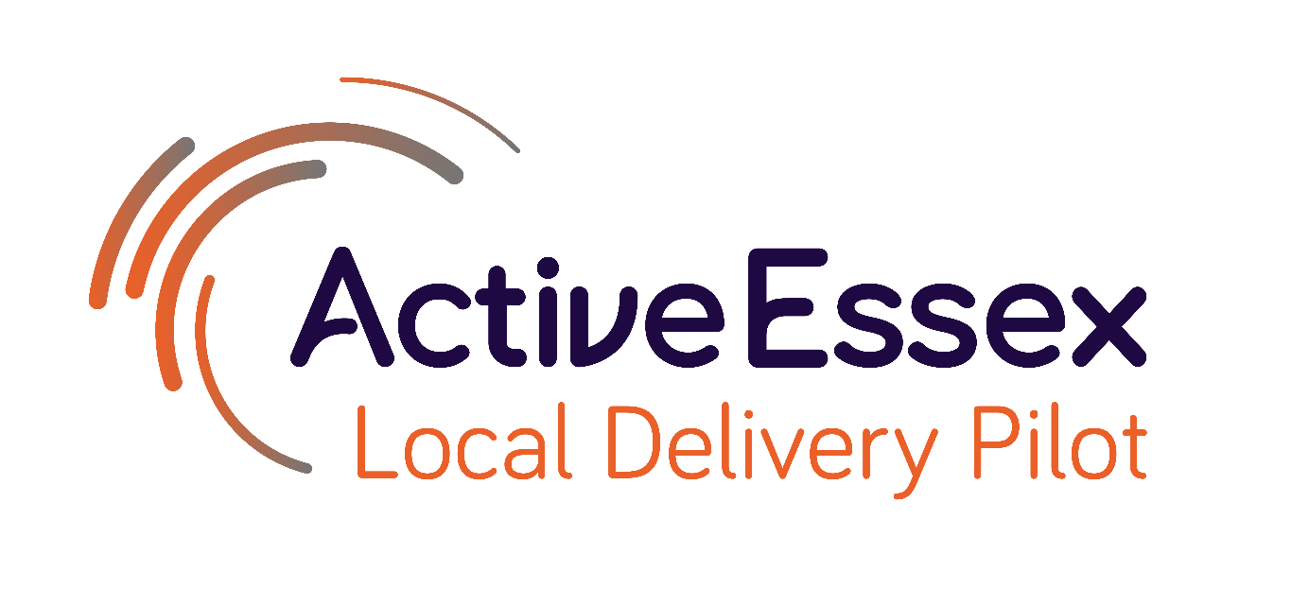

Evaluation Learning Report:

Updates, Insights & Reflections

October 2022

For further information, please contact hannah.taylor@essex.gov.uk
The Essex Local Delivery Pilot (LDP) is an initiative, led by Active Essex, to build healthier, more active communities across the county of Essex. The LDP is an important strand of the work of Active Essex, leading the focus on tackling high levels of physical inactivity, particularly in the most disadvantaged areas of Essex. The Essex LDP is the only one in the East region and is focused on over 400,000 people who live in the county’s most disadvantaged areas, and where individuals and families are facing the greatest inequalities.
The purpose of this report is to showcase some of the work that has been undertaken within the Essex LDP and consider how and why some of the changes we have observed in the last 6 months might have come about.
What’s been happening in Essex? - This section shines a spotlight on different activities that have been progressing over the past 6 months.
Our journey into realist evaluation so far - At the start of the year, we began a journey with a new evaluation partner, taking a collaborative approach to evaluation that utilises realist methodology. We have now developed our initial assumptions and beliefs and are in the process of testing them.
Gamification - The Essex LDP is primarily working with two partners to deliver gamification initiatives, Beat the Street and Street Tag. These seek to gamify physical activity to provide an incentive for individuals, families and friendship groups to reduce their physical inactivity.

Place-based Working - For Essex LDP, place-based working aims to understand context, connect local systems together, leverage resources, facilitate partnership working amongst stakeholders and work in collaboration to hardwire physical activity into local system settings, programmes, policy and deliverables. Key to this approach is to listen and understand the strengths, aspirations and needs of people in a community by working together using local resources and collaborating to gain local knowledge and insight.

Embedding Evaluation - A key focus of the current evaluation approach is to embed a culture of evaluation and learning to show that evaluation is “everyone’s business”.

What’s been happing in Essex?
It’s been an exciting six months in Essex!
There are three LDP test areas have been a particular hive of activity amongst many of our projects are now supporting the wider Essex community and the system change focus that underpins this. Of course, there has been too much going on for us to describe it all, but this section shines the spotlight on different activities that has been progressing over the past 6 months. Two areas that have not been included in this section are gamification and place-based working. These have both been areas of focus of our Realist Evaluation (more on that later!) and are described in more detail on pages 20 and 25.
- Dr William Bird, who has been a specialist health adviser to the LDP and Chair of the LDP Evaluation Group from the beginning in 2018 was appointed the new Chair of Active Essex in August, reinforcing the influence of the LDP on the wider agenda for physical activity and sport in Essex.
- The LDP Quarterly Impact Report for April to June clearly demonstrated significant work and was well received by the LDP Strategic Sponsors Group of system leaders in July.
- LDP investment in health was significant over this period, with investment in two out of the three new ICSs for Essex.
- The LDP impact on system change was clearly demonstrated in a new video where a large number of system leaders spoke about the influence of the LDP on how they will use physical activity to achieve wider outcomes in their organisations and networks (include video link). In addition, the LDP launched the inaugural Essex ABCD Stewardship Circle where 12 system leaders will be mentored by Cormac Russell for 12 months to deepen their understanding and application of ABCD.

Guiding principles for Active Essex
The Essex LDP has changed the way Active Essex works. It has paved the way for new and innovative thinking for tackling physical inactivity. The LDP approach has developed the culture and ways of working of the Active Essex Board and team of over 50 staff. The LDP has already influenced scaling up and replication in a number of areas, these include:

- Influencing different systems to use LDP ways of working
- Improving conditions for place-based working
- Influencing new policies and plans
- Influencing training of future leaders
- Influencing the adoption of ABCD
- Scaling up specific programmes beyond the 3 test areas
Find Your Active
These core approaches of the LDP have been critical in developing areas for change. One area that has been significantly influenced by the LDP learnings is Find Your Active (FYA). Particularly guided by an Asset Based Community Development approach, FYA used learnings from the LDP to create a ground breaking £2 millon campaign grounded in behaviour change aiming to get people more active in the ways that suit them.
The campaign was informed by speaking to inactive residents across Essex and designed to tackle their barriers to physical activity. Using these insights the campaign was developed and used multiple activities such as small grants, activity finder, website, community connectors, and supporting workplaces. Materials developed for FYA were embedded with behaviour change techniques and were relatable to target audiences of the campaign. Learnings from deep dives of Find Your Active projects have been used to inform materials to improve the programme overall and embed these across Active Essex more widely.
Key to the success of FYA was embedding the campaign across the system so that a large number of stakeholders, organisations and partners adopted. Working with multiple groups, organisations and individuals allowed for greater impact to residents health and wellbeing, social isolation and strengthened communities.
In May 2022, as a result of Ride London Essex, Active Essex created a strategic partnership with London Marathon Charitable Trust. In year 1 this has provided a £1 million grant to Active Essex and Active Essex foundation to expand the Find Your Active small grants programme, scale up Essex Pedal Power and increase active travel opportunities to schools and communities.
The FYA year 1 report can be found here
Levelling Up
Active Essex involvement in Levelling up is a tangible example of how the LDP has informed our ways of working. Although the Levelling Up agenda has a broad remit, Active Essex were able to steer Essex County Council’s approach and leverage over half a million pounds funding toward physical activity. Learning from the LDP has supported Active Essex position themselves as a key partner in this work. With geographical areas of focus the Levelling Up agenda aligning with the LDP test areas, there is obvious synergy between these pieces of work (explained further in a previous process report here). As Levelling Up moves towards delivery in further areas such as Braintree and Greenstead, Colchester; Active Essex have a role in shaping their approaches.
Cost of Living
As we face a cost of living crisis in the UK, Active Essex are drawing on our extensive learning from the LDP approach to influence how we respond. We are using our involvement in the Levelling Up agenda to inform and evolve our approaches for Cost of Living. We know from this work that the approach needs to influence different systems to work together on a common goal, influence policy and procedures and develop an approach that is relevant to our communities. Active Essex are supporting Essex County Council and wider partners to draw on these approaches to support those most in need effectively. Cllr Kevin Bentley, Leader of Essex County Council, included two major LDP initiatives in his cost of living crisis statement in July demonstrating the far reaching impact of the LDP on ways of working.

Essex Wide
Cycling initiatives
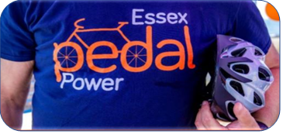
Cycling is one of the key ways Active Essex supports people to become more active, which is why the LDP is testing and replicating cycling initiatives. In May, RideLondon came to Essex for the first time, this major event of 20,000 cyclists on 100 miles of closed roads, attracted enormous attention for cycling, and gave the LDP extra momentum to get more people cycling in our most deprived communities. Our cycling work is also influencing the transport and highways system leaders to prioritise deprived areas, including where investment should be targeted for improved cycling infrastructure and active travel. ​C​urrent cycling initiatives include:
- Essex Pedal Power Clacton/Jaywick​
- Essex Pedal Power Colchester​
- Essex Pedal Power Harwich/Dovercourt
- Essex Cycle Grants​
- Colchester Wheels for All​
- ​Tendring Wheels for All Project​
- ​Basildon Sport 4 Confidence Disability Cycling Hub​
- £50,000 towards a new Safer Greener Healthier campaign to promote active travel in low-income communities

There are also further cycling projects in the pipeline. Essex Pedal Power will be expanding significantly over the next year, with new projects starting in Colchester, Harwich and Dovercourt and Basildon all funded by the LDP. In total, LDP has funded £1,485,730 towards Essex Pedal Power initiatives and have leveraged​ £3,088,324. As such we are supporting two new cycling posts, Cycling Assistant Relationship Manager and Cycling Evaluation Researcher. Both of which will help to increase capacity within our cycling projects to manage and demonstrate the impact.
Within the cycling programme, Active Essex LDP invested in the existing Essex Cycle Grant scheme in March 2022 to ensure deprived areas benefit more from the scheme. The scheme aims to support cycling activities and initiatives across Essex to engage more people in cycling. It is a joint venture between ECC Sustainable Transport Team and the Essex LDP. Since the launch, there have been 26 applications to the fund and organisations have received a total of £115,050 for cycling projects across Essex​. Newly funded projects this quarter include Care 4 Calais, Together we Grow, Get Cycling Tendring, SVP Springfield, Sociability, GO4 Café New Town Bike Kitchen.
Essex Pedal Power was used by Sport England to advocate at national level the huge importance and impact of free bike programmes in deprived communities, along with representatives of free bike programmes from Birmingham and Southall in London. This included presenting at three national conferences, and showcasing the impact of free bikes on a day long visit from Chris Boardman who is Commissioner of Active Travel England and Chair of Sport England.
Sport and youth crime prevention​
​ The Active Essex Foundation has increased its work in the sport and youth crime arena over the past 6 months. LDP has funded £144,436 in the Youth Sport and Crime project matched by £310,781 by National Lottery Community Fund which brings together the systems of criminal justice and community sport to prevent youth crime and violence Over the past quarter, with the embedding of crime prevention staff within the AEF, links with the Police, Fire and Crime Commissioner and Violence and Vulnerability Unit have significantly strengthened and have increased the influence of sport and physical activity as a preventative activity for at risk and vulnerable young people. The project was recently showcased by the National Lottery Community Fund to describe how the project supports young people to maximise their opportunities and how sport can play such an important role. LDP has funded £ 144,436 of the project, with leveraged funding including National Lottery Community Fund (£310,781)​ and Active Essex Foundation (£48,600)​.
ParkPlay
ParkPlay is two hours of community play, in a park or public space every Saturday morning. It aims to bring families and communities together through the power of play for all ages that is tailored to the local area. It is aiming to tackle lack of exercise, isolation, mental health and lack of escape. ParkPlay is really taking off in Essex and there are plans for six in Basildon, four in Colchester, and four in Tendring. To date there has been 585 ParkPlays, 13372 attendances and 2249 unique players.

Basildon
Trust Links
Trust Links Basildon has launched a new wellbeing programme using gardening and other activities, called Growing Together, to support local residents to improve the green spaces in their neighbourhoods. The project provides community gardening and other activities to adults with mental health complexities and mild learning disabilities. From their new Growing Together Hub in Vange, Trust Links Basildon will provide members with the chance to connect, benefit from horticultural activities, and access wellbeing support from the expert Trust Links team.​ The LDP has funded £X of the Growing Together project and leveraged funding has come from ECC Strengthening Communities (£60,000)​, Basildon and Brentwood CCG (£135,000)​, ECC Better Care Fund (£15,000), Basildon Health and Wellbeing Partnership (£5,000)​, ECC Contain Outbreak Management Fund (£5,000)​, Clarion Housing and Clarion Futures (£20,000)​, Essex County Council Locality Fund (£5,000)​, National Lottery Community Fund (£180,803).
Creative Basildon​
In September, Creative Basildon was awarded funding through the LDP to lead on a new collaborative approach to build the capacity of the voluntary sector in the build-up to Basildon@75. ​ ​
This project aims to define what volunteering means in Basildon, who volunteering is for and creating additional opportunities. The aim is to build a stronger, more diverse and dynamic volunteering sector in Essex by strengthening partnerships through cross sector working. Creative Basildon is funded through the LDP (£64,432) and match funding from the Arts Council (£250,000), ACE Creative People and Places (£40,000), and Heritage Lottery Fund (£30,000).​
Find Your Active Festival
Part of the plethora of the activities that have been delivered within our ongoing behaviour change campaign (informed and grounded in LDP ways of working) was, in September, the first Find Your Active Festival - held in Basildon. The festival boasted a range of free activities offered to residents. The day kickstarted with the largest ParkPlay of all time, followed by several 'give it a go' sessions that ran the duration of the day including Bollywood dance, parkour, Abula (a Nigerian ball game), inclusive cycling, archery and a range of games and competitive sports. The day was a success with over 350 residents taking part in the festival. Councillor Jeff Henry, Cabinet Member for Culture, Health, Leisure, Arts, said: "This was really exciting event for residents to have lots of fun and try sports they may not have before”.
To support residents to continue being active, 100 items of sporting equipment were gifted to households that had taken part in four or more of the day’s activities.
Recently funded projects in Basildon
Over the past 6 months, a number of new projects have been approved funding through the LDP, these include:
Project | LDP funding | Leveraged funding
Basildon Pool Pod | £31,056.90 | £5,000
GP training | £13,780.00 | £13,000
Highway to health | £47,268.00 | £9,603
Trust Links – Growing together | £105,000.00 | £425,803
Sport 4 confidence disability cycling hub | £41,318.00 | £44,108
Creative Basildon | £64,432 | £290,000
LDP Basildon health post | £30,000 | £30,000
 | £332,854.90 | £817,514.00

Colchester
Wheels for all Colchester
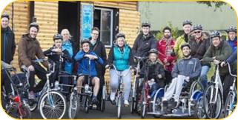
Wheels For All Training gives individuals, carers and support staff the confidence to work with adapted cycles for their disabled clients or family member so that all can enjoy the benefits of cycling in a sociable environment.​
Colchester Wheels for All’s celebrated its 1st Birthday in July. And what a successful first year it has been! There have been over 900 attendances, 12 volunteers recruited and fully trained and four roadshow events. The Colchester Wheels for All programme supported 381 unique participants in year 1 and is aiming to grow substantially to support 750 unique participants next year. The LDP funded Wheels for All £59,980.40, with match funding of £38,802 from Leonard Cheshire, Colchester Borough Council, Colchester catalyst, Cycling UK and Cycling projects.
​ Jo Smith and the team have met so many people who have become part of the Wheels for All family. Jo says “To the volunteers, the ones who really make it happen, a huge thank you, we just couldn't have succeeded without your passion and support”.​
Project:ME
Project: ME aims to support young people to strengthen their minds, bodies, confidence, and ability to make great choices for their future. The project is delivering programmes for children and young people in Colchester, delivering a range of courses including physical activity and life skills, delivered in a safe, fun, and supportive way and to facilitate motivational speakers, themed discussions, and wellbeing workshops to maintain personal growth. Project:ME has been funded £40,441.93 through the LDP and secured £40,441.93 in match funding.
Recently funded projects in Colchester
Projects that have commenced in the past 6 months:
Project | LDP funding | Leveraged funding
Mobile skate park | £13,578.80 | £1,000
Project:ME | £40,441.93 | £13,771
LDP Comms post | £92,100.00 | £45,000
Essex Pedal Power | £501,600.00 | £533,000
Street Tag continuation | £58,410.20 | £45,500
Active environments and Active travel capacity | £90,000.00 | £23,483
 | £796,130.93 | £661,754.00

Tendring
Essex Pedal Power – One year birthday celebration
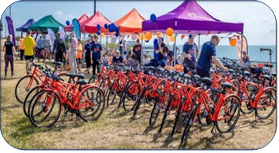
Essex Pedal Power celebrated its first anniversary in July 2022 in Clacton Clacton and Jaywick. The anniversary was marked with a large community event with live music, family activities, an e-cargo bike area, and a further giveaway of 25 bikes to eligible applicants. To date, there have been 410 bikes given away out of a total of 1200. Bike giveaways will pause during the winter months and recommence in spring 2023. In July, funding to extend EPP in Clacton/Jaywick was approved to 2025.
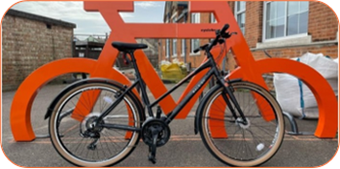
We have also received our first data evaluation report of the Clacton/Jaywick Essex Pedal Power (EPP) pilot. This report serves as a baseline as well as beginning to unpick what works and demonstrate the impact that the programme is having. The report also highlighted some learnings from the past year and recommendations for improvement. This exciting piece of work has already helped to shape EPP in Clacton/Jaywick as well as the new areas of EPP delivery.
Recently funded projects in Tendring
New projects in Tendring over the past 6 months:
Project | LDP funding | Leveraged funding
Essex Pedal Power – extension of the Clacton/Jaywick operation to 2025 | £250,097 | £169,225
Essex Pedal Power Harwich/Dovercourt | £250,000 | £350,000
Tendring Wheels for All project | £188,600.00 | £427,000
Harwich and Dovercourt Listen and Connect project | £30,502 | £30,000
Beat the Street in Clacton and Jaywick | £63,650 | £25,000
Street Tag in Walton and Harwich | £21,000 | £15,000
LDP comms post | £50,000.00 | £25,000
 | £853,849 | £1,041,225

Our journey into realist evaluation so far
Initial Steps
At the start of the year, we began a journey with a new evaluation partner, taking a collaborative approach to evaluation that utilises realist methodology.
Our evaluation partner is a consortium led by Hartpury University and including members from Sheffield Hallam University and Durham University whose role is to support, guide and challenge the evaluation process, ​provide learning and reflection spaces and provide capacity building around evaluation methods for all those interested in evaluative thinking. Our internal evaluation team is now made up of a new Active Essex Intelligence Manager, a Senior Researcher, two new embedded Researchers and an Analyst. This team will take main responsibility for data collection, analysis and sharing evaluation findings​.
The aim of a realist approach is not just to determine if an intervention or programme works but also to identify how and why it works, for who, where and under what circumstances. Typically, the ‘realist cycle’ has 3 phases; develop assumptions and beliefs, test our ideas, and refine assumptions and beliefs.
The first task for the evaluation team was to work together to develop an evaluation framework that would help us explore “system change” and “impact” (Figure 1). This led to the formulation of the two main research questions:
- How and under what circumstances is the Essex LDP hardwiring physical activity into the system?
- How and why is Essex LDP contributing to their impact priorities?
The second task was to identify the evaluation areas of focus, which can be used as examples of how the LDP is hardwiring physical activity and creating impact in practice. The learning from these areas are likely to be transferrable to other areas of delivery, something which will be tested as we move through the evaluation.
Our initial focus areas are:
- Gamification - How the LDP is using an emerging concept to promote physical activity and connect people and their place.
- Place-based Working - Understanding how and why place is important to how we work, in order to empower communities to reduce physical inactivity.
- Working with the ECC Sustainable Travel Team - How & why the LDP has developed a working relationship with the Essex County Council Sustainable Travel Team towards a shared common purpose and understanding.
- ECC Levelling Up Agenda - Understanding how the LDP is positioning itself to align objectives and demonstrate how PA can be used to achieve Essex County Council Levelling Up outcomes.
- Influencing the Youth Justice Sector - How the LDP can demonstrate the importance of using physical activity as a catalyst to reduce youth violence and youth crime.
- LDP Workforce - How the LDP is increasing capacity within key organisations and upskilling the workforce to incorporate physical and/or ways of working into daily practice.

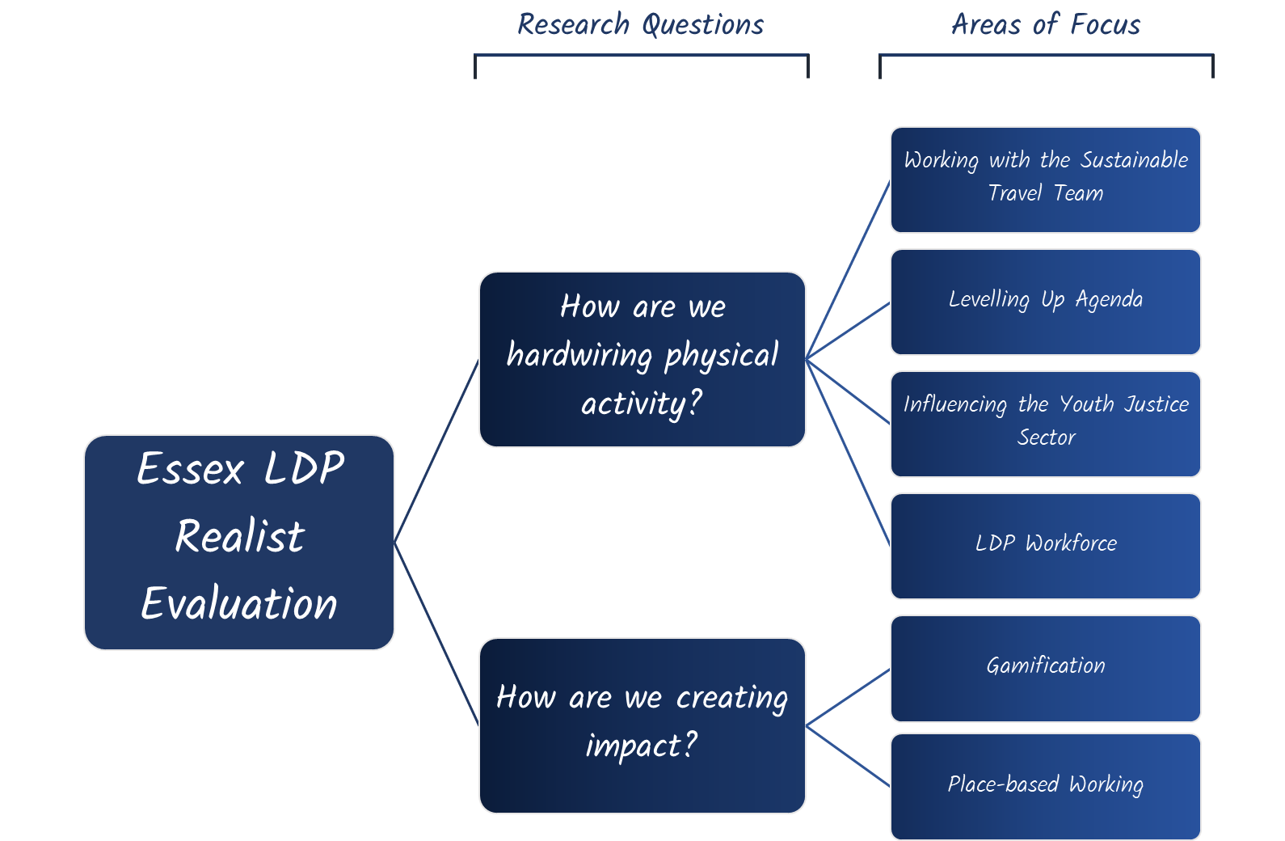

Developing Assumptions & Beliefs
A key part of developing our assumptions and beliefs was having conversations with relevant stakeholders (internal and external) whose work centred around our areas of focus in addition to reviewing previous conversation transcripts about how and why the LDP works as it does. Based on this, we wrote assumptions & beliefs in the form of “If, Then, Because” statements. It was important for the assumptions & beliefs to be broad and all-encompassing, capturing ways of working, as opposed to project specific.
We used the opportunity of an evaluation awayday to present these assumptions & belief statements to a group of stakeholders so they could be ‘checked and challenged’. Attendees included members of the LDP core team and our partners from all levels of delivery; from delivery partners working directly with the community, to community coordinators working with local community groups and organisations, to senior stakeholders working within Active Essex and the local councils involved in the LDP.
We used the feedback received on the assumptions & beliefs to inform and refine them, while also being careful not to dismiss data and information that was collected prior to the awayday.
Below are our finalised initial assumptions & beliefs:
- Area of focus | - Assumptions & Beliefs
- Gamification (1/3) | In recent years using gamification to promote PA has increased greatly in popularity. If we embrace this popular social movement, then people will want to be part of this, as it embraces what people are currently doing. This will promote people getting out and about in the local community and create opportunities to reduce physical inactivity. As it will provide incentives (intrinsic & extrinsic) to take part (fun, low cost, rewarding, competition, connections, quality time) and be flexible to individual routines.
- Gamification (2/3) | The gamification of PA is a relatively novel concept that has emerged and grown over the last few years. This has occurred with little evidence to support its effectiveness in reducing physical inactivity in our target audience, individuals who live in the most deprived communities of Essex. If we can convince people that the gamification of PA is a good idea, then we can implement it more widely across the system. This will increase our ability to capture evidence around who it works for, where it works and why. This will be possible as we will have more support to do so (funding, political will, visibility/positive image).
- Gamification (3/3) | How individuals perceive their local area and the connection they hold with it, is important for engaging them in PA. If we use gamification to encourage people to go out and explore their local place, then we will create connections with people and places in the local area. As this will creative positive experiences with new areas (and change previous negative perceptions) and form healthy habits.
- Place-Based (1/3) | We know that even the most deprived and disadvantaged communities contain a range of assets (i.e. people ...). If we can build trust and relationships within communities and encourage local community members and groups to connect to each other. As a result, we will be able to build community resilience by empowering the community to identify and make better use of local assets because they will have an understanding of what their community already has.
- Place-Based (2/3) | Top-down approaches have not been successful in encouraging PA in local communities. Consequently, if we can distribute leadership to the local community, then they will take responsibility for and ownership of creating opportunities to reduce physical inactivity. This is because they have local experience, meaning they understand the needs and wants of their local community.
- Place-Based (3/3) | Communities already possess a wealth of assets and knowledge that can help tackle physical activity in their local place. If we can support, guide and fund local individuals and/or groups to galvanise and realise their own ideas, then we will catalyse small scale community projects which respond to the individual needs of that place. This will create more opportunities to be physically active because we will be helping to remove current barriers to these types of initiatives (funding, knowledge gap, capacity).
- Working with the Sustainable Travel Team (1/2) | Traditionally, parts of the system operate within their own bubble, leading to less opportunities to work together across the system. If we are able to build a strong working relationship with the sustainable travel team, then we can change these traditional ways of operating. This will allow us to achieve active travel solutions that are not possible when we work alone. As this will allow us to have access to and influence over the resources, funding and expertise at our collective disposal.
- Working with the Sustainable Travel Team (2/2) | Traditional ways of working have involved a disjointed system, which creates a knowledge gap around the “bigger picture” and what we are all trying to achieve. If we can align our objectives with those of the sustainable travel team, we can develop a shared common purpose around what we are both looking to achieve. This will widen our collective sphere of influence, connect infrastructure and increase passion, creating additional opportunities to be physically active that meet both our desired outcomes. In doing so we will be adaptable and flexible in understanding and co-designing solutions, while collectively being more than the sum of our individual parts.
- Levelling Up Agenda (1/3) | Levelling up is about tackling inequalities, therefore, everyone should have access to opportunities to take part in sport/PA and it should not be exclusive to for those that have more. If we position PA as an important part of the levelling up agenda, then we can use sport/PA to tackle inequalities. As this will increase the access individuals in disadvantaged areas have to sport/PA opportunities.
- Levelling Up Agenda (2/3) | Levelling up is trying to reduce inequalities across a number of key areas within the system (i.e., economy, environment, health, family). If we can ensure PA is part of the levelling up agenda, this can provide a vehicle by which levelling up can achieve its priorities, helping to tackle inequalities and embed PA into the fabric of life. As PA will be part of the levelling up strategy and its associated actions.
- Levelling Up Agenda (3/3) | The Essex LDP has been developing core principles and changing ways of working across the county, with the purpose of tackling inequalities. If we align ourselves with the levelling up agenda, then this will provide opportunities to collaborate and share learning. Enabling us to continue to advocate for and grow the ethos, principles and ways of working of the Essex LDP and influence system change across Essex (health, social care, transport, education, employment, economy etc.). This will occur as we will provide stories and evidence which will support taking this approach.
- Youth Justice (1/2) | There is a lack of evidence available to convince the YJ system to use PA. If we build evidence/recognition of the benefits of using PA as a catalyst to reduce crime & anti-social behaviour, then we can influence the youth justice system to utilise and invest in PA interventions, embedding PA as part of a package of support. This is because confidence in the effectiveness of PA as a catalyst to reducing crime & anti-social behaviour in young people will be increased
- Youth Justice (2/2) | We know that there is a relationship between crime & anti-social behaviour and living in deprived areas and sport alone is not enough to engage young people. If we create an incentive to engage in positive behaviours, then we will increase PA and associated benefits in young people less likely to engage with traditional sport and PA opportunities. This is because peer to peer influence in a fun and social environment is key to engaging these young people.
- LDP Workforce (1/1) | The benefits of PA are well known but it is not currently embedded well in day-to-day practice. If we upskill the current workforce, ensuring we have the right people and the right skills, then they will have the confidence to use PA in day-to-day practice. This is because people will have the capability, opportunity and motivation to do so.

Testing and Refining Our Assumptions & Beliefs
We have started to gather data to test some of our assumptions and beliefs, focussing initially on gamification and place-based working. We intend to use a range of methods to do this including analysing project data, secondary research, documentary analysis, community engagement, stakeholder interviews and staff reflection sessions.
Following this, we will be able to start using the data we have gathered to support or oppose our assumptions and beliefs so that we can refine them.
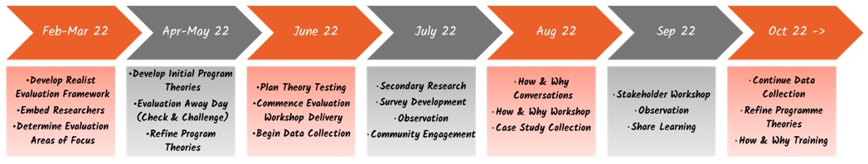
Gamification

What is Gamification?
Gamification seeks to gamify physical activity to provide an incentive for individuals, families and friendship groups to reduce their physical inactivity. This concept has grown in popularity in recent years, with many people being familiar with the app-based game, Pokémon Go.

Gamification in Essex
Currently, the Essex LDP is primarily working with two partners to deliver gamification initiatives, Beat the Street (BTS) & Street Tag (ST). Both games look to turn towns and the local areas into a giant game, where people earn points through walking, running and cycling. These points then contribute towards leader boards with individuals able to join and contribute to teams, for example their school. Those high up on the leader boards can then win prizes, such as vouchers to spend, which act as an incentive to participate. The intention of both games is to promote individuals being more physically active in their local area and increase community cohesion.
Street Tag
Street Tag is a private limited company who have produced a mobile app-based game, where individuals collect virtual tags within the local area using their smart phone. Tags are collected by visiting the area near which they are located, then this along with steps completed are converted into points.
Street Tag’s partnership with the Essex LDP started with an investment being made for a game in Basildon in 2020 and this has since been replicated in Colchester, Clacton, Harwich & Dovercourt and Walton-on-the-Naze. With leader boards for the community, schools, workplaces and care homes, we have seen 4,486 people taking part, travelling a total of 1,337,093 miles. Within the Basildon game, of those players who provided a valid postcode at registration (428), 52% live in areas of high deprivation (IMD 1-4).
Further investment in Street Tag has recently been agreed by the Essex LDP and North Essex CCG to recruit a Street Tag Coordinator for Colchester. This person will seek to increase participation and engagement levels of Street Tag across the 4 existing Colchester leader boards as well as launching a new Secondary School leader board and trialling new technology in care homes.
Beat the Street
Intelligent Health is a private limited company that own the Beat the Street game. In Beat the Street, players collect points by tapping on “beat boxes” which are placed physically around the local area and can simply be tapped with a card. The Essex LDP has funded two Beat the Street games in Tendring; the first in Harwich & Dovercourt and the second in Clacton & Jaywick.
The game in Harwich & Dovercourt engaged 2,817 players, with 35,166 miles travelled over the five-week game phase. As a result of playing, 57% of inactive adults became active and 49% of less active children became active.
The game in Clacton Jaywick saw 3,614 people take part, travelling a collective distance of 38,019 miles over the six-week game phase. Following Beat the Street, 38% of inactive adults had become active and 46% of less active children become more active. The game also led to significant improvements in mental wellbeing; the proportion of adults reporting low and very low feelings of anxiety increased by 11% and the proportion reporting very high feelings of worthwhileness increased by 7%.
Clacton & Jaywick will also see a short game in October which will trial an app-based version of the game.

What are our assumptions & beliefs around gamification?
We are working to test and refine the following assumptions & beliefs around how & why the Essex LDP is using gamification:
- In recent years using gamification to promote PA has increased greatly in popularity. If we embrace this popular social movement, then people will want to be part of this, as it embraces what people are currently doing. This will promote people getting out and about in the local community and create opportunities to reduce physical inactivity. As it will provide incentives (intrinsic & extrinsic) to take part (fun, low cost, rewarding, competition, connections, quality time) and be flexible to individual routines.
- The gamification of PA is a relatively novel concept that has emerged and grown over the last few years. This has occurred with little evidence to support its effectiveness in reducing physical inactivity in our target audience, individuals who live in the most deprived communities of Essex. If we can convince people that the gamification of PA is a good idea, then we can implement it more widely across the system. This will increase our ability to capture evidence around who it works for, where it works and why. This will be possible as we will have more support to do so (funding, political will, visibility/positive image).
- How individuals perceive their local area and the connection they hold with it, is important for engaging them in PA. If we use gamification to encourage people to go out and explore their local place, then we will create connections with people and places in the local area. As this will creative positive experiences with new areas (and change previous negative perceptions) and form healthy habits.

What have we done to understand gamification?

Project Data

Data from Street Tag and Beat the Street games provide an opportunity to understand to what extent gamification interventions increase physical activity and wellbeing in our target audiences.

Secondary Research

A literature search was conducted to review the research around gamification, including how gamification contributes to increasing PA levels, motivation’s people have for engaging with gamification interventions and challenges faced by previous gamification initiatives.

Community Engagement
The recent Beat the Street game in Clacton & Jaywick presented a good opportunity to collect qualitative data around gamification. We had brief conversations with over 50 players in the local area and were able to learn about what motivated them to play and the impact that the game was having on their lives. We also identified two individuals whose BTS stories we wanted to capture as case studies.
- Stakeholder Interviews
Interviews have been conducted with key stakeholders involved in the planning and delivery of Beat the Street and Street Tag to capture their reflections.

What have we learned about hardwiring?
Gamification is a popular concept
The Essex LDP has spent over £230,000 on gamification interventions with over £100,000 additional funding leveraged from partners including District and Town Councils, CCGs and the Essex County Council Levelling Up fund, demonstrating that partners across the system are keen to join us as we test the gamification of physical activity for different groups and communities across Essex. More work is needed to understand how and why our partners have been persuaded to invest.

What have we learned about impact?
Gamification motivates people living in areas of deprivation to engage in physical activity
The data we are receiving from Street Tag and Beat the Street shows that we are managing to reach LDP target areas (IMD 1-4) and that there is relatively good take up in these places; BTS engaged 6% of the population of Clacton & Jaywick in the recent game.
We are learning that it is not one, but a combination of motivations that explain why people are taking part in our gamification initiatives. These motivations include it being fun, the collective reward from participating in a team, providing a family activity to get children active, healthy competition with prizes, flexibility around individual routines and providing a purpose.
Playing increases physical activity and wellbeing… at least in the short term
Game data from Essex and the literatures clearly shows that playing increases physical activity levels during the game period for those who were previously inactive as well as those who were already active. There is also some evidence that playing Beat the Street in particular leads to long-term behaviour change. Our conversations with Beat the Street players in Clacton & Jaywick suggested that playing may lead to the formation of long-term habits, however follow-up would be needed to confirm this. Research supports not only the physical benefits but also increases in mental wellbeing when playing, with this being more profound for individuals who are less active before they start playing.
Gamification can be used to connect people and places
It has been suggested that playing leads individuals to explore and discover areas locally. Many of the players we spoke to said they had primarily remained close to where they live while playing, however, there were examples of people who discovered new routes and areas locally while playing. We also found that playing causes people and groups to connect more in the local community. This involved people who had not previously been known to each other and has led to new friendships and connections developing, which remain after the initiative has finished.
The community would like more ownership of games happening in their local area
Conversations with players in Clacton & Jaywick identified that some felt there could have been more community involvement in the planning and implementation of games given that they understand the local area and the wants and needs of their community.

Place-based Working

What is place-based working?

For Essex LDP, place-based working aims to understand context, connect local systems together, leverage resources, facilitate partnership working amongst stakeholders and work in collaboration to hardwire physical activity into local system settings, programmes, policy and deliverables. Key to this approach is to listen and understand the strengths, aspirations and needs of people in a community by working together using local resources and collaborating to gain local knowledge and insight. By working collaboratively with local people and communities, it aims to understand the system from a local perspective, taking an asset-based community development (ABCD) approach to emphasise and build on the existing strengths, capacity and knowledge in the community.

Place-based working in Essex
Asset Based Community Development training
Asset-Based Community Development (ABCD) challenges the traditional deficit-based approach that has historically tried to solve urban and rural development problems. It proposes that local assets (people and physical assets like local parks) are key to ensuring sustainable community development. Since 2019, the Essex LDP has taken a proactive approach to understand ABCD, with an aim to using it to underpin our work. So far, we have trained over 300 practitioners and system leaders across Essex and have seen a number of positive outcomes including changes to how the LDP team and other system leaders work.
Future plans for our ABCD work include:
- inviting the 150 people trained by the LDP in ABCD to join an Essex-wide network to share and develop their work in community building.
- providing new training in ‘Discover ABCD’ to the wider LDP network early in March 2023 for those who have not yet undertaken this training.
- Nurture Development will oversee a succession and legacy plan to enable the Active Essex Foundation to become the main agency for ABCD in Essex. Nurture Development will train 15 carefully selected people to become ABCD Guides who will provide ABCD training and services led by the Active Essex Foundation, and the Guides will also be the main catalyst for ABCD work in their organisation and place.
Local implementation groups
Each of the three LDP areas have formed a local implementation group to suit the local context:
Basildon recently reviewed their implementation group and have now formed the ‘Find Your Active Basildon Strategic Leadership Group’. This group is made up of strategic leaders working and operating within the borough across a range of system settings. Its role is to enable the Basildon LDP to review and prioritise its available resources, ensuring effective collaboration and the maximisation of opportunities. The Strategic Leadership Group will be supported by an Operational Delivery Group having the same system setting coverage, but at a more appropriate community-facing level. This group is responsible for delivering the ambitions of the Strategic Leadership Group.
For Colchester there is an LDP Operational Group who meet bi-weekly to discuss actions relating the to the LDP and a monthly Strategic group meeting, both include Colchester Borough Council colleagues, Active Essex and Community 360. There is a Colchester LDP Investment Panel which meets ad-hoc when new proposals need to be discussed; this group has a Terms of Reference and includes members that are representative of the 3 main target audiences for LDP. The One Colchester partnership also operates as a group where the LDP is embedded and connection to community and voluntary groups is made. It has a wide membership with over 40 people in attendance each meeting and LDP is a standing agenda item.
In Tendring, the implementation group for LDP work and investment is made up of 30 organisations ranging from large public sector organisations to smaller community-based organisations. The group play an active role in promoting and assessing micro-grants and are engaged with the larger requests for LDP investment. The group meets in person twice a year to discuss progress, discuss priority issues, and horizon scan about future opportunities and hardwiring the long-term sustainability of the work of the LDP in Tendring.
Microgrants Programme
The LDP microgrants programme is a fund for local people who have a great idea to get their local community more active. It has primarily been used as a medium for our LDP Coordinators to increase community building and action if money is required. The grants are between £50 – £2,500.
A key principle of the LDP is to put local people in the driving seat, recognising them as important assets in any community. The microgrants programme enables us to invest in local passionate people who want to use physical activity to make a positive difference in their neighbourhood.
Since the programme launched in 2019, we have invested almost £230,000 in 113 local projects.
Basildon Community Involvement Network (CIN)
The CIN is a network for community development workers in Basildon which is funded by the Essex LDP and run by Swan Housing. The network aims to provide a space for community development workers to come together to spread news of what’s happening in Basildon, share good practice as well as inspiring people and giving them motivation to continue with community development work. The network has held 7 events in total (some face-to-face and some virtual), engaging around 150 organisations. To ensure ‘line of sight’ to physical activity, each agenda includes a talk related to physical activity or from a project delivering a physical activity intervention. The network also allows the local LDP coordinator for Basildon to make connections with community groups and organisations with the aim of identifying potential LDP investments and microgrants.
The LDP funding for this work is coming to an end in 2023 and there has been a commitment made by Peabody, Clarion Housing and Swan Housing (all the major housing associations in Basildon) to continue the network beyond this time.

What are our assumptions and beliefs around place-based working?
We are working to test and refine the following assumptions & beliefs around place-based working:
- We know that even the most deprived and disadvantaged communities contain a range of assets (i.e. people ...). If we can build trust and relationships within communities and encourage local community members and groups to connect to each other. As a result, we will be able to build community resilience by empowering the community to identify and make better use of local assets because they will have an understanding of what their community already has.
- Top-down approaches have not been successful in encouraging PA in local communities. Consequently, if we can distribute leadership to the local community, then they will take responsibility for and ownership of creating opportunities to reduce physical inactivity. This is because they have local experience, meaning they understand the needs and wants of their local community.
- Communities already possess a wealth of assets and knowledge that can help tackle physical activity in their local place. If we can support, guide and fund local individuals and/or groups to galvanise and realise their own ideas, then we will catalyse small scale community projects which respond to the individual needs of that place. This will create more opportunities to be physically active because we will be helping to remove current barriers to these types of initiatives (funding, knowledge gap, capacity).
N.B. There is an intention to add an additional assumption & belief statement relating to Active Essex’s work with the systems and structures within each of the LDP areas as it has been recognised that this is an important element of our place-based work.

What have we done to understand place-based working?

Secondary Research
A literature review has been conducted to understand more about some of the concepts included in our assumptions and beliefs about place-based working such as trust, community resilience, top-down and bottom-up approaches and distributed leadership.

Staff Reflections
We ran a workshop with the three LDP coordinators for Basildon, Tendring and Colchester, presenting our assumptions and beliefs and asking if they correctly explain what is happening in LDP areas. We also conducted a workshop at an Active Essex Away Day where we discussed the findings from the literature review and whether these reflected what staff are seeing in their daily work.
- Project Data
We have project data and provider reflections from the LDP microgrants programme. We have also identified projects that appear to be good examples of place-based working, such as the Basildon CIN, and have taken opportunities to observe and ask questions of those involved.

What have we learned about hardwiring?
‘Joint effort’ might be more appropriate than top-down or bottom-up approaches
Previously we assumed that a bottom-up approach was the “gold standard” of community development work, however, research suggests that a joint effort or “convergence” approach may be more appropriate to make best use of “expert” knowledge and assets alongside local knowledge and assets. This idea was also brought up by coordinators in their workshop and the team at the AE awayday when they were presented with the second assumption & belief. The literature notes the importance of “translators” within this approach as a means of communicating information from “top to bottom” and vice versa. The concept of translators in the LDP has been explored further, with local coordinators being highlighted as a good example of this.
Bringing people together increases joint working
Through both our local implementation groups and the Basildon CIN, we have seen that bringing people together and identifying a common purpose increases joint working (and reduces silo working).
In the case of our implementation groups, systems partners have been brought together to align around the common purpose of reducing inactivity. For CIN attendees, they are encouraged during the networking session to identify shared agendas and joint working opportunities, something which many reported had happened in their end of event feedback form.
If you can convince system leaders of a way of working (like ABCD), this will influence policy and practice
Colchester Borough Council has recently introduced a new way of working labelled ‘Communities Can’. This has been a key development for Colchester which local stakeholders have attributed to their learnings from the ABCD training that has been taking place over the past couple of years. The ABCD way of thinking has been driven down through the organisation by a senior leader who is a strong advocate for ABCD following the training she attended.
We are currently working with Hartpury University to understand more about how and why ABCD works.

What have we learned about impact?
A microgrants programme can be used to get people active in novel ways
Through the microgrants programme, we have seen many novel ideas come to life and getting people active, including a drumming circle, forest school sessions and aerial hoop skills. We have learned that community groups have some great ideas, however in many cases, the local coordinator role has been needed to help groups fully form their ideas and ensure that there is a clear line of sight to physical activity.
Further work on the learnings from the LDP microgrants programme is currently underway.
Bringing community groups together enables them to gather information for the benefit of the communities they work with
Speaking to attendees of a Basildon CIN event highlighted that the main purpose of attending was to find out about things happening locally so that they were better able to signpost. It was also evident that people were interested in issues and information relevant to Basildon as opposed to other areas.

Embedding Evaluation
Upskilling to Embed
A key focus of the current evaluation is to embed a culture of evaluation and learning. To change how people perceive evaluation and make it “everybody’s business”, we have been conducting several activities. The intention is to upskill individuals so they are able to embed evaluation into their day-to-day practice.
Workshop Series
We have worked with our academic partner in a collaborative way to build realist evaluation into the ways of working of the Essex LDP. Our evaluation partner has been delivering a series of online workshops with a focus on “Sharing, Learning, and Capacity Building” to upskill the embedded researchers and wider Essex LDP stakeholders in realist evaluation principles. This work aligns with the Sport England’s National Evaluation and Learning Partner (NELP), evaluation and learning communications framework, and these workshops have been designed in a way that is inclusive and co-productive to make sense of how, why and for whom programmes work, building on the experiences of the staff involved in the workshops. The workshops have followed a theme of producing a realist evaluation, with the first sessions being “An introduction to realist evaluation” and subsequent workshops focused on “Developing explanatory accounts”, “capturing realist data”, “testing our explanatory accounts”, and “communicating our findings to relevant audiences”. So far there have been ten sessions delivered, with a further three planned for October and November.

How & Why Hub
Each month, we host a “How and Why Hub” which acts as an informal space to explore different topics of a realist approach. This session allows attendees to bring feedback of their experiences of realist evaluation as well as exploring challenges that they may face in evaluation. So far, 24 members of staff have accessed the live workshops with recordings produced and shared with attendees. This is a key vehicle in facilitating the “everyone’s business” approach that we are promoting through our evaluation.

Research Governance for Embedded Researchers
The Essex LDP has two embedded researchers who are able to work closely with those delivering LDP initiatives. As the evaluation researchers are also embedded within Essex County Council, this has made it easier to liaise with the relevant colleagues in the Research & Citizen Insight team who oversee research governance within the council.
On completing the research & information governance procedures required by ECC it was found that the evaluation of the Essex LDP presented a much larger and ongoing project compared to regular research projects within the council. It was therefore agreed that we could complete the process and then have regular reviews with a member of R&CI to see if any amendments need to be made.
Another consideration for embedded researchers is how we obtain consent from those involved in evaluation activities. It is vital that individuals are properly informed about the evaluation activities they participate in and how the information gathered by these will be used. However, we have found the process by which you inform participants and receive consent for the evaluation activities influences their engagement with the evaluation. We have worked with colleagues to refine our processes so they are more practical, while ensuring we have still properly informed and received consent from those participating in evaluation activities. This has included:
- Producing concise online versions of consent forms
- Implementing verbal consent practices for informal community-based and observation evaluation activities
- Implementing a consent process for partners involved across multiple LDP initiatives and evaluation activities

Sharing Learning in an Accessible Way
It is important that we share any learnings from evaluation of the LDP in an accessible way so that these can be taken forward by the team. The ‘evidence to action’ session we delivered at the Active Essex awayday showed that, despite initial reservations about the accessibility of the information, after some thought and discussion the team were able to interpret and use evidence from a literature review and relate it to their day-to-day work. Using this approach seems to be a more accessible way for us to share evidence from literature than circulating a literature review.
It has also become apparent the terminology we use to convey our findings is very important for how individuals engage with our evaluation work. For example, when discussing distributed leadership as part of the ‘evidence to action’ session, we described an approach as "joint effort", rather than “a convergent approach” as it is called in the literature. If we had instead used this more ‘academic’ terminology, it may have been harder to engage the team in this discussion. In light of this, we have decided not to use the term “programme theory” and instead use “assumptions & beliefs” so the work we are doing is not perceived as something to be solely understood by academics. Similarly, we refer to “how and why conversations” as opposed to “realist interviews”. Not overcomplicating language with academic “jargon” has been important for improving accessibility and engagement with the LDP evaluation

