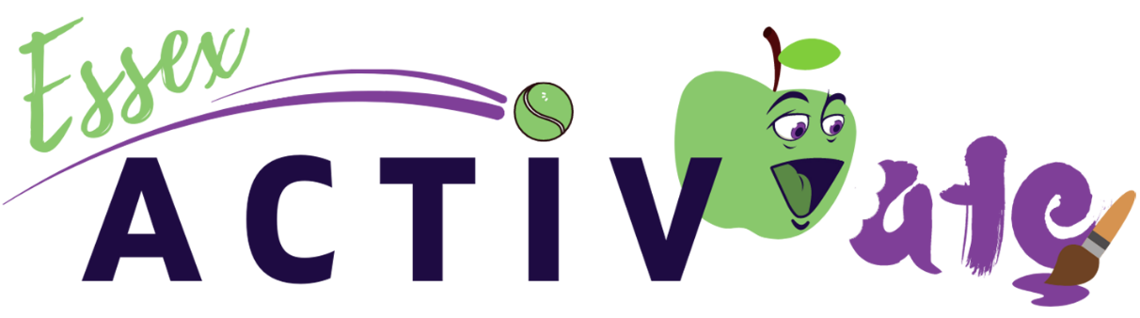

Mental Wellbeing Toolkit
Working in partnership with our Mental Wellbeing Steering Group, we’ve pulled together this toolkit to help you incorporate mental wellbeing support and activities into your sessions and conversations with families. We welcome you to explore these videos, worksheets, case studies and other useful information, to inform your conversations with children, parents and guardians, as well as providing youngsters with the option to be mindful, enjoy some calm time and explore their thoughts and feelings.
Please be sure to continue this support throughout the holidays, then link up with relevant contacts (such as schools, services or charities) if support may need to continue during term-time. If any issues arise from these activities or conversations, seek guidance from your Locality Officer.
Videos:
Organisation | Videos
Roots to Wellbeing | #BeActive Childens Yoga Jungle Animals - YouTube  #Give Rock Painting with Creature Rock - YouTube  #KeepLearning Creative Childrens Activities - YouTube  #Take Notice Creating a Family Portrait - YouTube  #BeActive Removing Tension - YouTube  #Keep Learning Visual Aid to Track Activity - YouTube  #Keep Learning Techniques to help you relax - YouTube  #Connect Stress Buster 7:11 Breathing - YouTube  #Connect Grounding Meditation - YouTube  #Connect With your breath and nature - YouTube  Sing - In a Lovely Day - YouTube
Mind | How to relax | 8 relaxation tips for your mental health  The 5 Ways to Wellbeing  5 ways to get moving and feel better  How to manage your mood with food | 8 tips

Worksheets:
Organisation | Worksheet
Chat 1st | Youth Wellbeing Hub - Anger.pdf  Youth Wellbeing Hub - Anxiety.pdf  Youth Wellbeing Hub - Body Image.pdf  Youth Wellbeing Hub - Bullying.pdf  Youth Wellbeing Hub - Coping with Change.pdf  Youth Wellbeing Hub - Depression.pdf  Youth Wellbeing Hub - Exam Stress.pdf  Youth Wellbeing Hub - General Wellbeing.pdf  Youth Wellbeing Hub - Insomnia and sleep poster.pdf  Youth Wellbeing Hub - Loneliness.pdf  Youth Wellbeing Hub - Panic Attack Poster.pdf  Youth Wellbeing Hub - Stress.pdf

Other Useful Links:
Organisation | Information
Active Essex | Children's Mental Health - Active Essex
The Mental Health Foundation | Access stories, stats, podcasts and guidance
Gov.uk | Guidance for the public on the mental health and wellbeing aspects of coronavirus
Anna Freud | Resources to empower young people to make informed choices about their mental health and wellbeing
Young Minds | www.youngminds.org.uk / Text YM to 85258
Childline | www.childline.org.uk / Telephone 0800 1111
The Mix | Essential support for under 25s
Kooth | Online mental wellbeing community – providing free, safe and anonymous support
The Emotional Wellbeing and Mental Health Service | Advice and support to children, young people and families / Telephone 0800 953 0222
Kids Inspire | Mental health and trauma recovery support for children, young people and their families
Essex County Council | Mental health: Adult Mental Health and Wellbeing team
Motivated Minds | Individual Wellbeing - Online Support

Blogs, Stories & Inspiration:
Organisation | Link
Active Essex | Young People, Movement and Mental Wellbeing - Active Essex
Peaceful Pony | Spotlight Saturday - Peaceful Pony - Active Essex
Inclusive Training | Activity Alliance supports Active Essex to deliver inclusive sessions to children - Active Essex
Project:ME | Tackling Loneliness – Tips from Young People
Young Minds | Eleanor - Why I Practise Self-care Every Day
Young Minds | Rose - Tips For Coping With Peer Pressure

